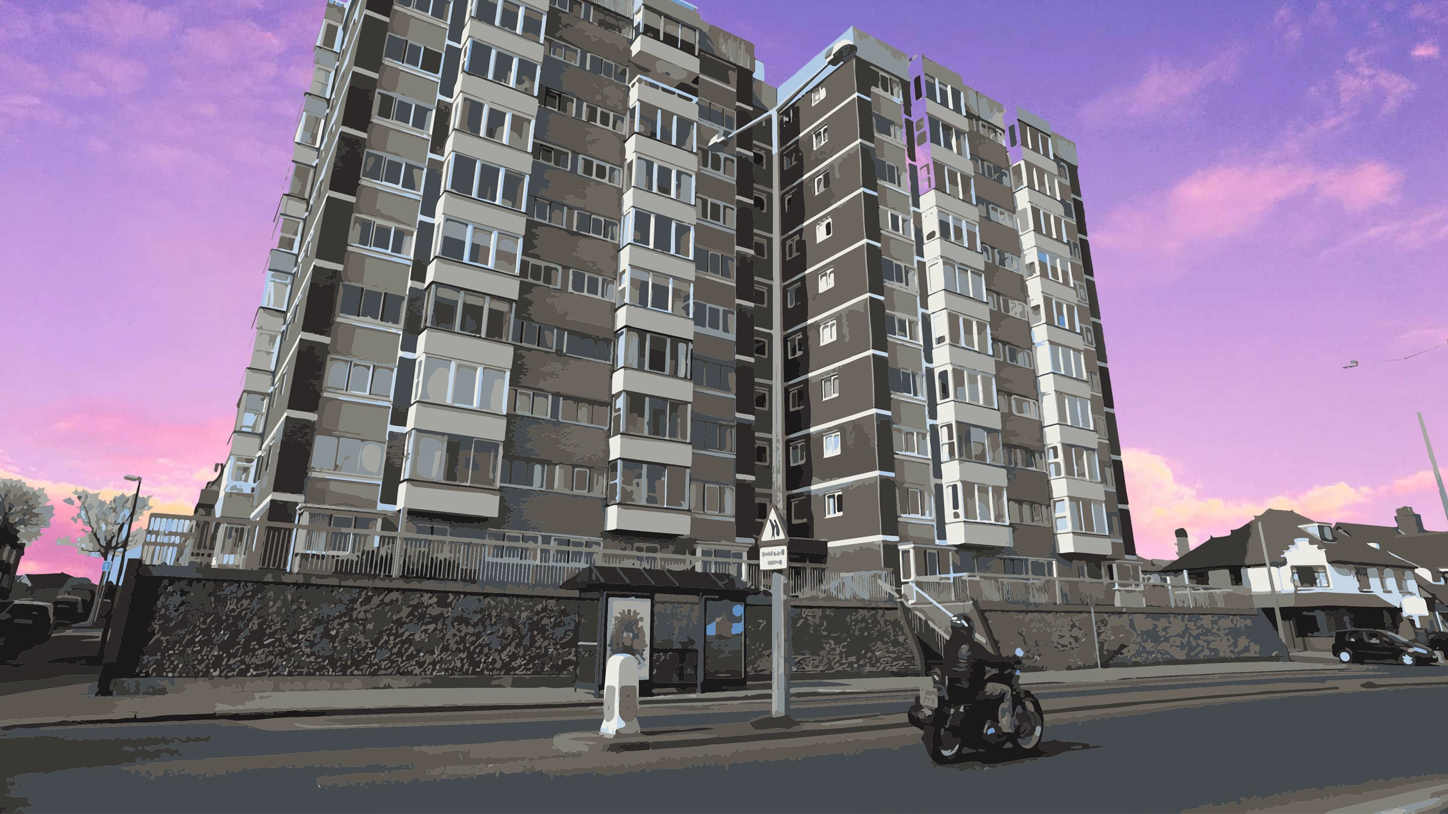
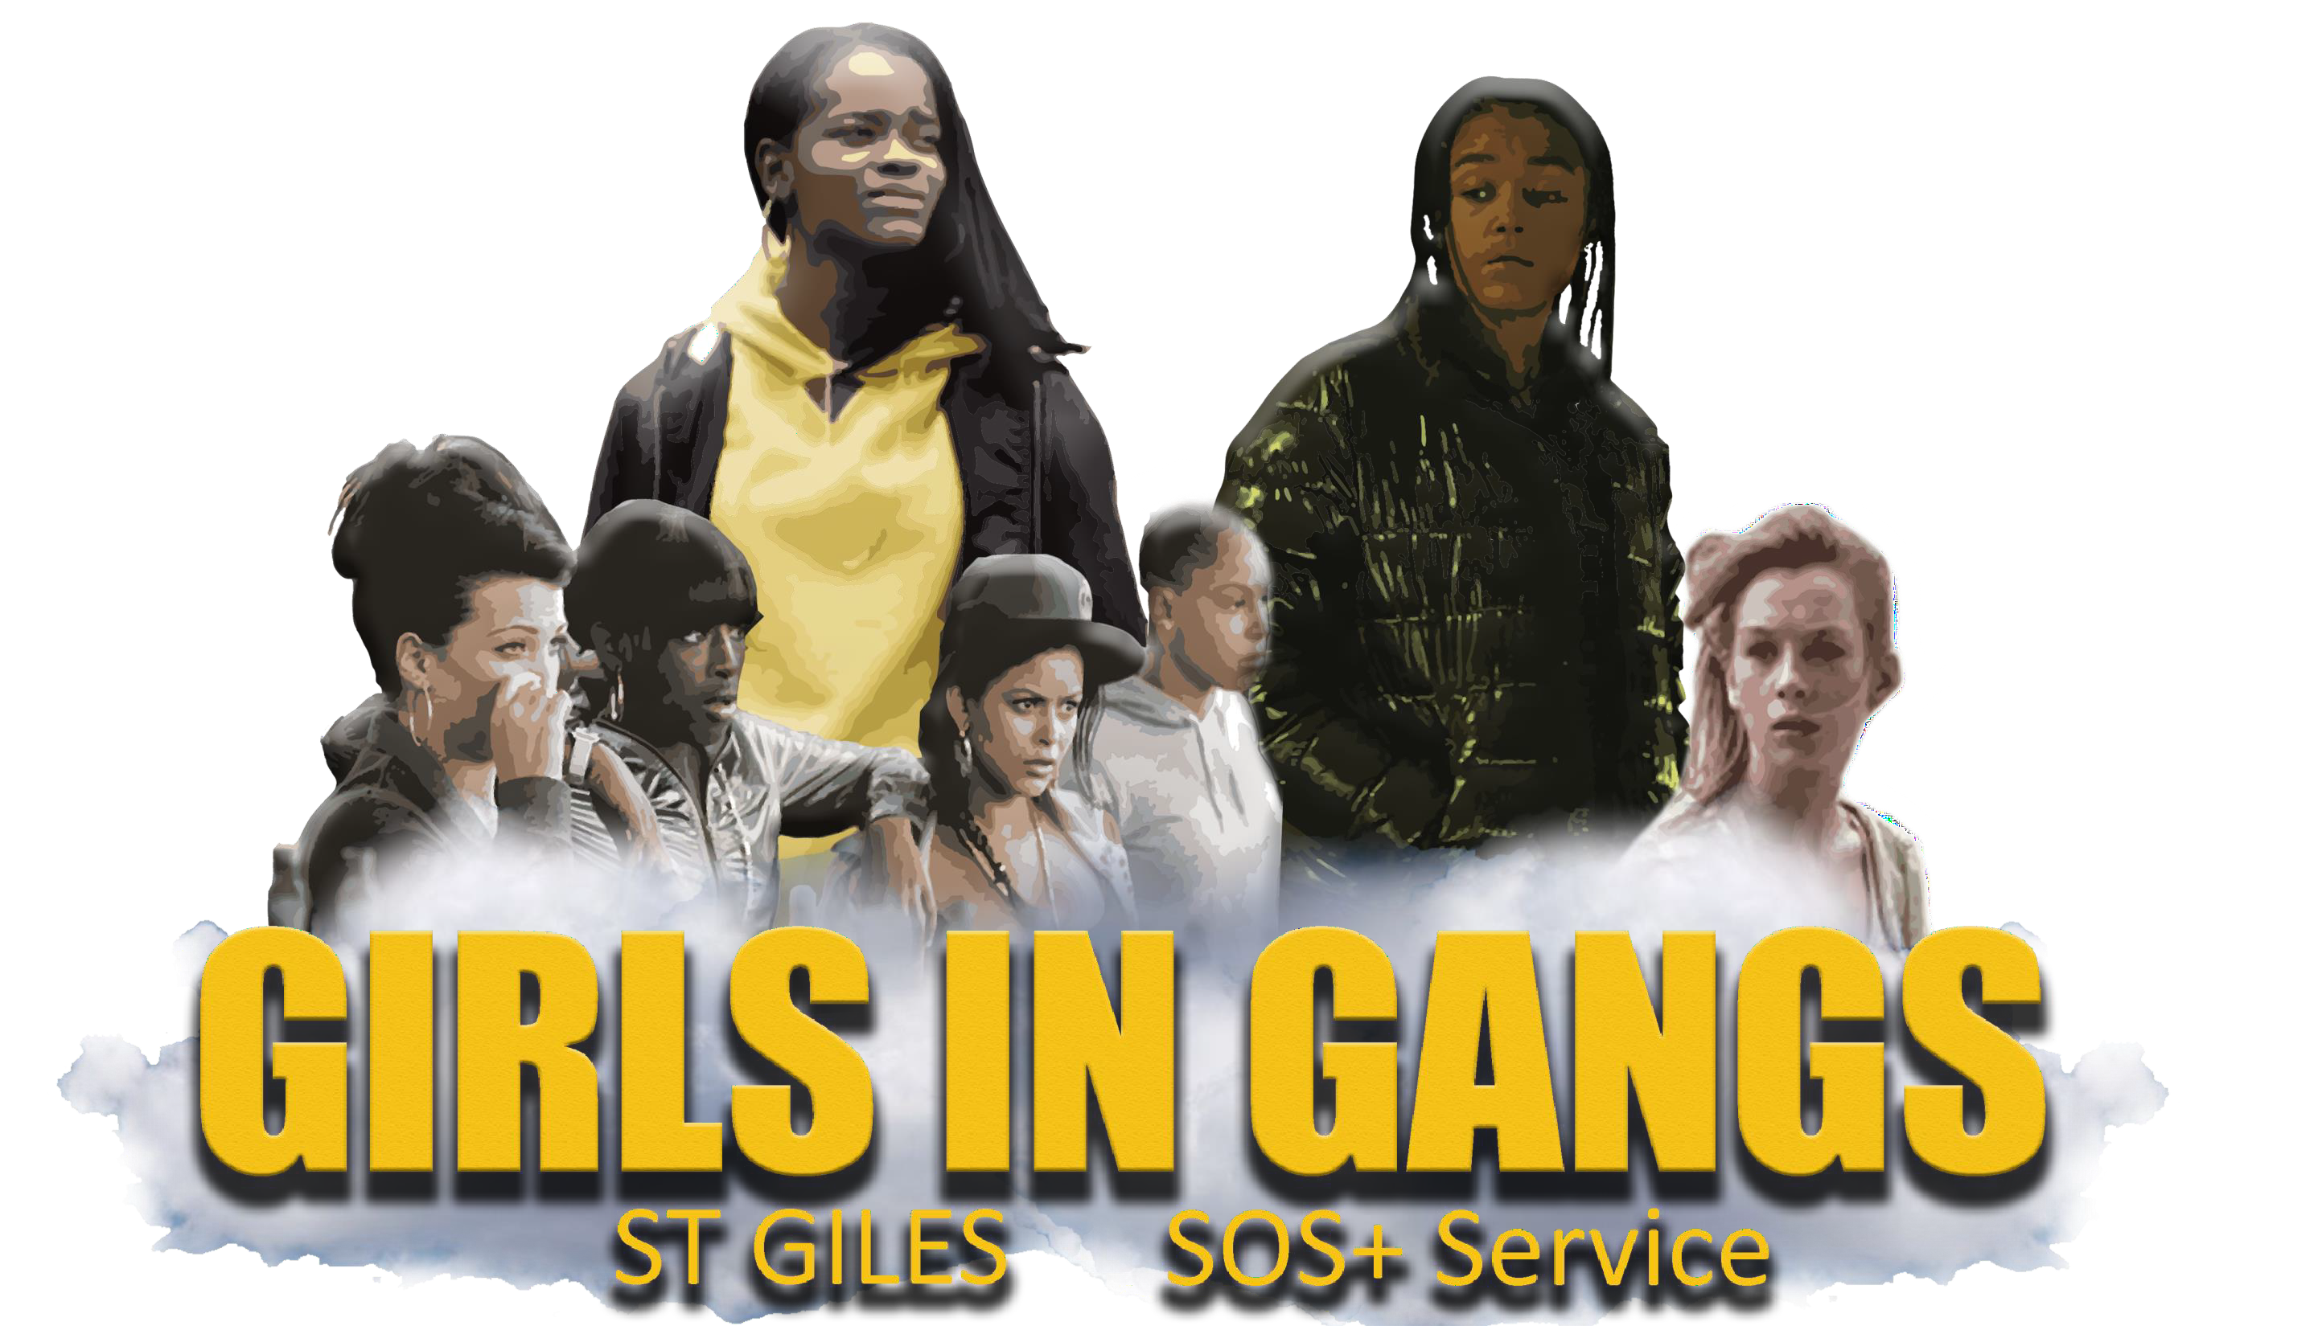

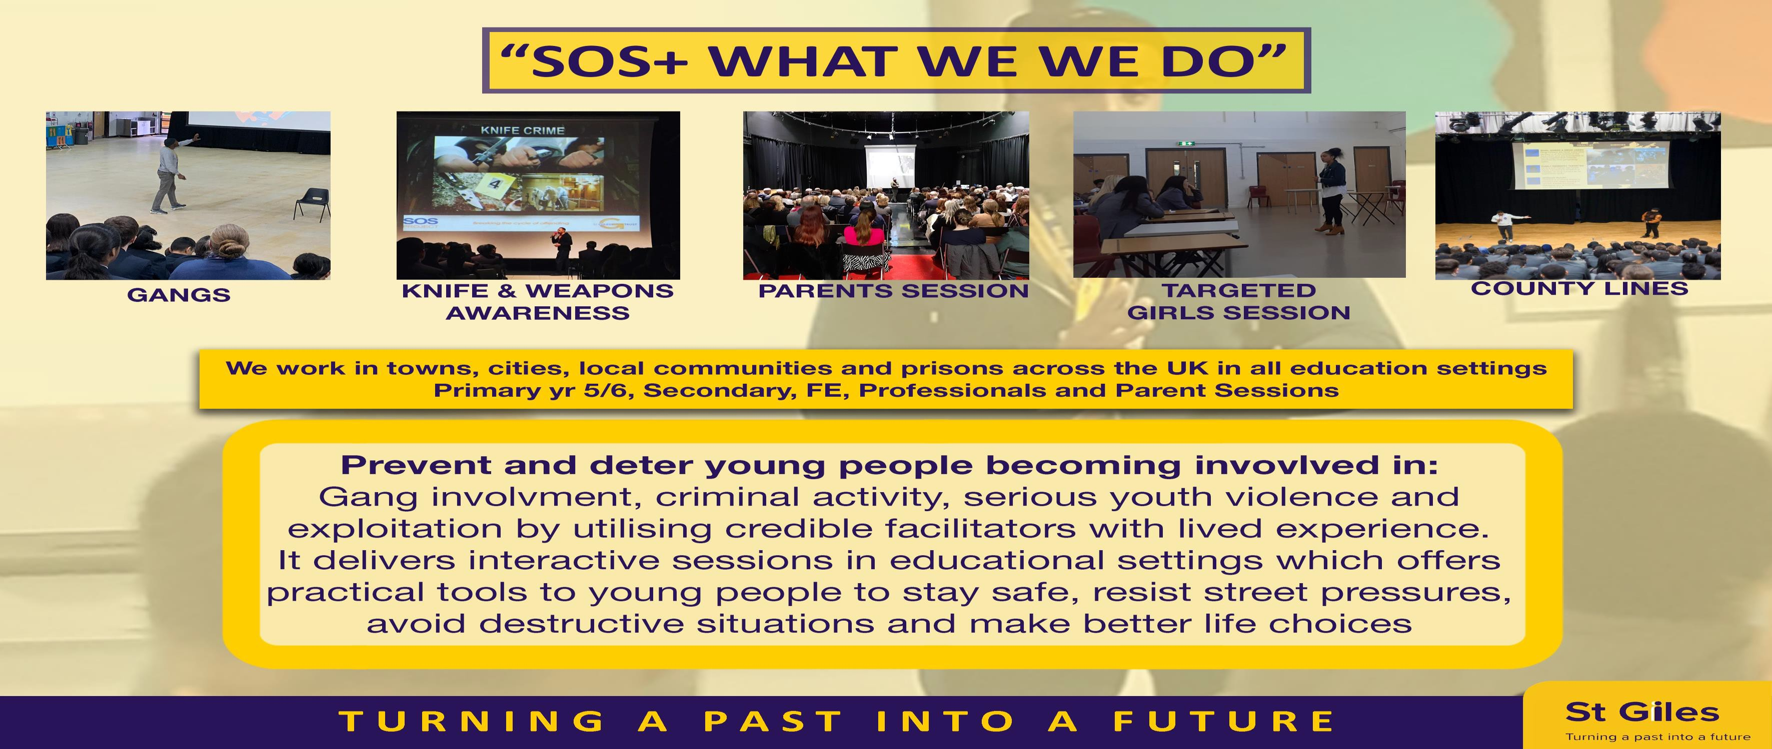

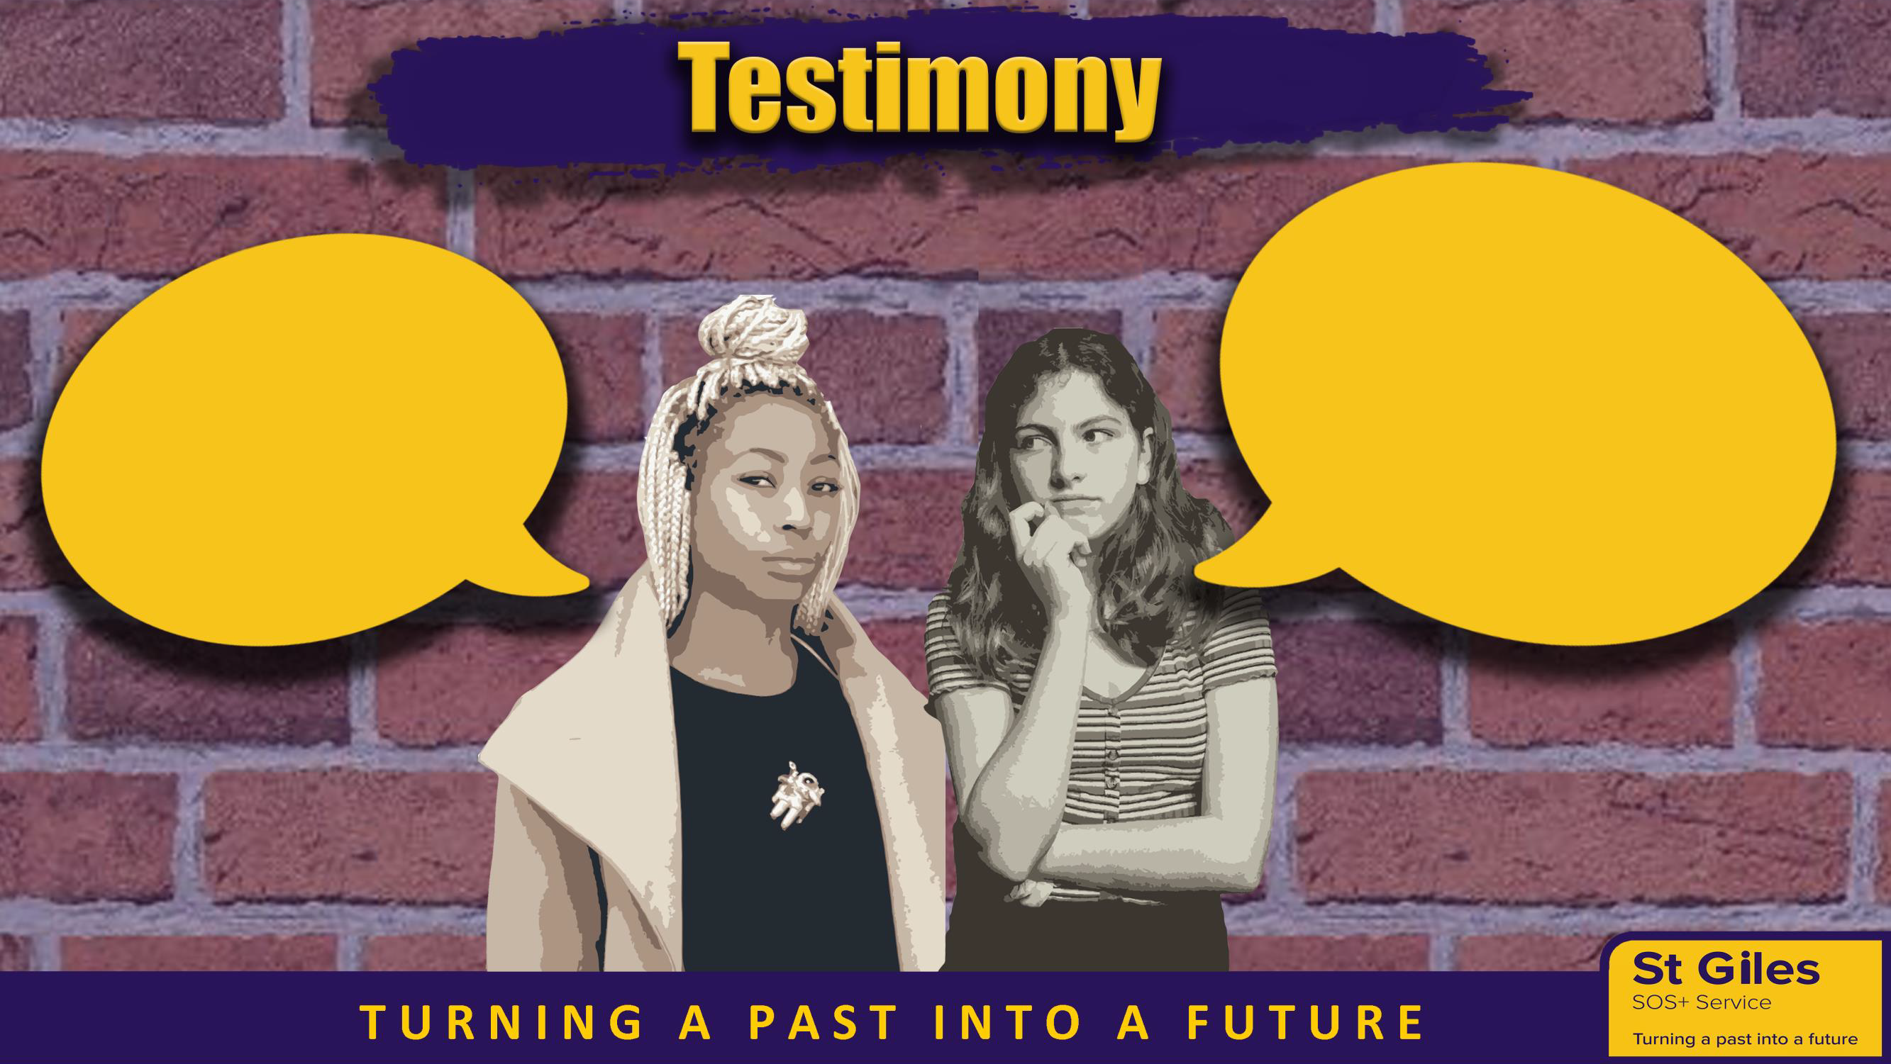
Saying “NO” at the right time, could possibly stop your life going down
the wrong path.
I learnt that too late.

I suffered so much trauma before I truly found my purpose,
You don’t have to experience that if you be your true self!

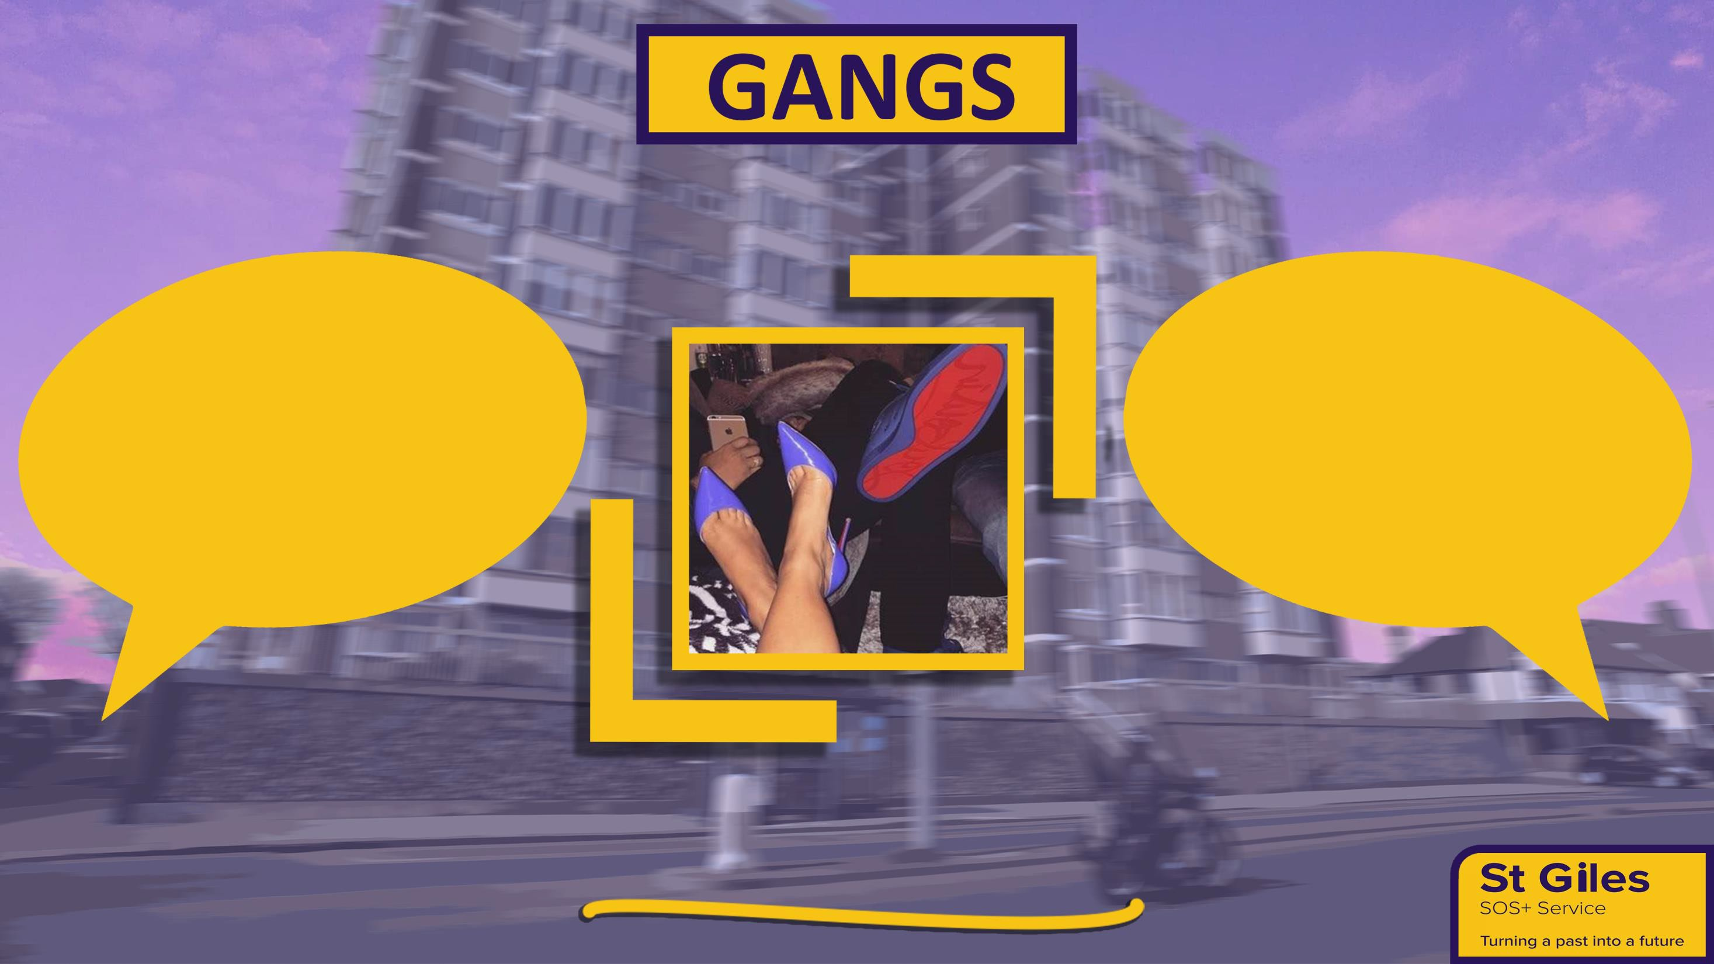

“Group of associated, Friends or members of a family that identifies with or claims
control over territory in a community an engages, either individually or collectively, in illegal, and possibly violent, behavior”.


34% of 6,830 Girls

identified by

councils as being

involved in gangs

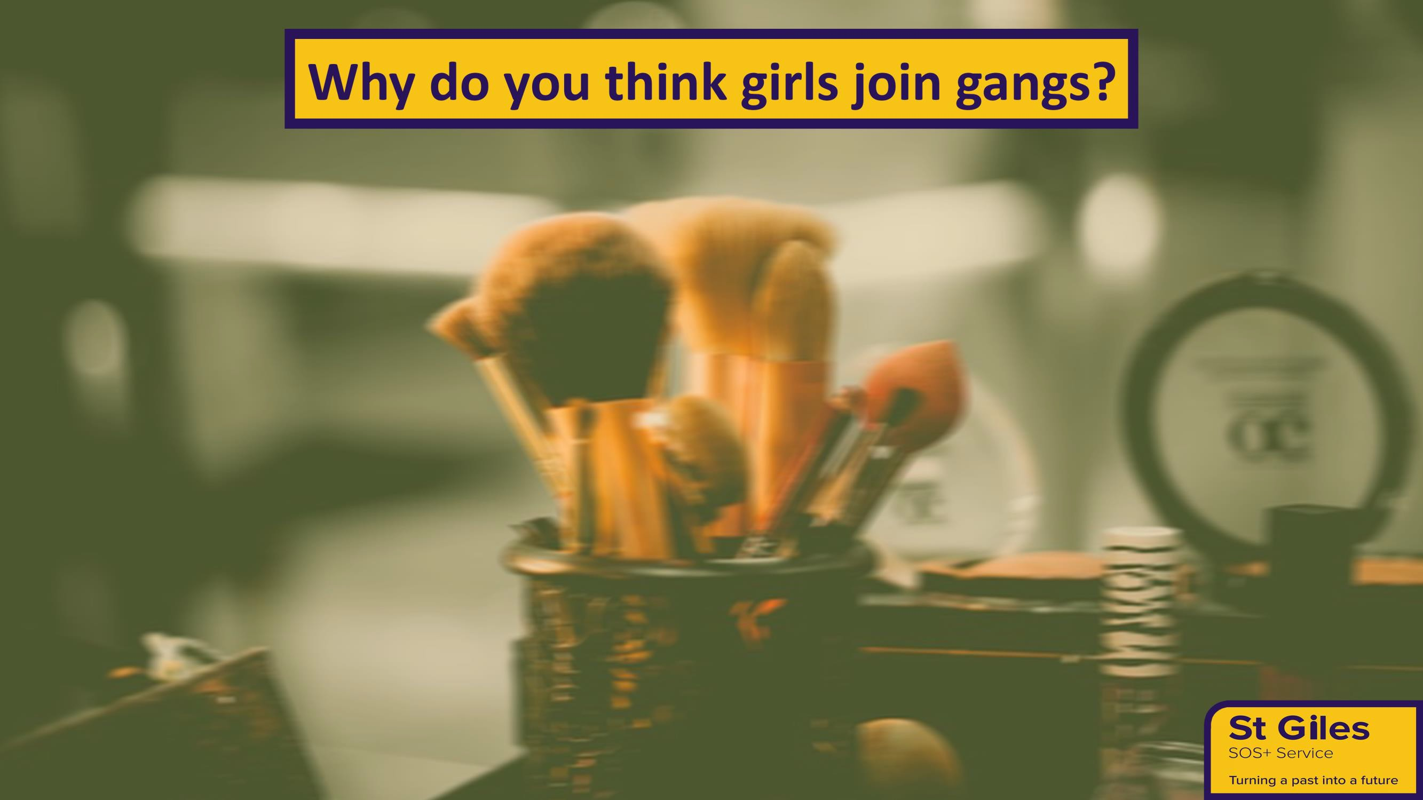
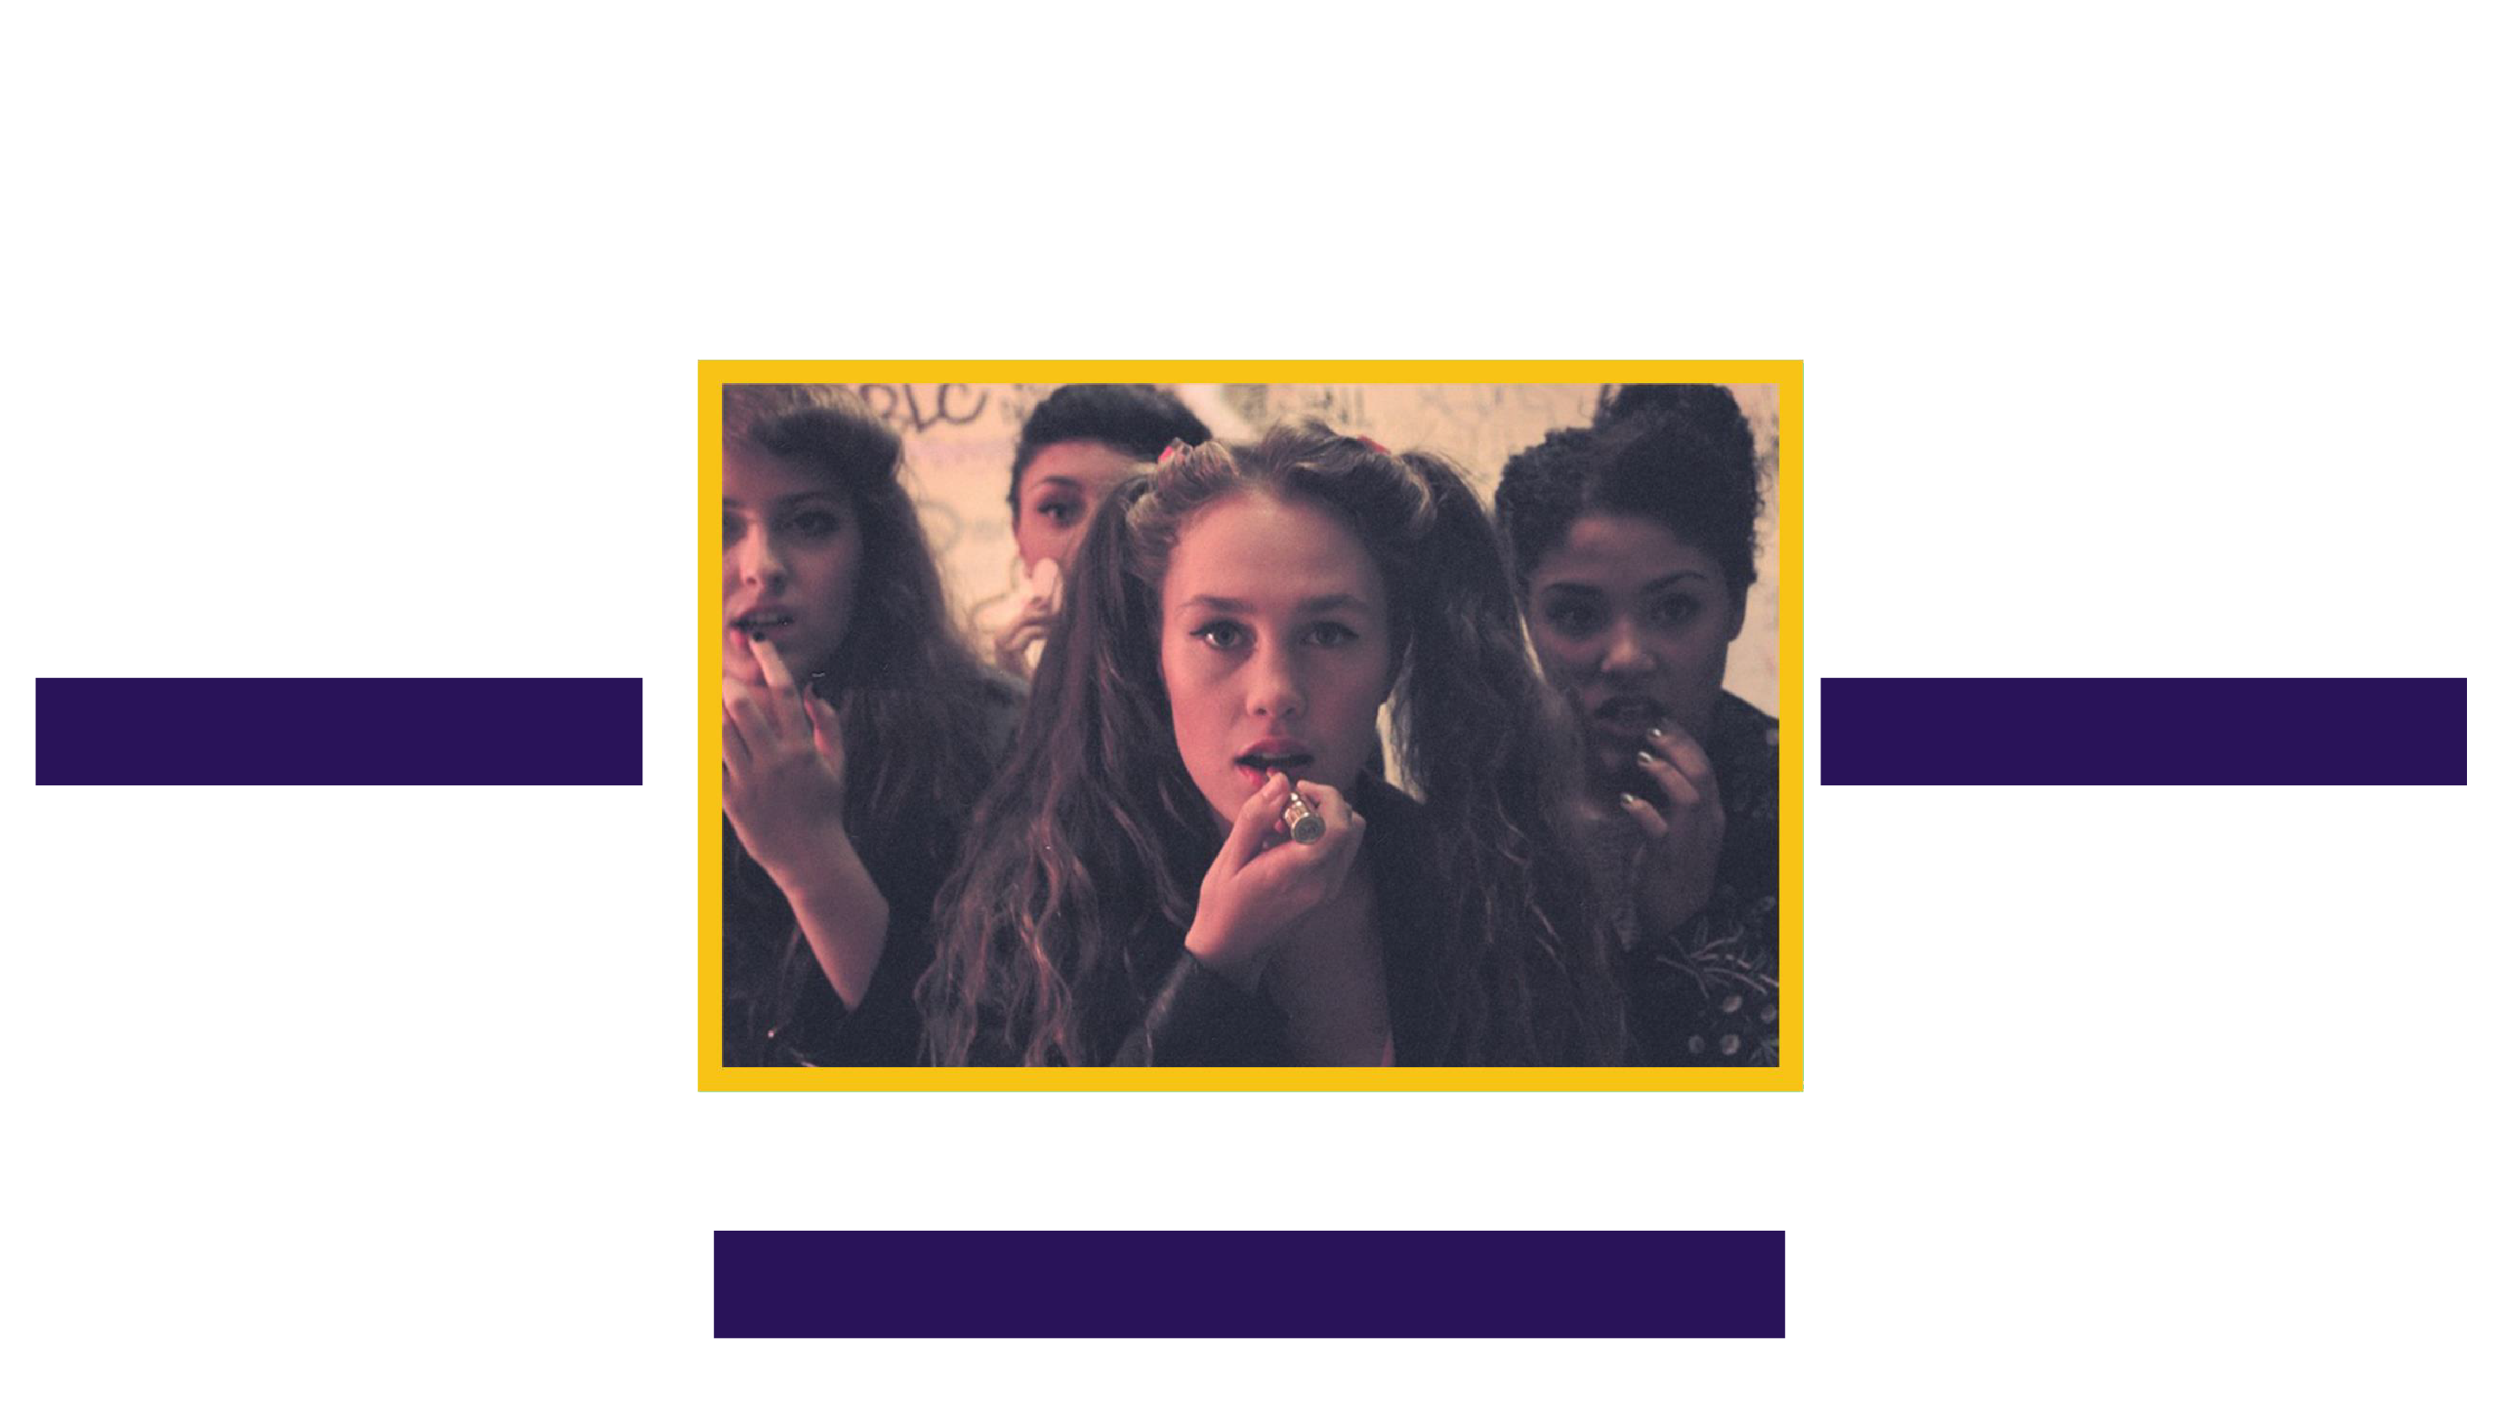

What makes a gang? Recruited or exploited?

Why would an individual join a gang?

Reasons Females Join gangs

Popularity

Belonging
(protection/security) Upbringing Vulnerability
Respected Feared/ significant

Lack of positive male role model

Boyfriend / Girlfriend

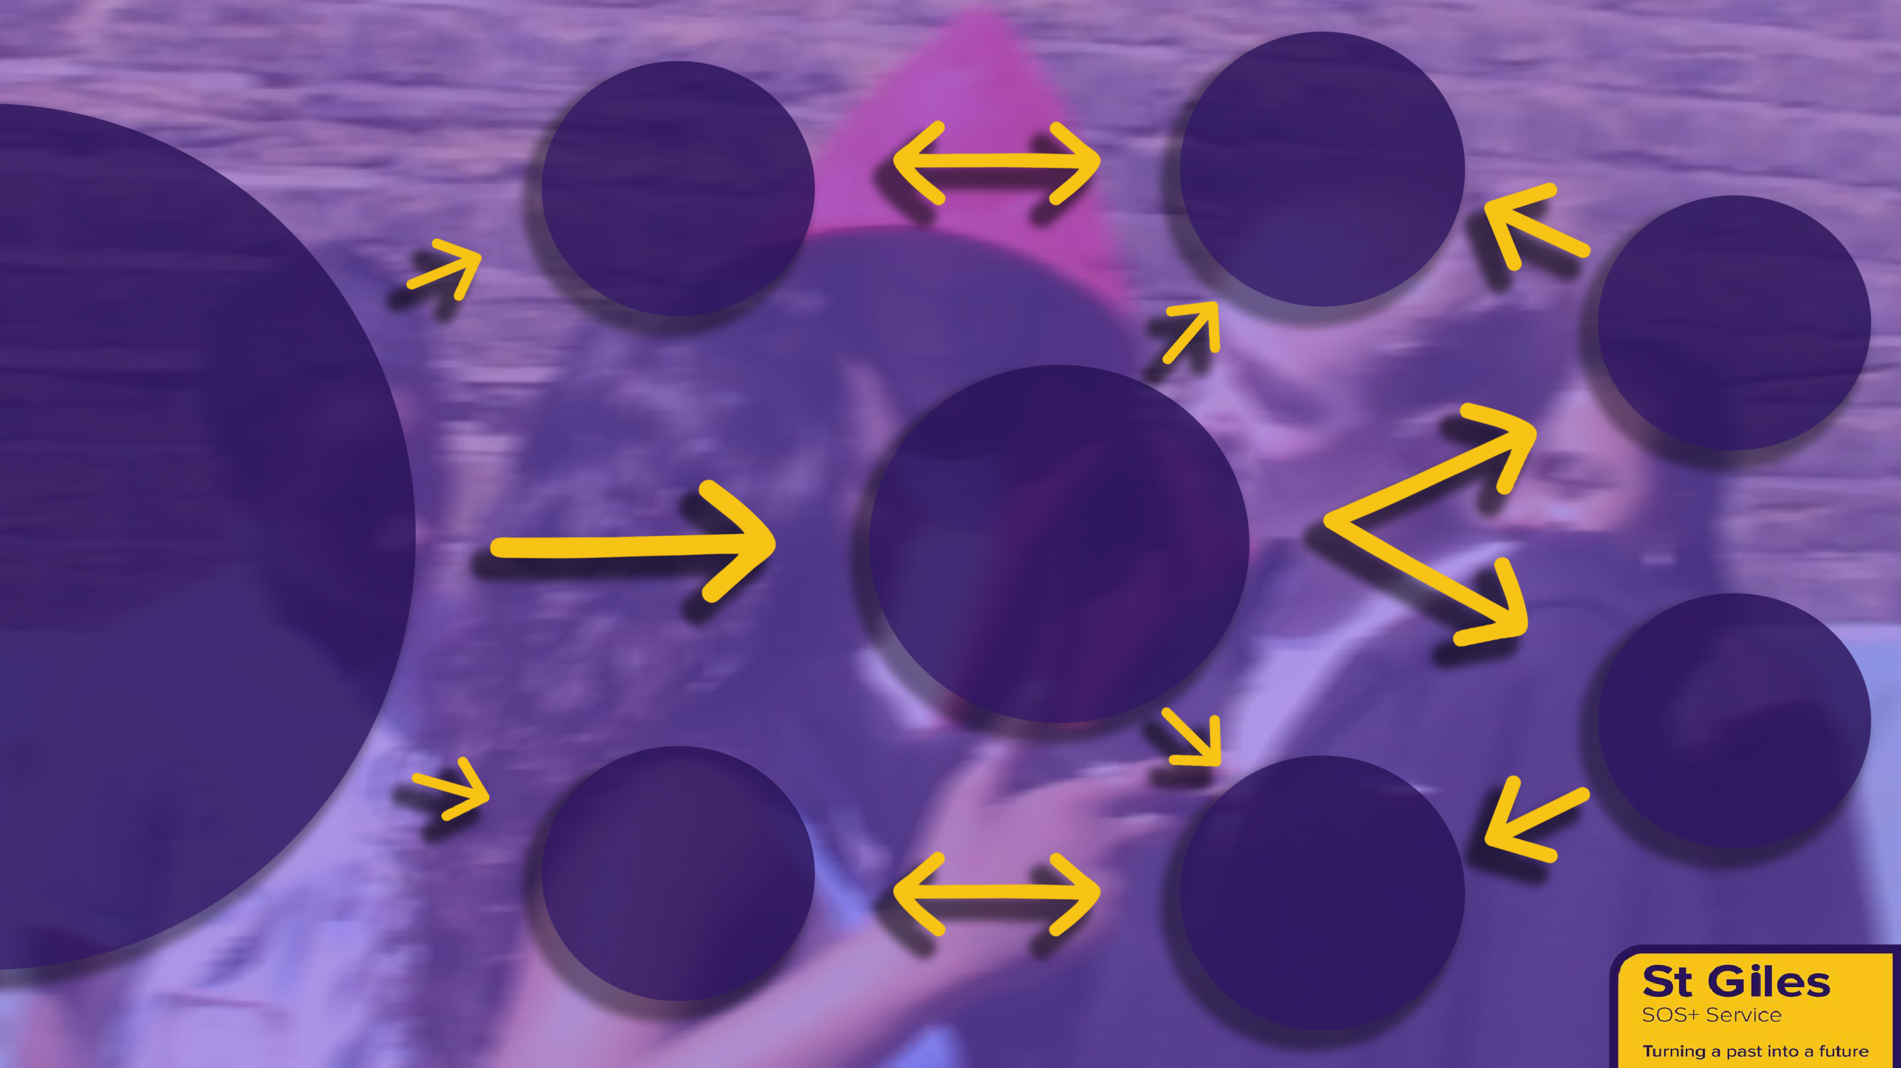
Environment
Disengaged from family and services

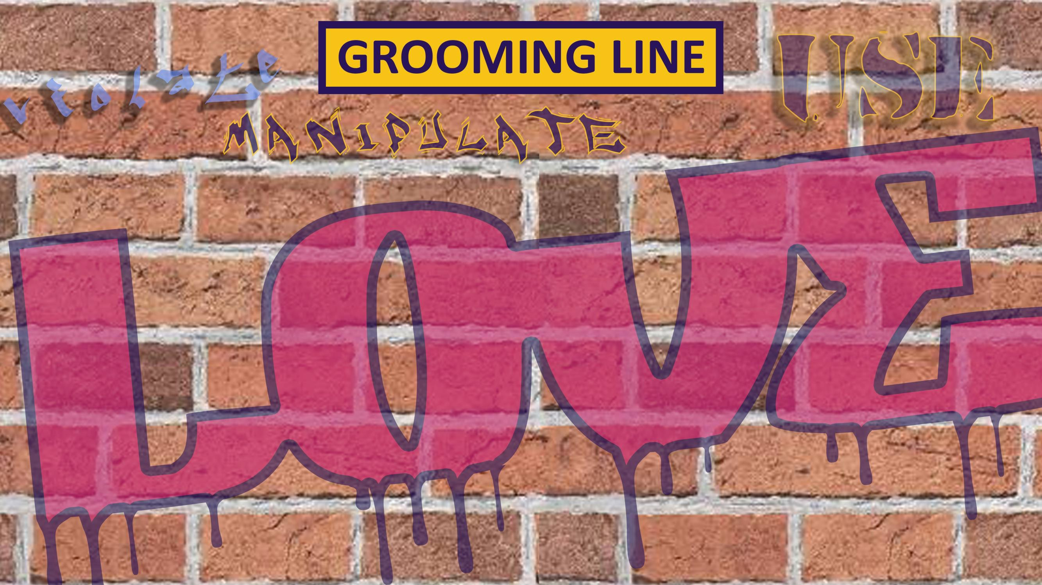
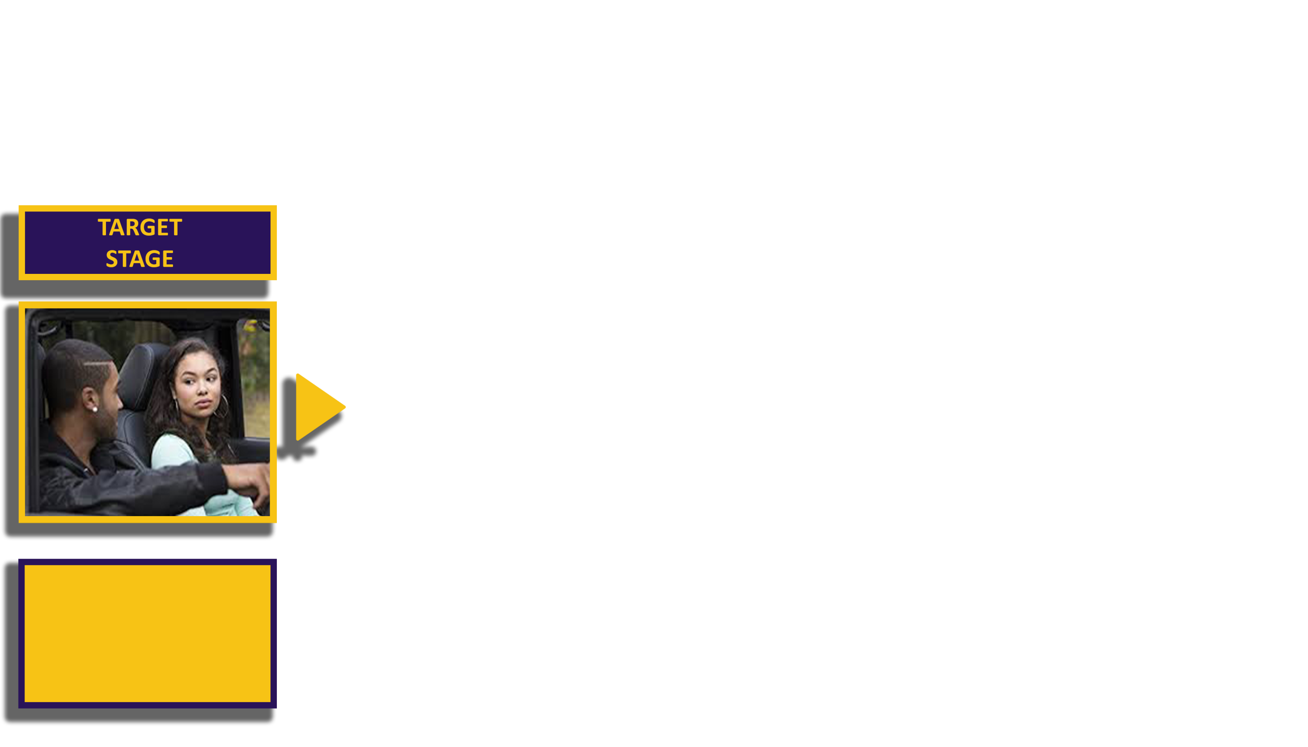
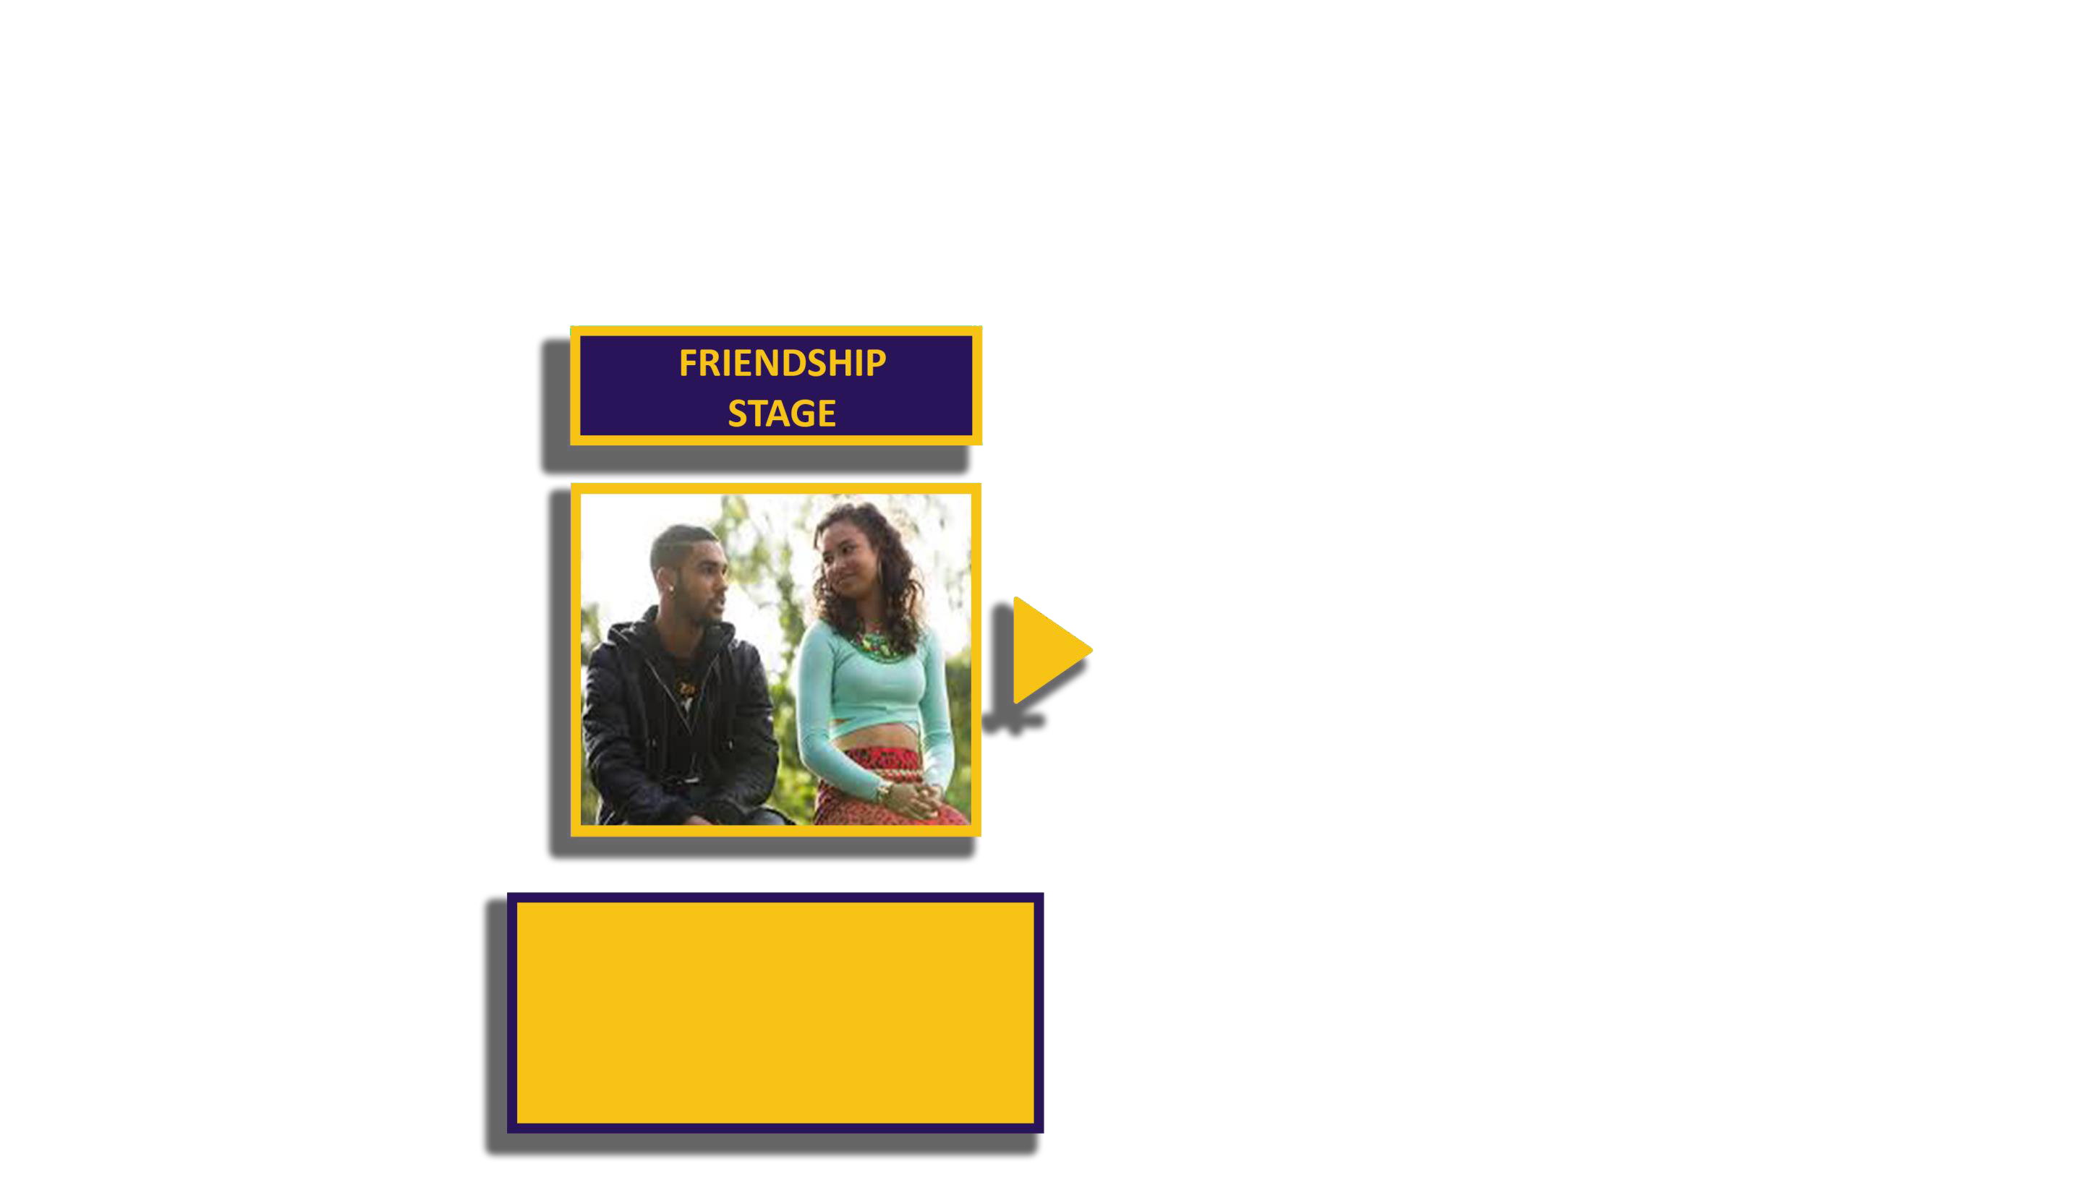
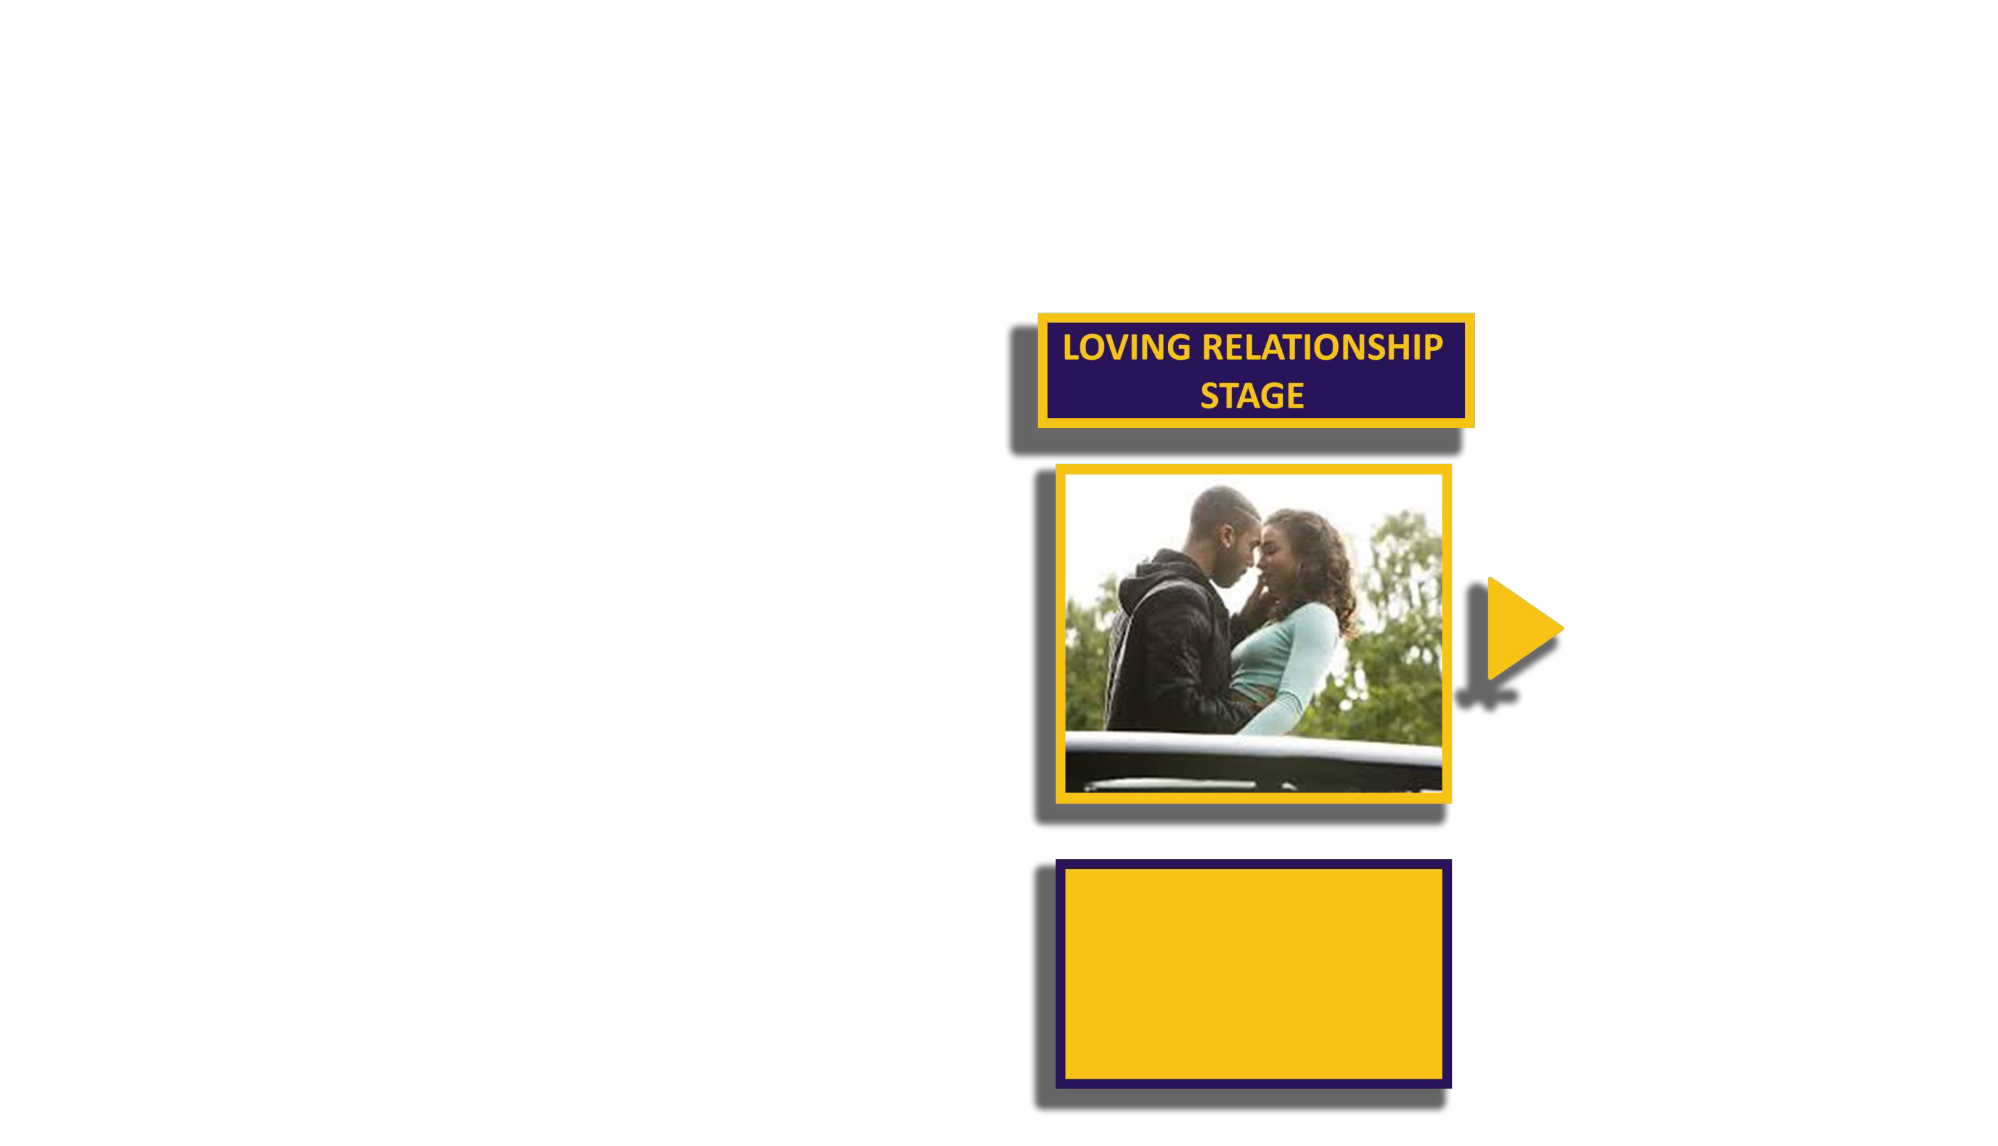
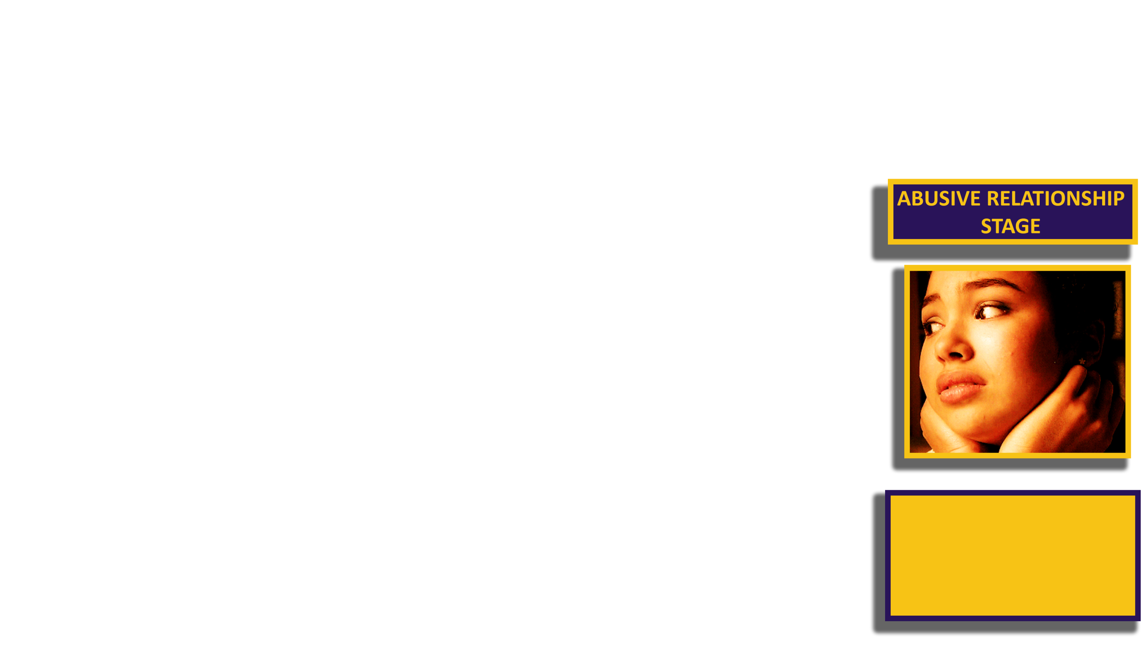
Social Media Local Area School
DEEMED AS A CONFIDENT CONVERSATIONS
INVITED OUT
DATES
FAMILY MEMBERS ENTANGLEMENTS RELATIONSHIPS CLOSE FRIENDS
PUT INTO A DANGEROUS SITUATION
BECOMING A HOLDER
EMOTIONAL ABUSE

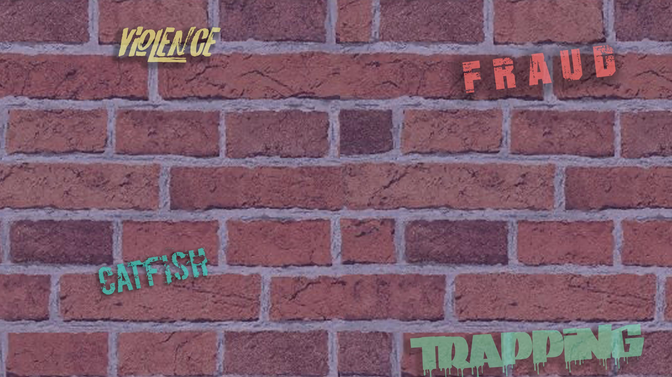
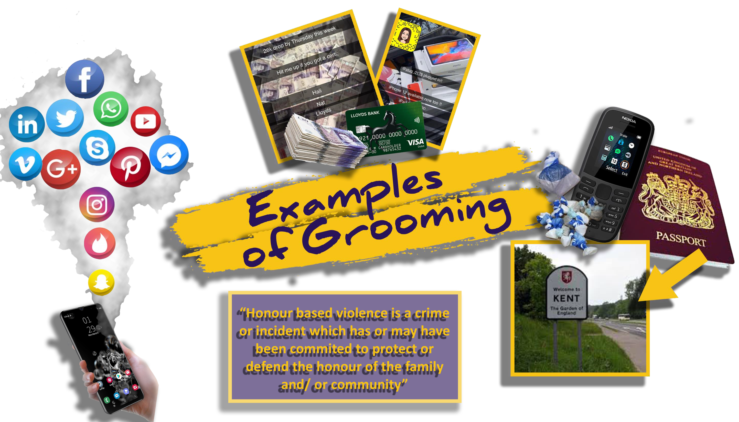

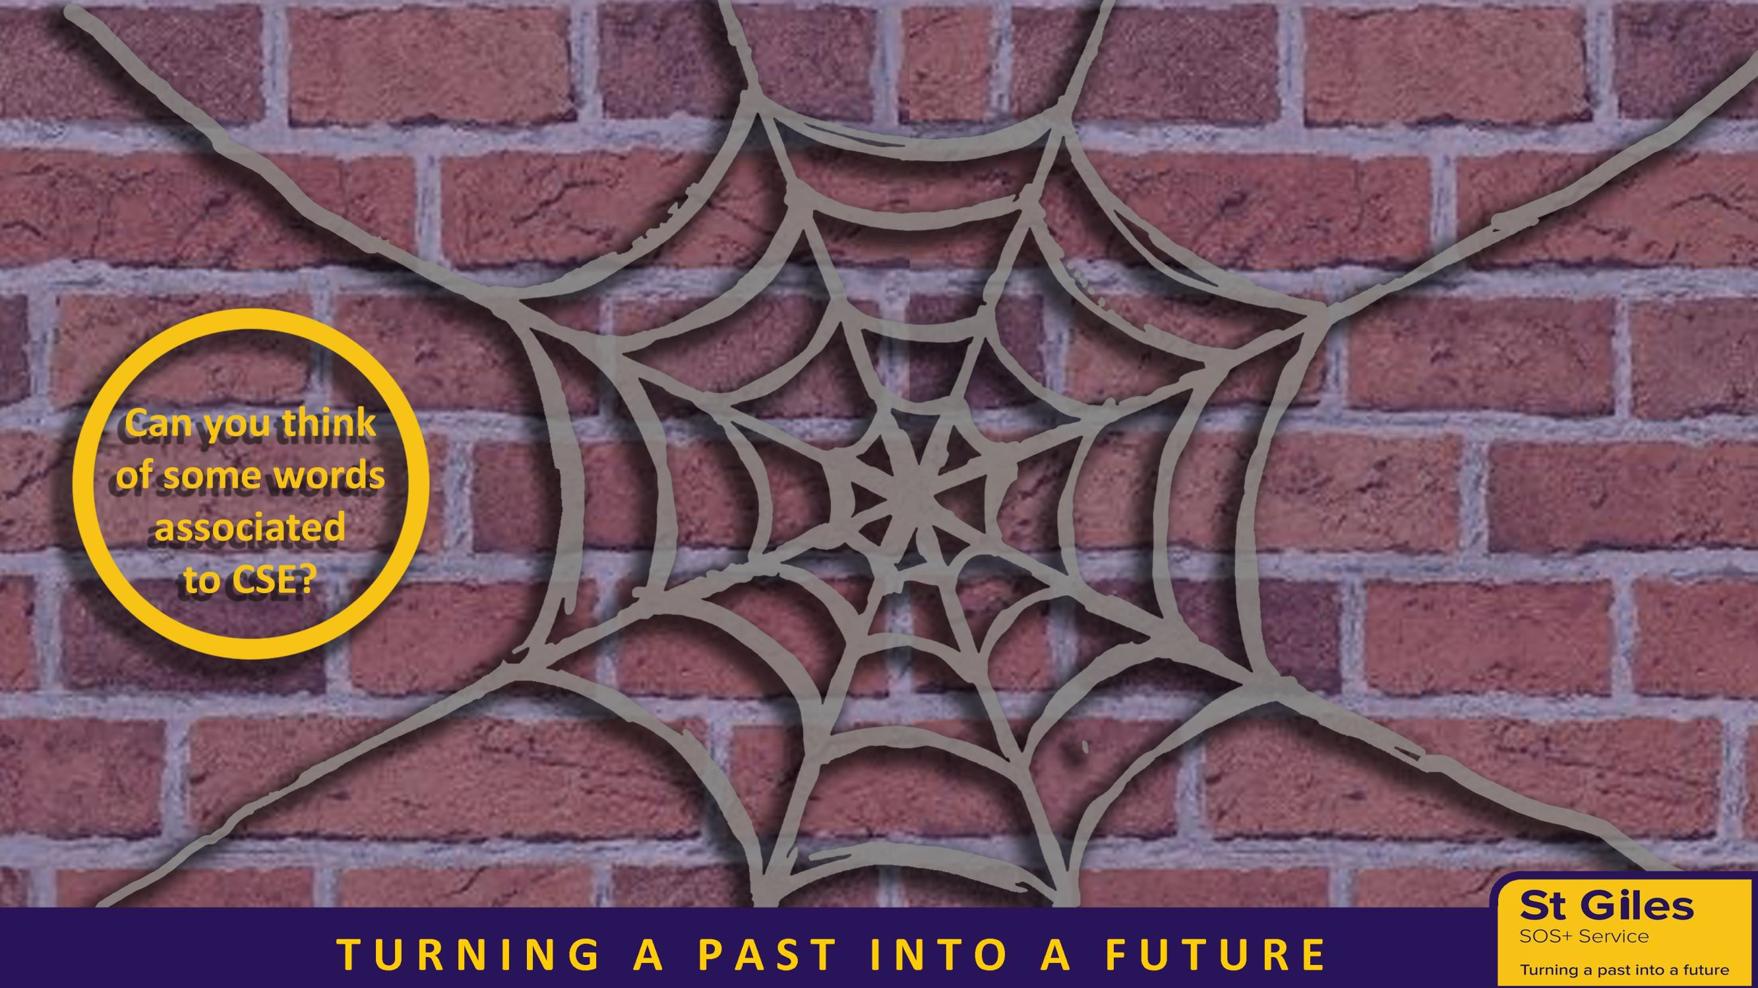
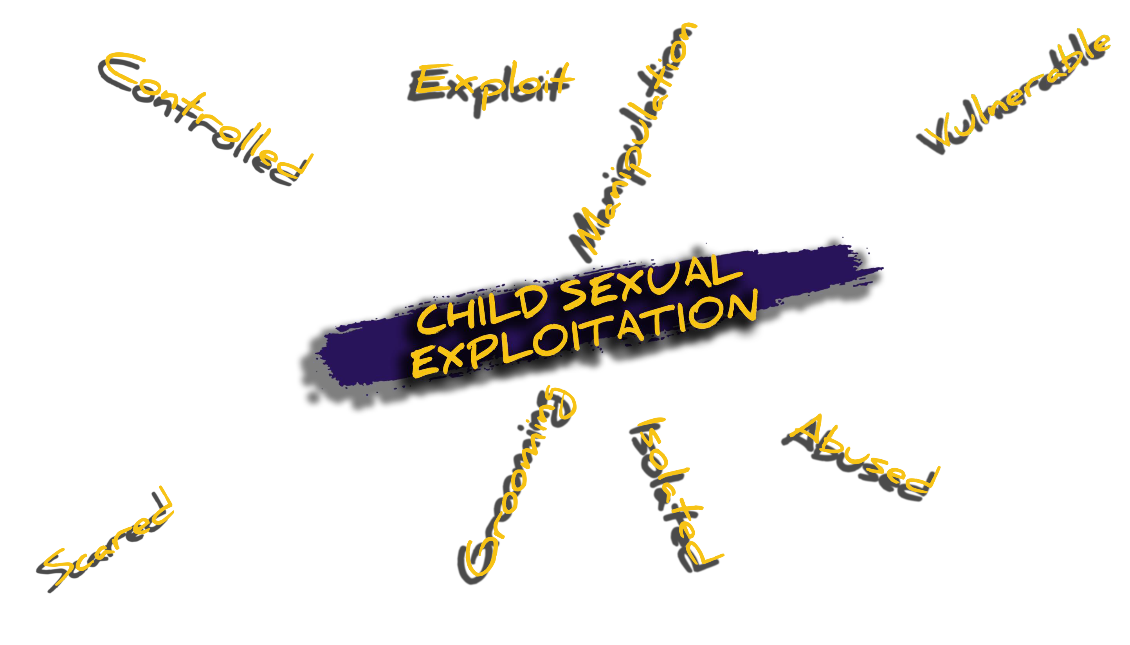



Child sexual exploitation is a form of child sexual abuse
It occurs where an individual or group takes advantages of an imbalance of power to coerce, manipulation or deceive a child or young person under the age of 18 into sexual activity
The victim may have been sexual exploited even if the sexual activity appears consensual
Child sexual exploitation does not always involve physical contact; It can also occur through, the use of technology

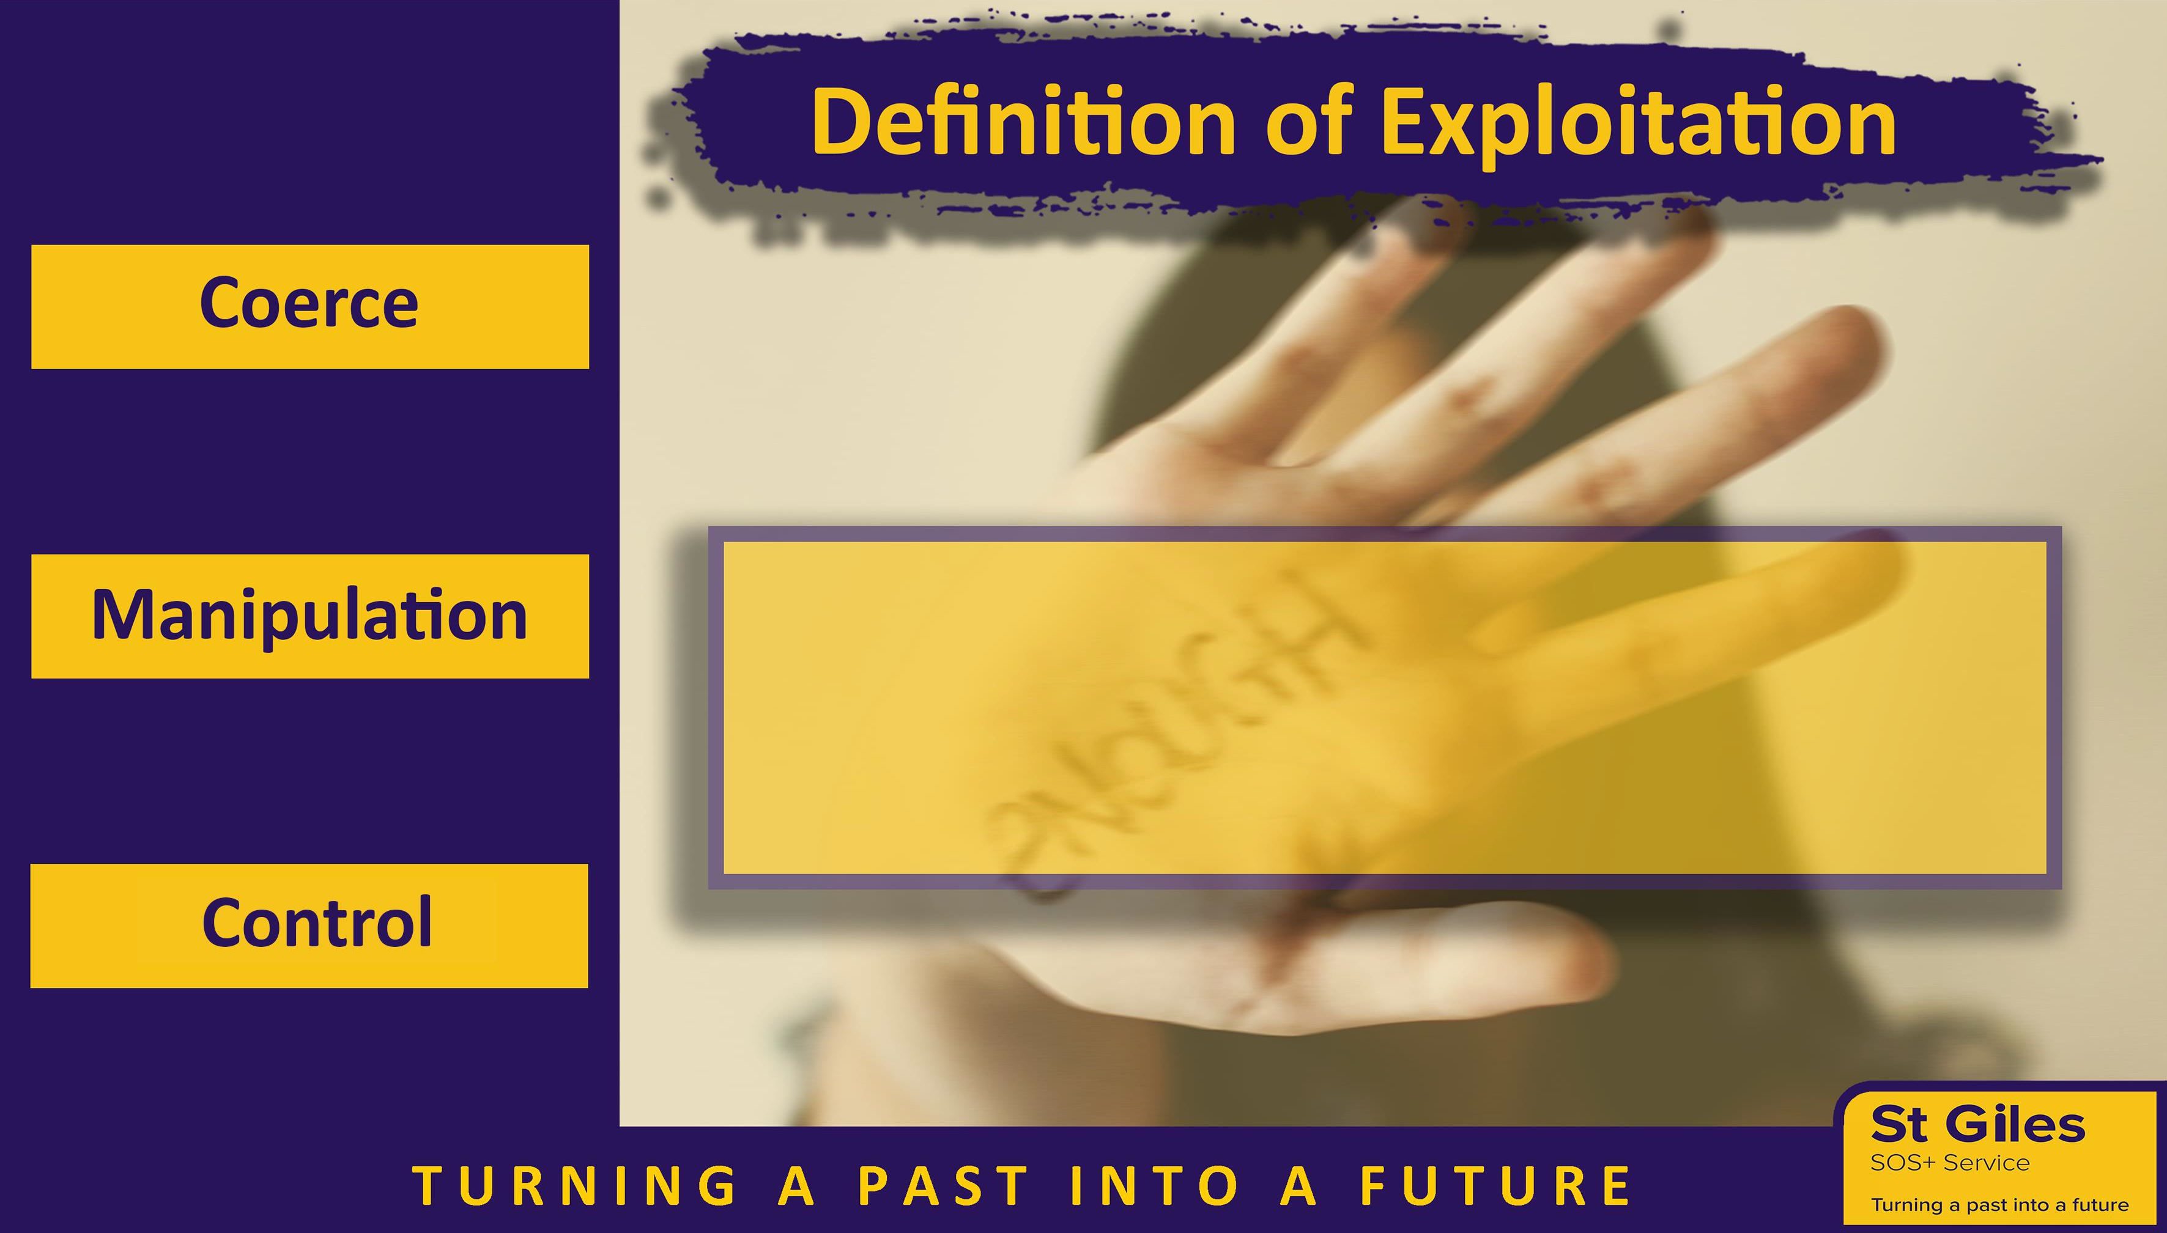

“A common feature of CSE is that the child or young person does not recognize the coercive nature
of the relationship and does not see
themselves as a victim of exploitation”




All three attended a party of a
Friend’s older sister.
May 13, was groomed that night Kim13, was sexually assaulted And Emily never returned.

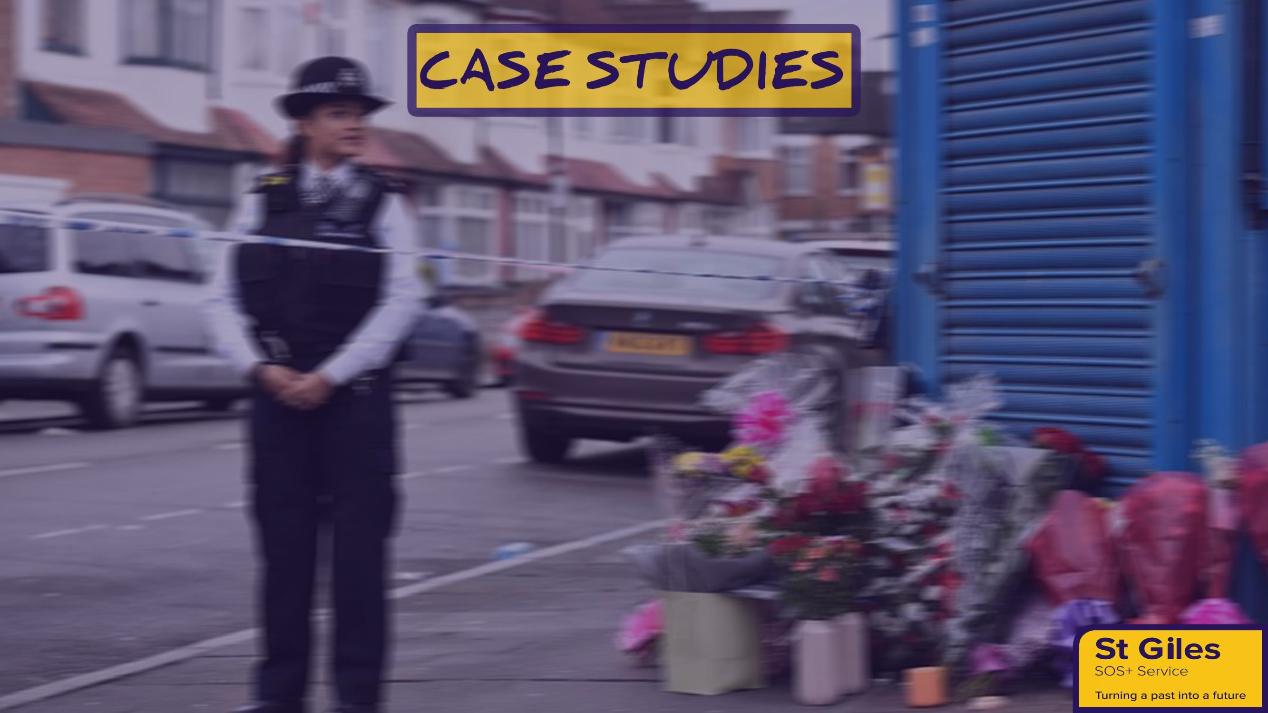
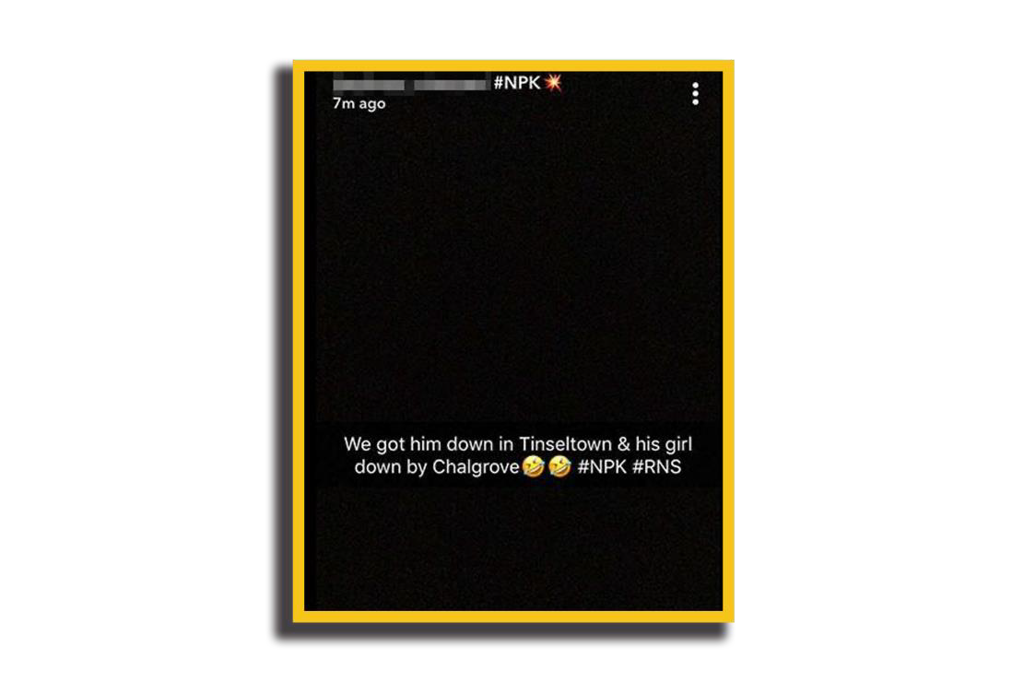
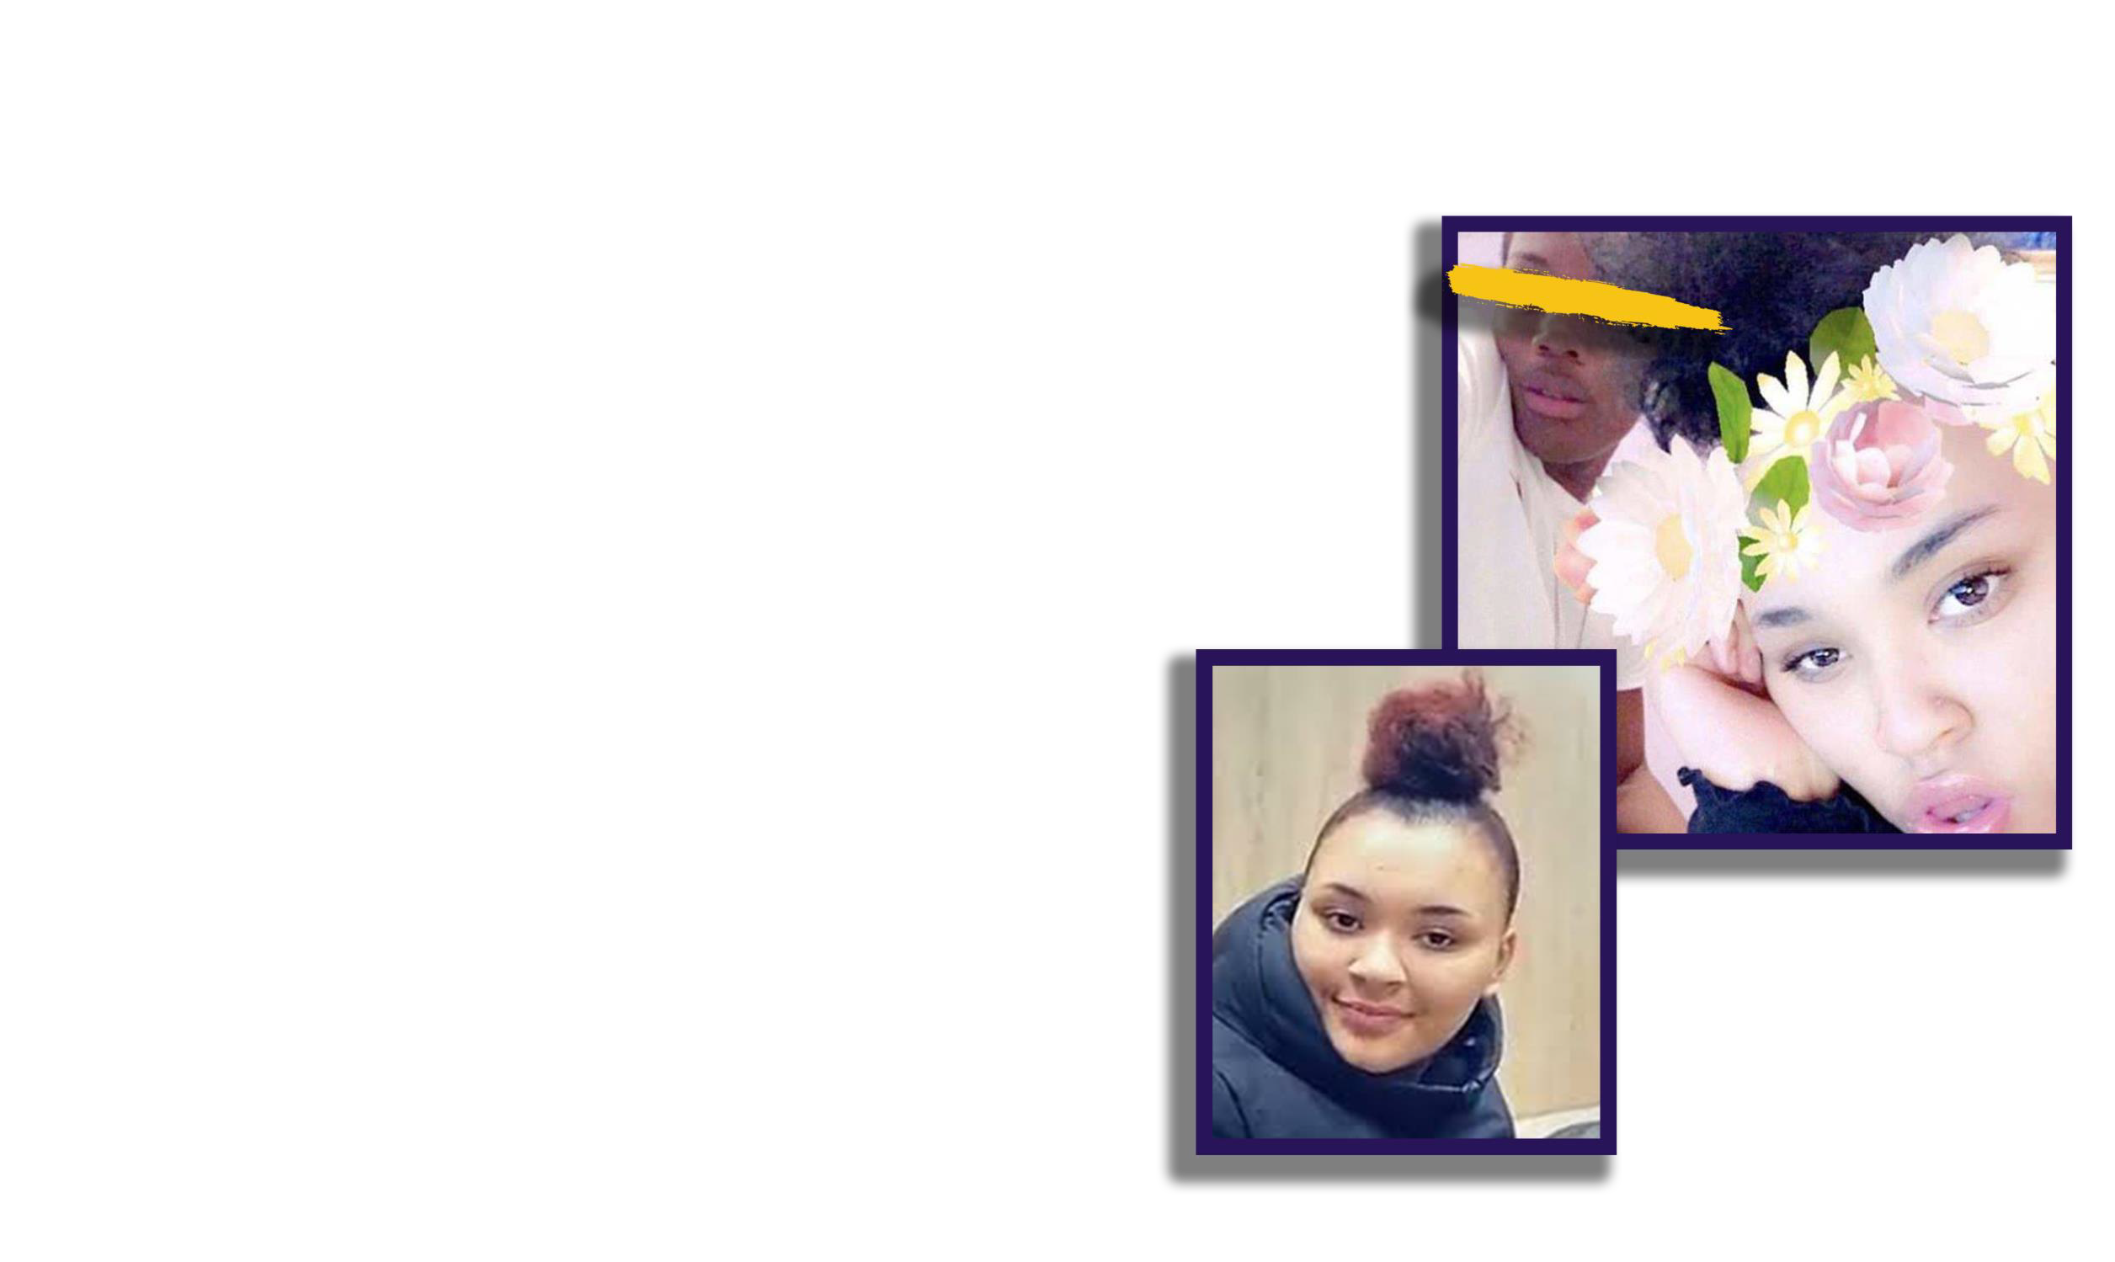


17yr old Tanesha was shot on the 2nd April 2018 In Tottenham, North London in a drive by whilst Back from the shops with friends.
This was retaliation after being in an altercation With her boy friends rival gang while on a date in a Central London restaurant.
Tanesha tried to protect her boyfriend from being shot and in return was shot herself.


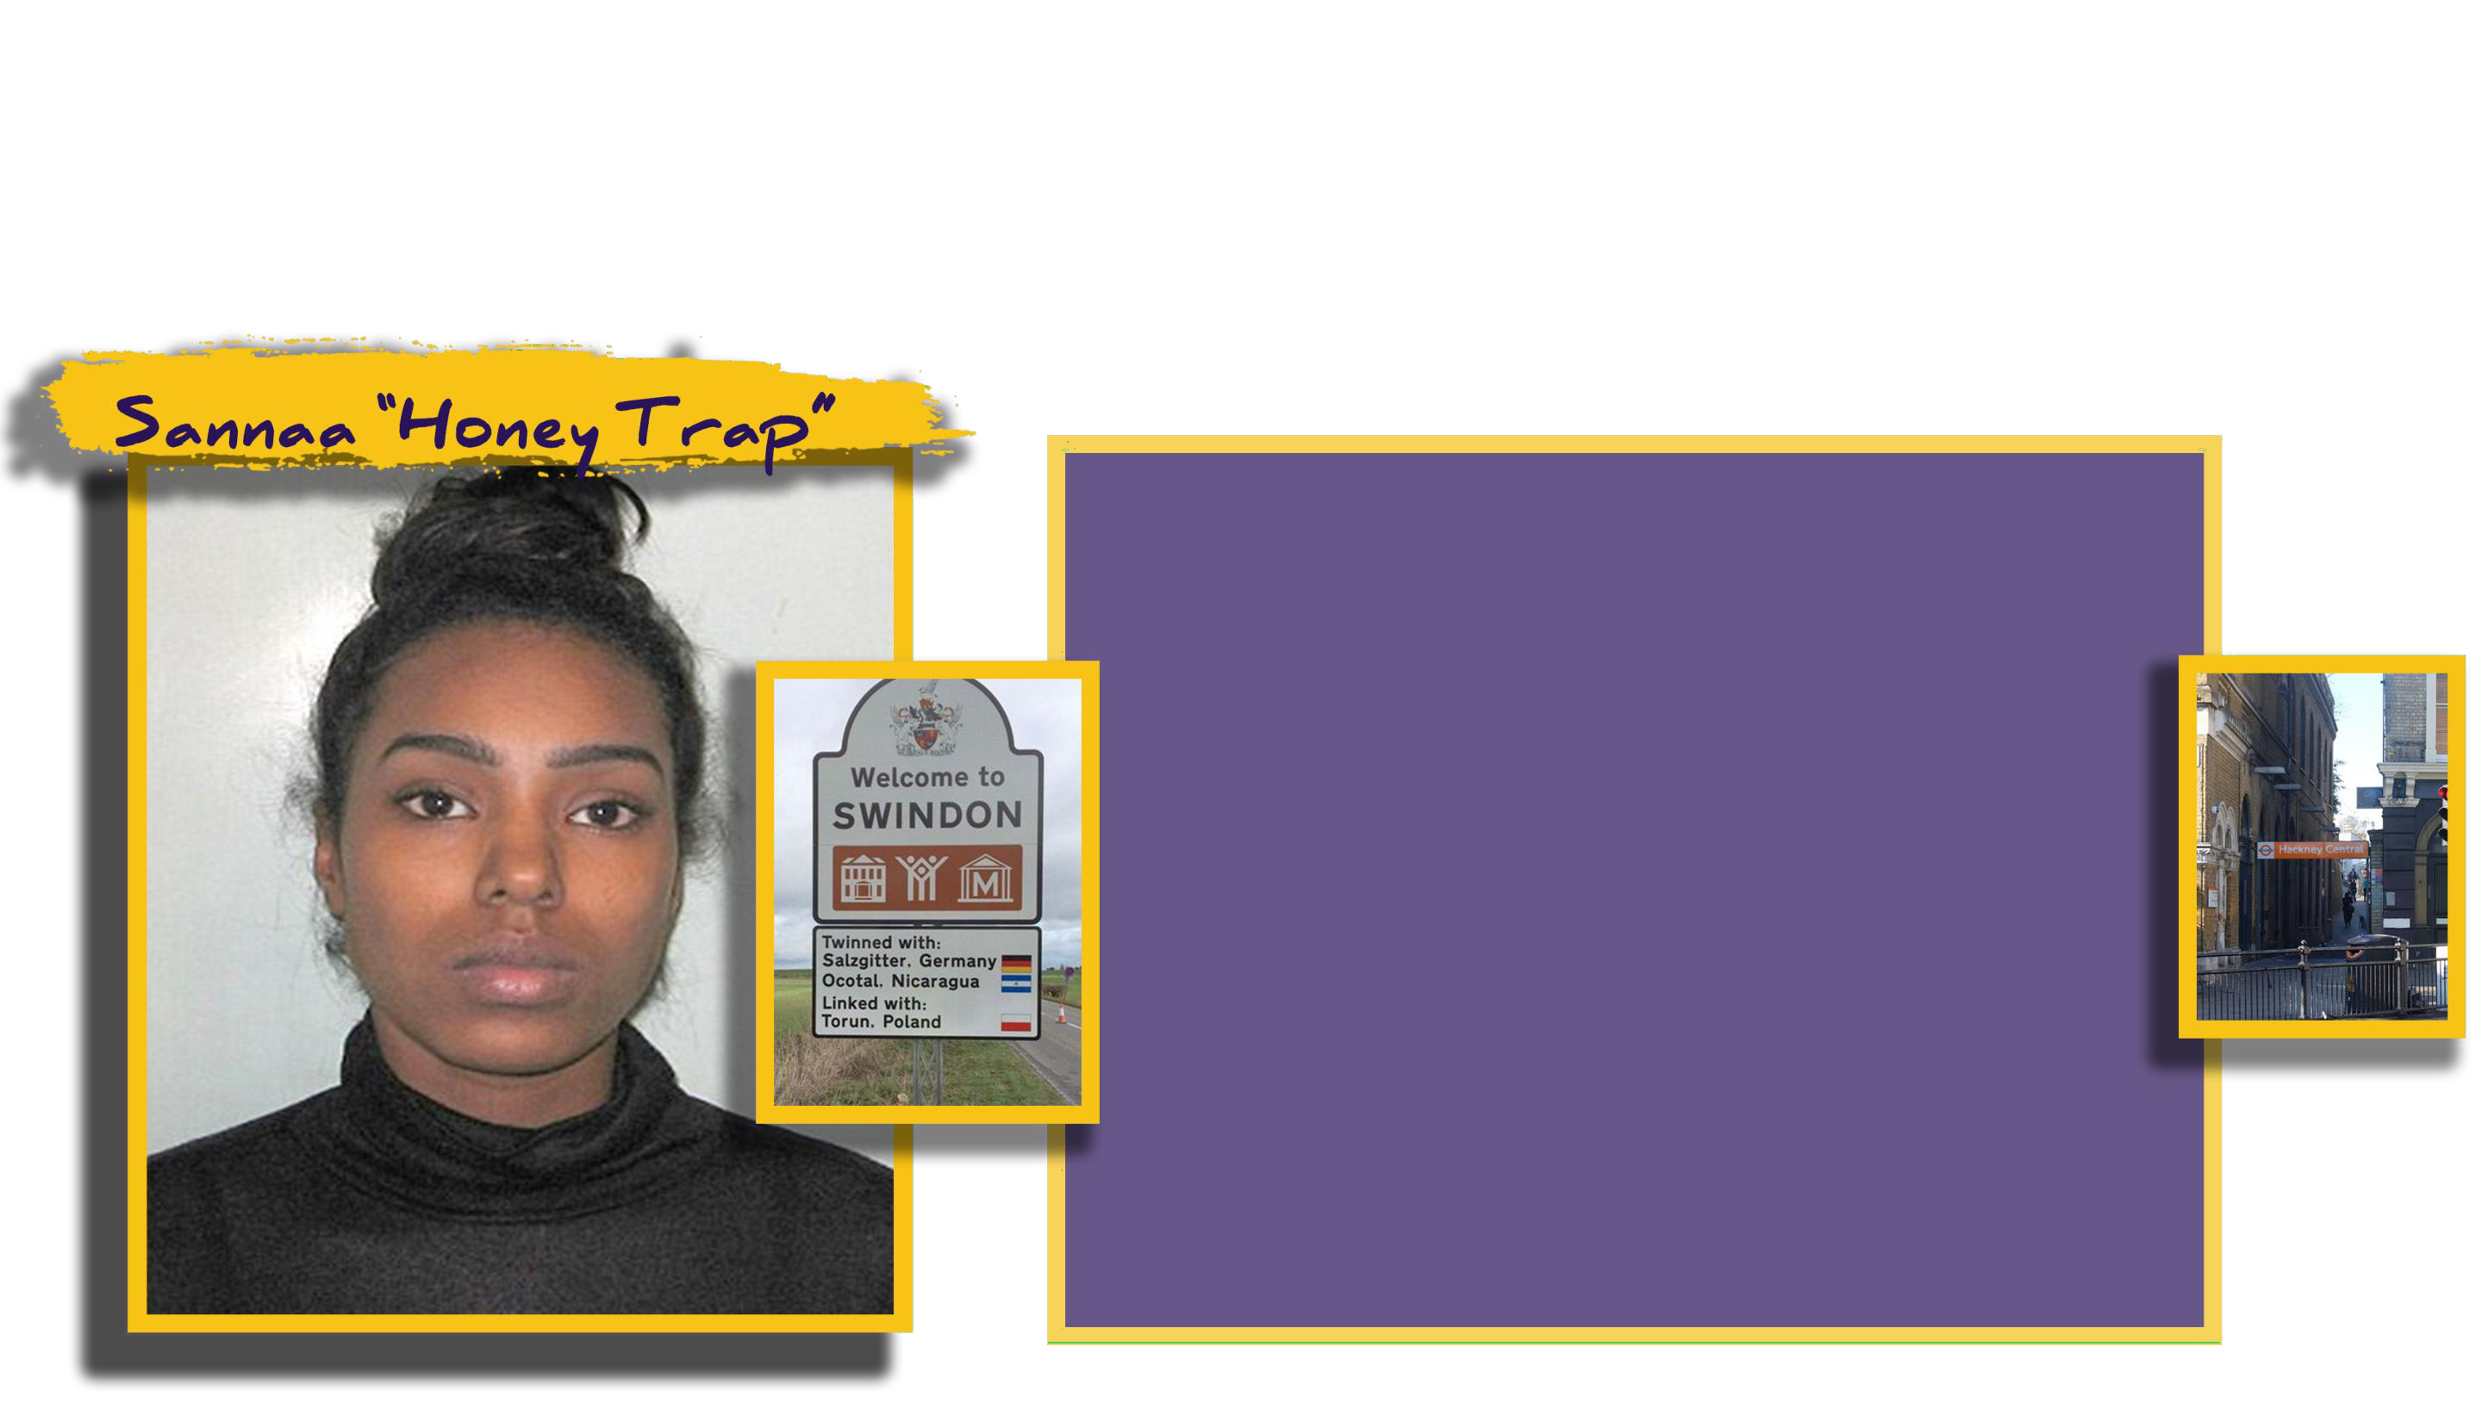

Sanaa 18, travelling back from Swindon with two Males. Sanaa Set up three boys to attack one of the males when they arrive at Hackney Central station.
He got away but was looked for by the gang,
as they made Sannaa call the victim to come
and meet her as she had claimed ‘she got away’ Where they rushed and stabbed him three times killing him.
Phone evidence shows Sanaa in communication with Her co-defendants before and after the attack. Sanaa was sentenced to 14yrs detention.


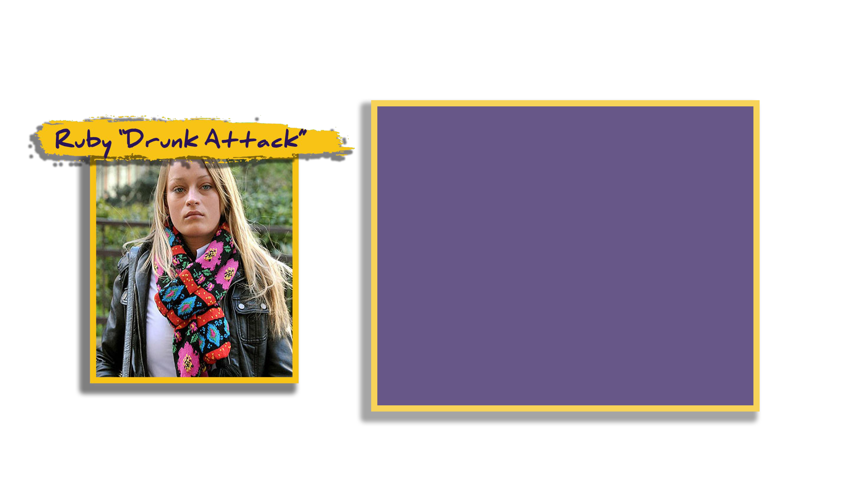

Mr Bayham 62, was stamped on by Ruby then 17, For being Gay. A punch by Ruby’s male friend then 19, knocked him to the ground causing fatal fracture of the skull.
Ruby was drunk at the time on a night out, at Trafalgar Square shouting homophobic taunts before the attack.
Ruby later bragged about this on social media, Only for the victim to die 18 days later in hospital. Ruby was given 7 years in Prison.

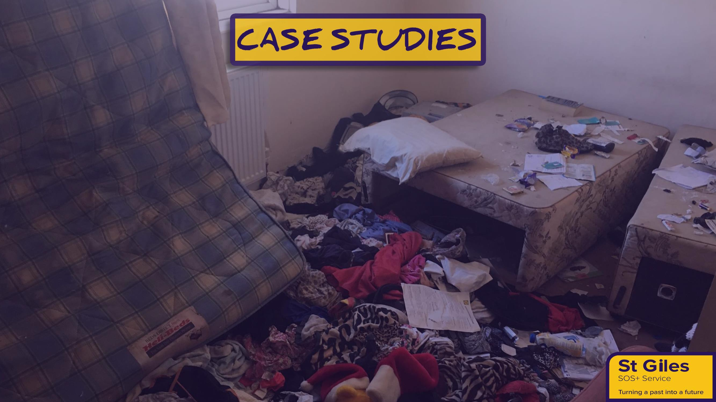


Known as “Little miss attitude” and described as
arrogrant by local drug users. Sold cocaine and heroin
Groomed young children to be runners in 4
hotspots county lines.
Groomed a young boy by claiming he owed the gang money
Naliah was sentenced to 5 years in prison

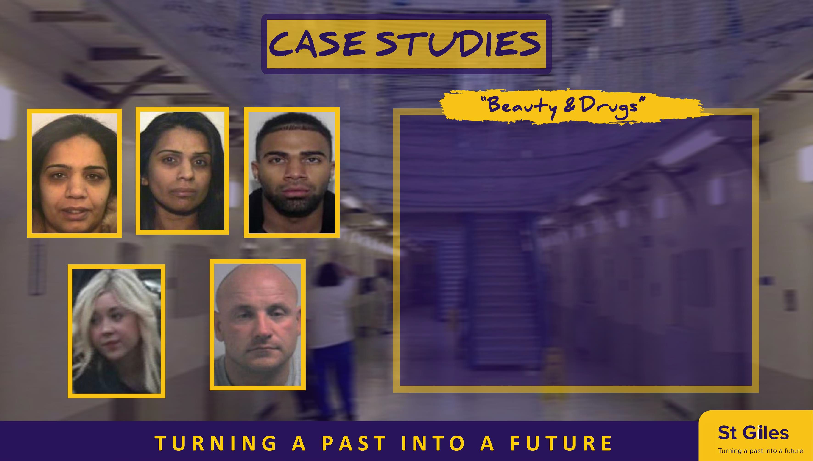

Shanzia and Abia Din both females in their 40s Sentenced to 15 and 18 yrs
Operated online beauty product supply “Beauty Booth” in Bury a front for their covert criminal enterprise
The Dins were farming out heroin, cocaine and amphetamines to contacts in south Yorkshire, through the Wrafter family – Peter 58 and his daughter Natalie

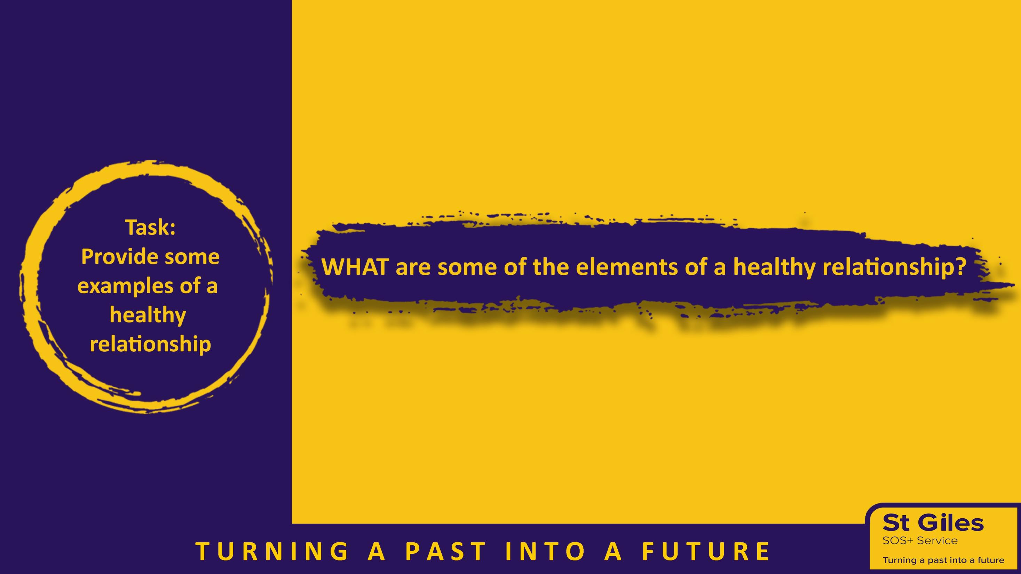

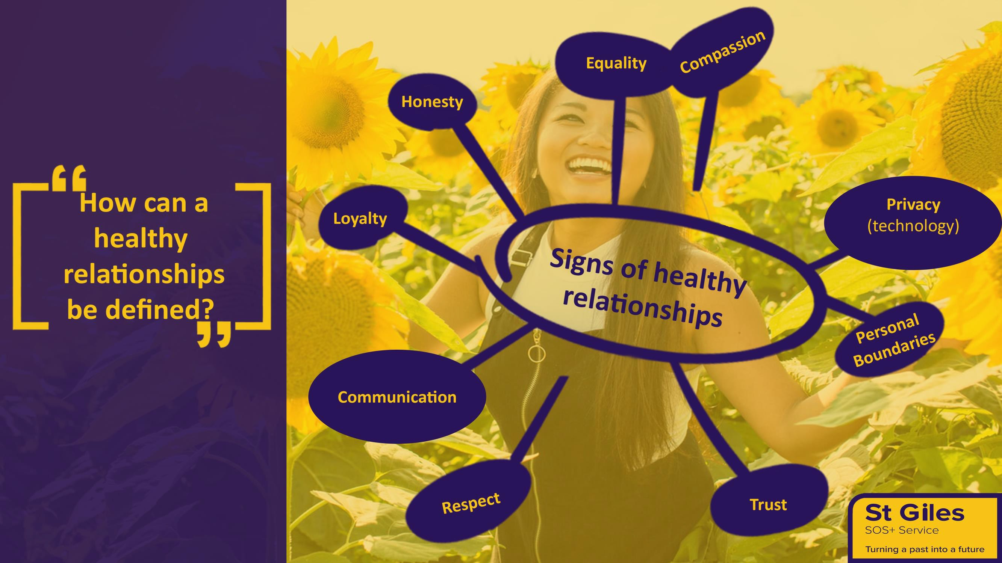

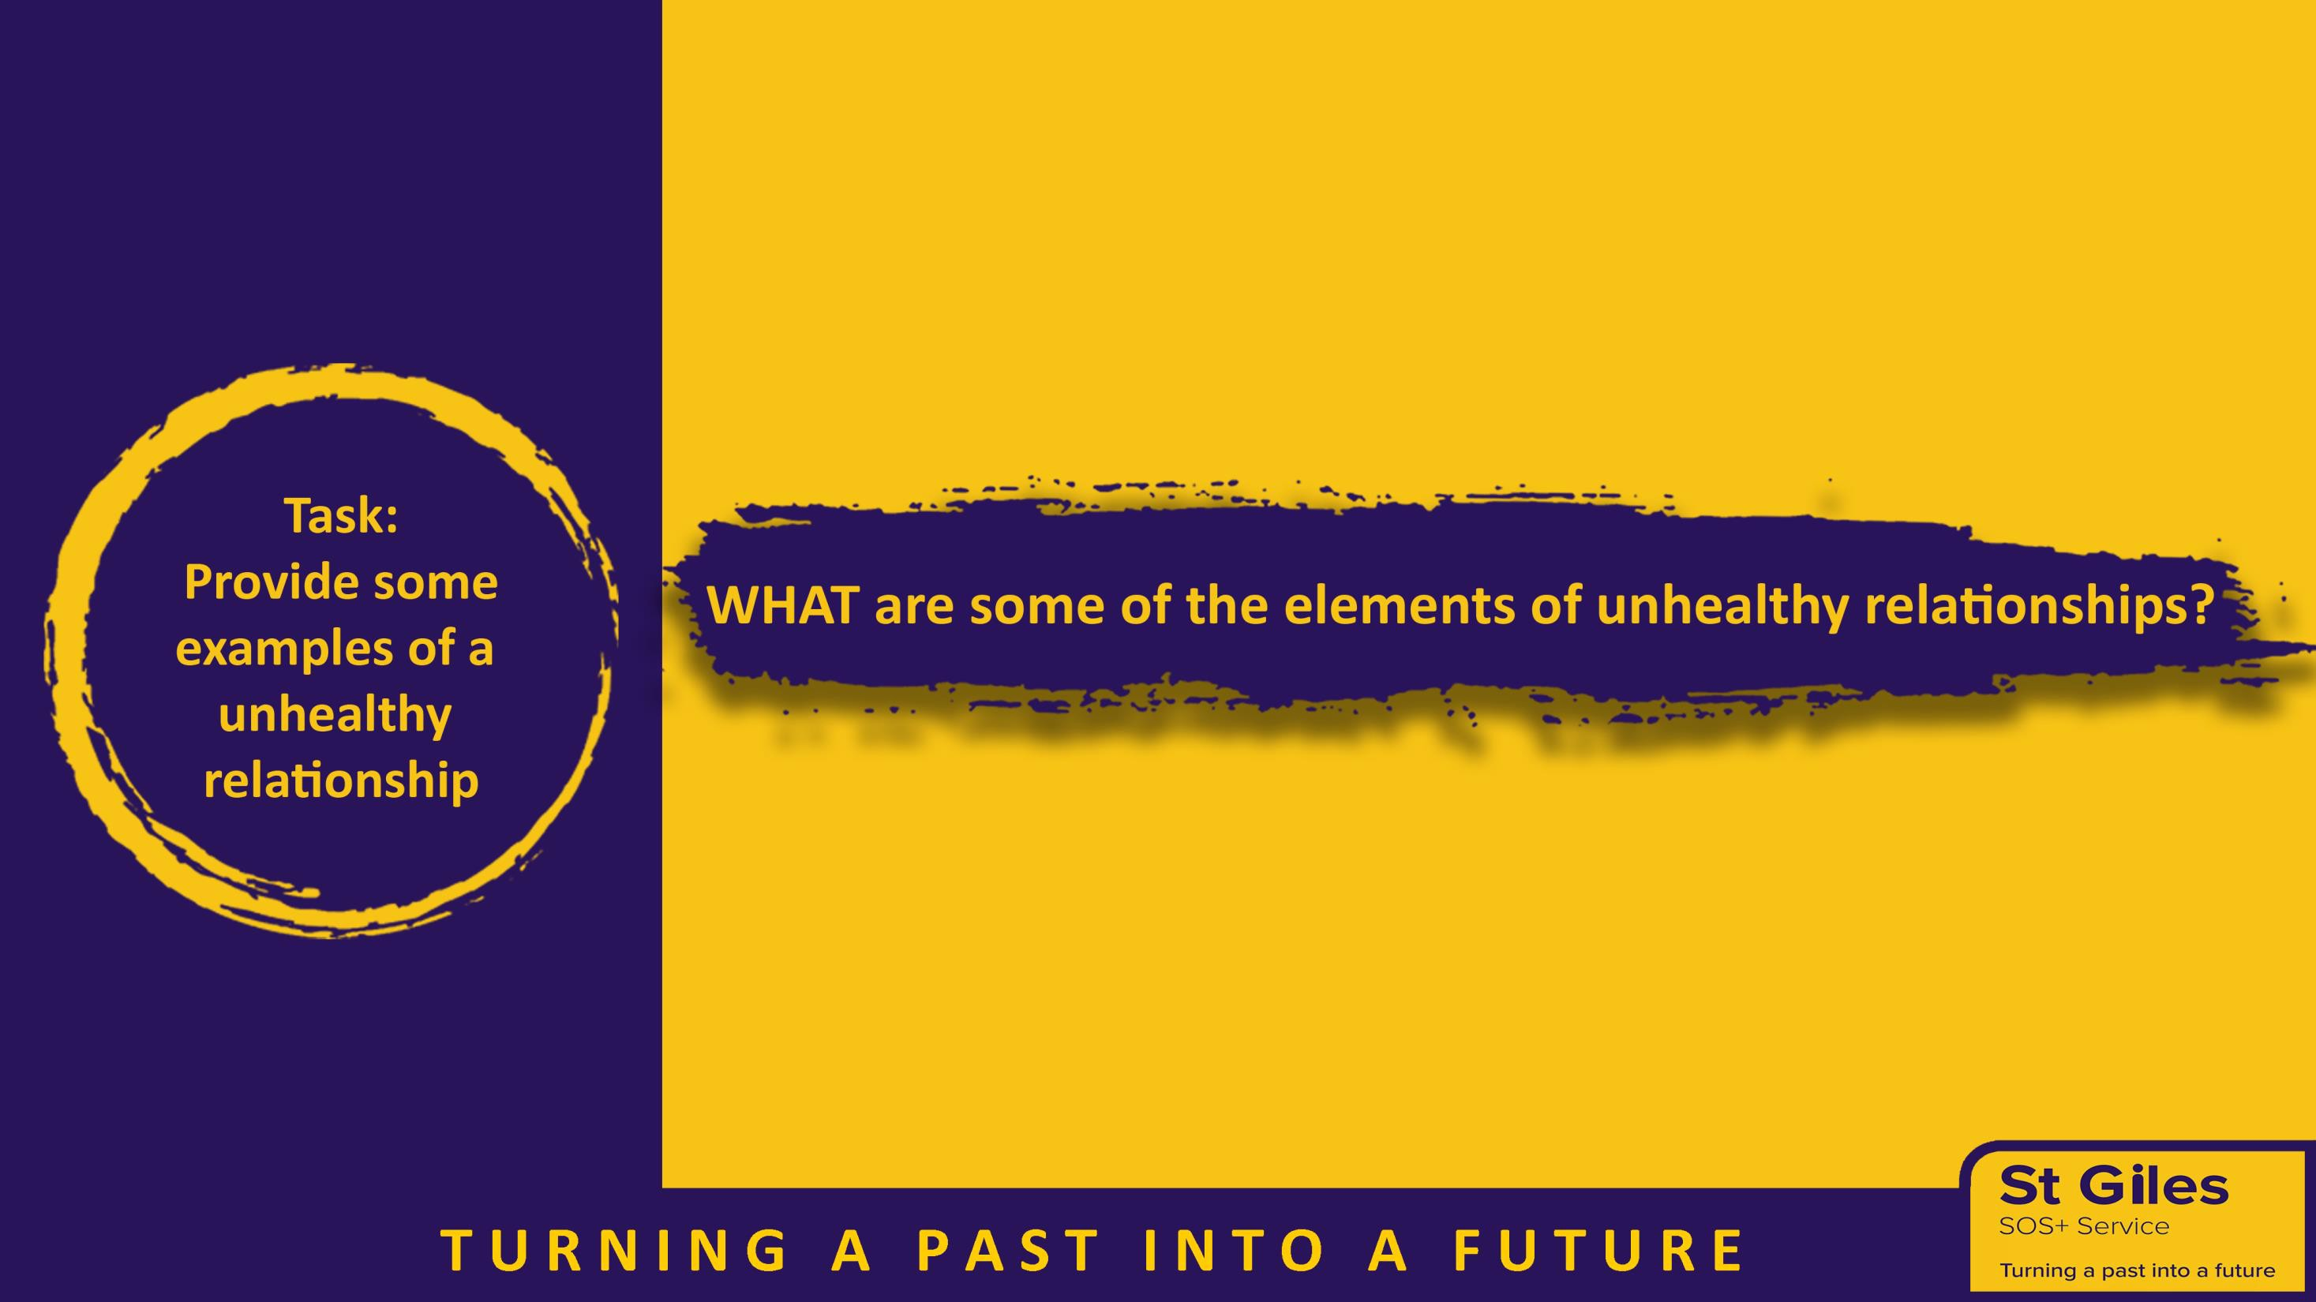

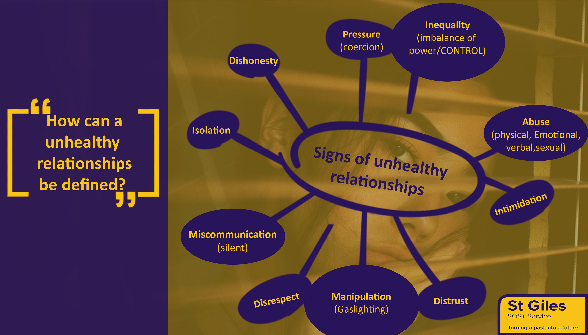


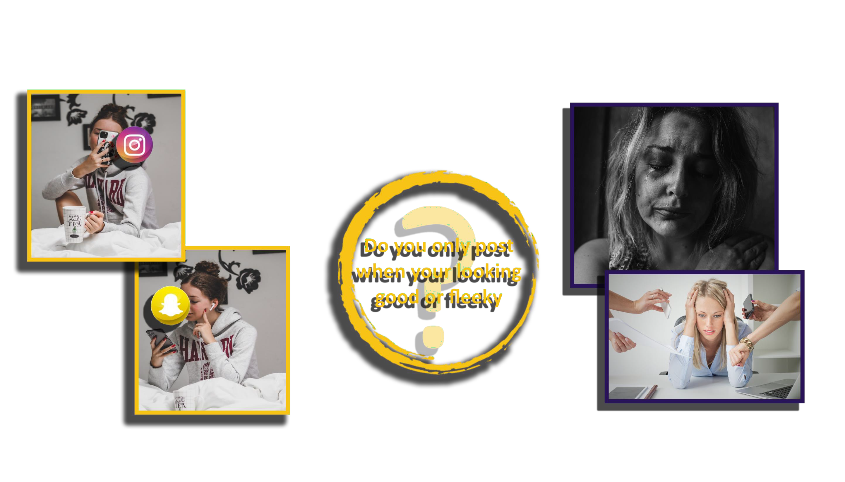

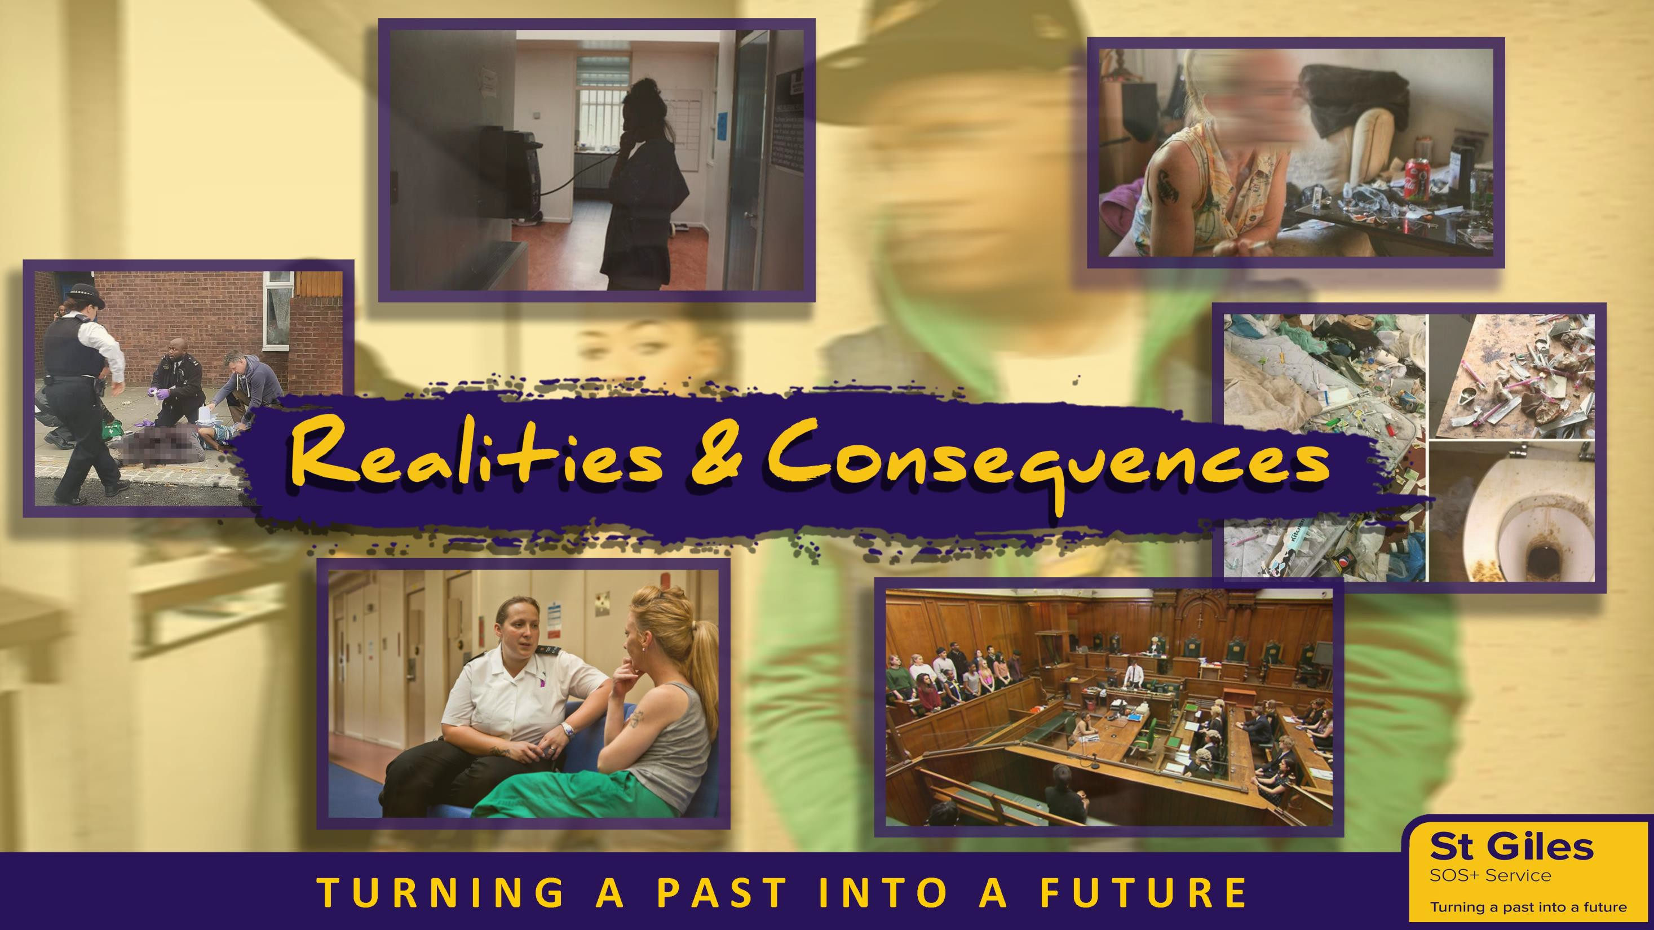

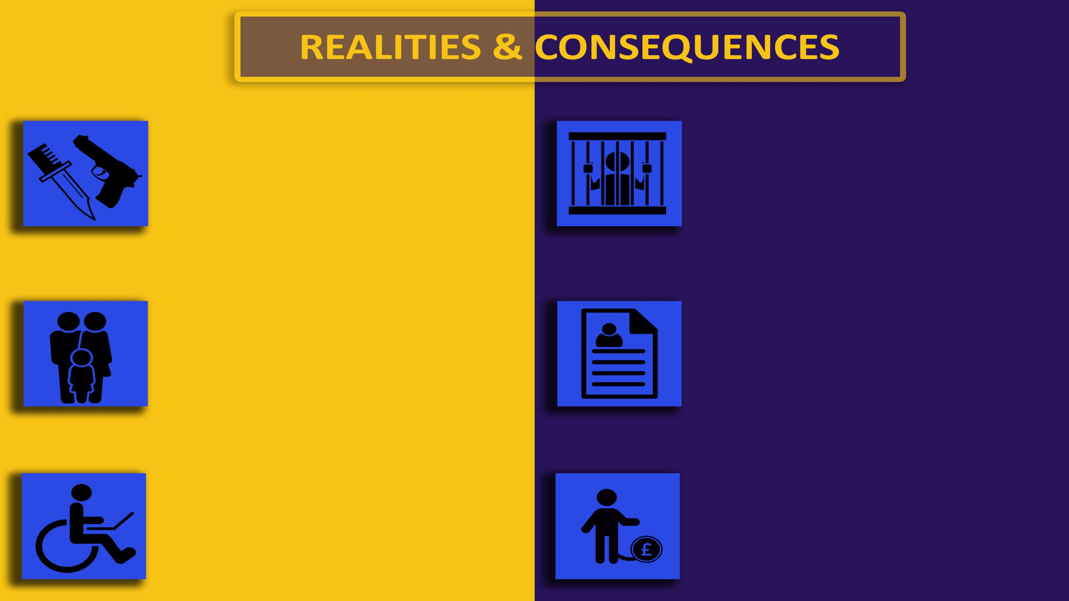
RIVAL GANGS & DRUG USERS
Drug runners are most vulnerable as they’re at the bottom of the food chain and are susceptible to being targeted and violently attacked by rival gangs/drug users.

FAMILY MEMBERS TARGETED
OCG’s and gangs can target family members to threaten or retaliate on drug runners as an exploitation tactic.

SERIOUS INJURY
Violence is a central theme in County Line cases leading to serious injuries involving kidnapping, gun & knife crimes, acid attacks etc.

PRISON
Prison sentences for intent to supply Class A drugs can be severe depending on the role you play and the amount you possess.

CRIMINAL RECORD
If you have a criminal record you might not be accepted into a college or university, get a job or travel to some countries like;
USA, Canada or Australia.

DEBT BONDAGE & MODERN DAY SLAVERY
Modern day slavery Act (2015) is valid when
a young person is trafficked for the purpose of Exploitation.

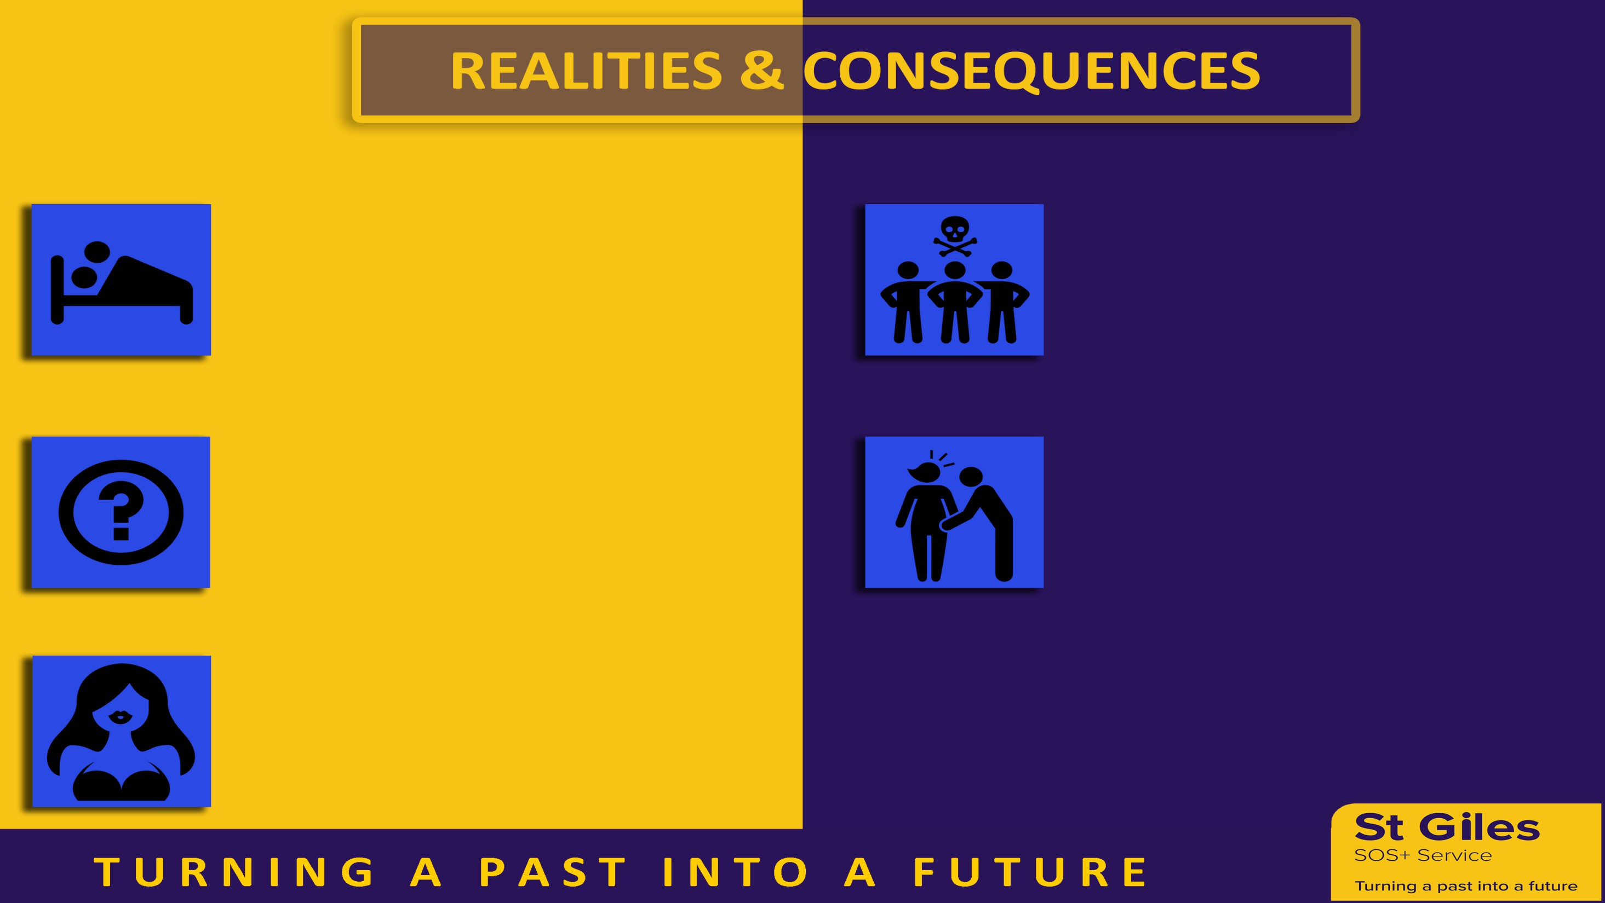
INTERCOURSE INITIATION
(with gang, users & other dealers)

UNFORSEEN EXPECTATIONS
(from gang involvement)

HONEY TRAPPING
(joint enterprise)

RIVAL GANGS
(retaliation / humiliation)

SEXUAL ABUSE
(rape as a method of youth violence or retaliation)

