Review of Team Around the Family plan for (insert the name of the child or young person)
Date of the review ___________________________________
Date TAF started _______________________________
Name of the child | Date of birth | Does the child have a disability? | Name of the parent with Parent Responsibility (PR)
Name of the Early Help Champion | This is usually the person who has completed the EHA
Contact and telephone number
EHM Number | This will be given to you by customer service when you phone them to inform them you are starting a TAF.
Actions  (copy and paste from plan) | Completed? | How has it made a difference? | What else needs to happen now? | Who will do it? | By when?
 | If not, detail why not? Actions should not be allowed to drift from one meeting to the next.  Challenge agencies to meet their commitments.  If the family has not carried out their actions, ask and record why not.  Be supportive but challenging. This is about improving the life of the child. | Remain child focussed.  This should describe the impact on the child or young person.  It should also be focussed on the impact with regard to what we are worried about.  Do not go off track.  Include the exact words from the chid and the family whenever possible.  If we have not asked the chid what difference it has made to them- Why not? | .Where there is not enough impact, agree a ‘Plan B’.  Do not try the same things over again if they are not making a difference to what we are worried about. |  | Be realistic, but challenging with regard to timescales. There is a need to remain focussed and not to allow drift.

The scaling question below should be used to establish how concerned each person is about the issues identified in the assessment above. The Professional, the parents/carers, and the child or young person should all score separately. There is no need to come to a consensus. The scaling is very powerful in understanding where families are at in their thinking about change; and for opening up a discussion about why scores are similar or different for each person involved.

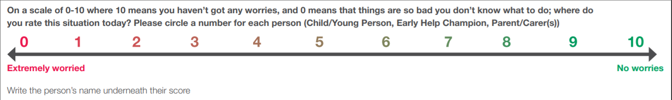

I have contributed to, and agreed the content of this plan:
Child/young person’s signature

__________________________________________________________ Date: ____________________________
Parent’s/Carer’s Signature

_______________________________________________________________ Date: _______________________________
Early Help Champion’s signature

__________________________________________________________ Date: ____________________________

Next review Date ______________________________________________ NB The plan needs to be reviewed at least once every 6 weeks

