Child Exploitation Awareness Day 2020
Campaign Briefing for Partners

What is Child Exploitation Awareness Day?
Wednesday 18th March 2020 marks National Child Exploitation Awareness Day that aims to highlight the issues surrounding Child Exploitation.
The day encourages everyone to think, spot and speak out against abuse and adopt a zero tolerance to adults developing inappropriate relationships with children or children developing inappropriate relationships with other children.
This is a National Awareness Raising day which gives Local Authorities, Organisations, Projects, Schools and individuals an opportunity to focus on the issues of child exploitation (including sexual, criminal exploitation and county lines) and raise awareness of the signs, indicators and what to do if concerns are raised.
Why are we running a Campaign for Child Exploitation?
Within North Yorkshire and City of York multi-agency partners have come together to develop an awareness campaign, alongside North Yorkshire & York Youth Commission (NYYYC), to create a series of resources and key messages to share across the partnerships to raise awareness across four key groups; Children and Young People; Parents and Carers; Professionals and the General Public. 5 pictorial messages (see overleaf from page 3) have been created by NYYYC members quotes from interview extracts on child exploitation and how young people interact online.
The purpose of this year’s campaign is branded under the headline of ‘Did you know…..’ and is to expand on the three national areas in line with the national campaign – www.stop-cse.org:
- Understanding how young people utilise social media and the risks involved
- How parents can support young people to access their online worlds safely
- How professionals can recognise young people who may be being exploited and what to do about it if they do
What Can You and Your Organisation Do?
- Post Child Exploitation Awareness Day content on your social media accounts (suggested content overleaf)
- Follow NYSCP (@NYSCP1) & CoYSCP (@YorkSCP) on Twitter and NYYYC (@NorthYorksYC) on Twitter and Instagram (yc_northyorks) to share Child Exploitation Awareness Day posts on your accounts and get messages out across your networks
- Mobilise colleagues by sharing this briefing and asking them to join you in supporting the Child Exploitation Awareness Day campaign
Need More Info?
For more information about the Child Exploitation Awareness Day campaign in North Yorkshire and City of York or to discuss in more detail how you and your organisation can get involved, please contact NYSCP (nyscp@northyorks.gov.uk) or CoYSCP (www.saferchildrenyork.org.uk/contact-us.htm).
Thank you in anticipation of your support for the 2020 Child Exploitation Awareness Day campaign.
Ideas for Social Media
Look out for our posts on the NYSCP Twitter / CoYSCP Twitter / NYYYC Twitter / NYYYC Instagram feed and re-tweet/share them to your followers. In addition, feel free to use the below pre-populated messages along with the 5 pictorial messages (see overleaf from page 3) of what Child Exploitation is to tweet from your organisation’s social media accounts:
- Exploitation is abuse #CEADay20
- Exploitation is about more than just CSE, think about criminal exploitation, county lines, trafficking and modern slavery #CEADay20
- Look at the bigger picture. Communities and Families can be safeguarding partners when it comes to tackling child exploitation #CEADay20
- Exploitation and its impact doesn’t stop because you turn 18. Young adults are still vulnerable too #CEADay20

- The time to build relationships with children and families is crucial #CEADay20
- Children can’t consent to their exploitation #CEADay20
- Disruption of perpetrators and the creation of safe spaces is crucial. See @NatWorGroup Disruption Toolkit: www.nwgnetwork.org/post_typ/tools #CEADay20
- Don’t assume someone else will report it, take responsibility: www.safeguardingchildren.co.uk/professionals/forms-for-professionals/ #CEADay20
- Children and families need you to believe them #CEADay20
- We need to disrupt perpetrators through any means possible, don’t place the burden on victims to disclose #CEADay20
- Think #ContextualSafeguarding. Exploitation doesn’t take place in isolation and the risk of exploitation is usually posed outside of the family home. Public and Online spaces need to be safe for children #CEADay20
Please don’t forget to use the campaign hashtags on your posts:
#CEADay20
Email banners / Skyscraper Images
Why not include a banner on your email signature or a Skyscraper Image in the lead up to Child Exploitation Awareness Day? Copy and paste the pictures below to use:
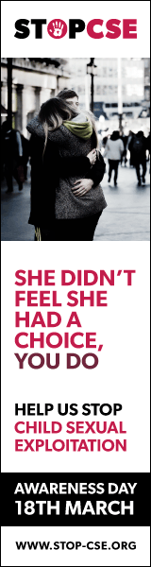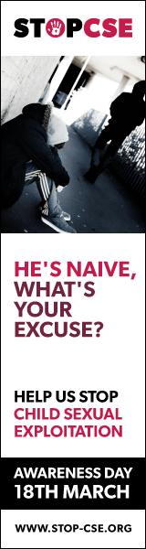

Twitter Child Exploitation Pictorial Messages (right click and then click ‘save as’ to download an image)
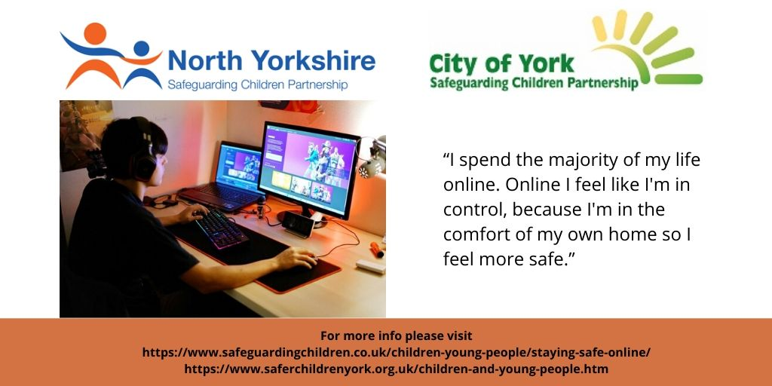

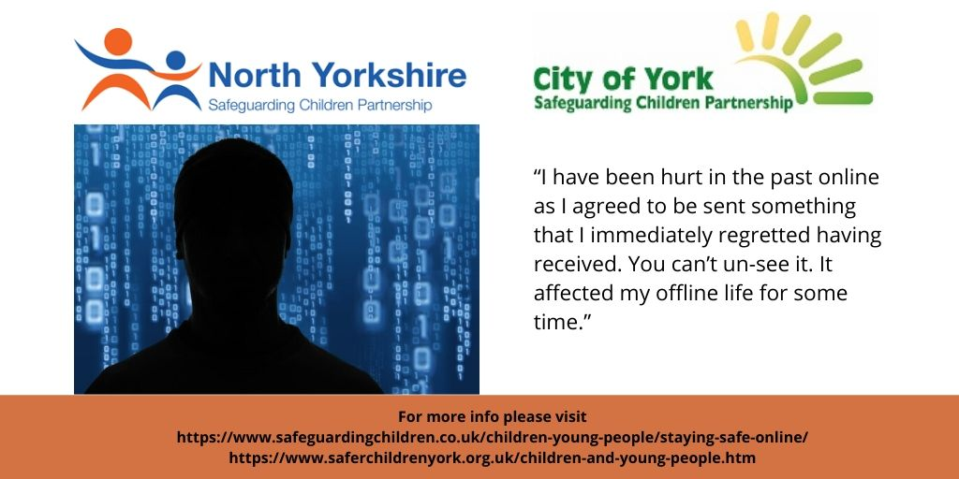

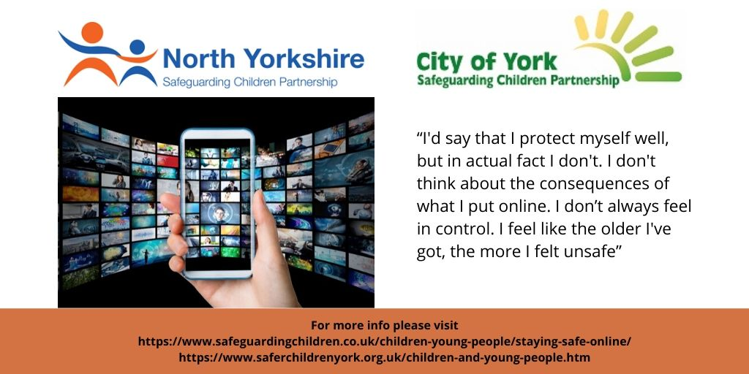

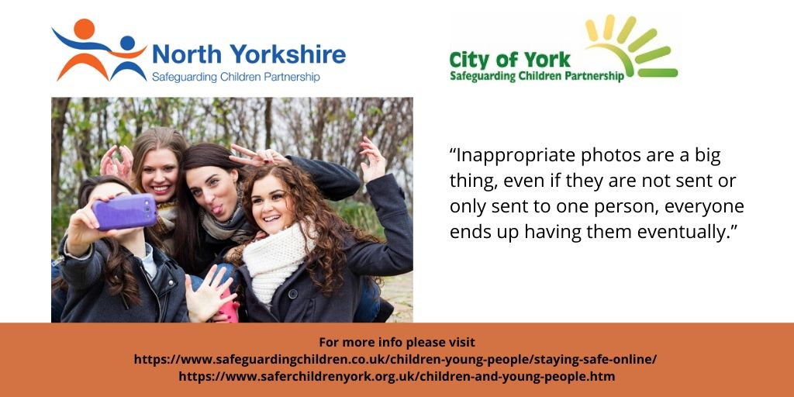

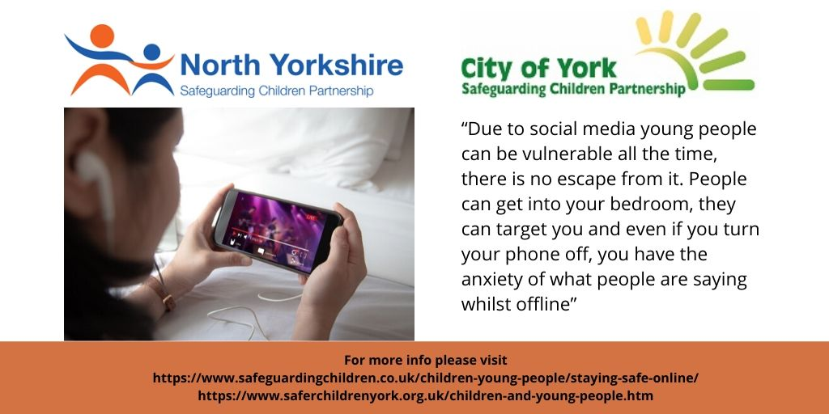

Facebook Child Exploitation Pictorial Messages (right click and then click ‘save as’ to download an image)
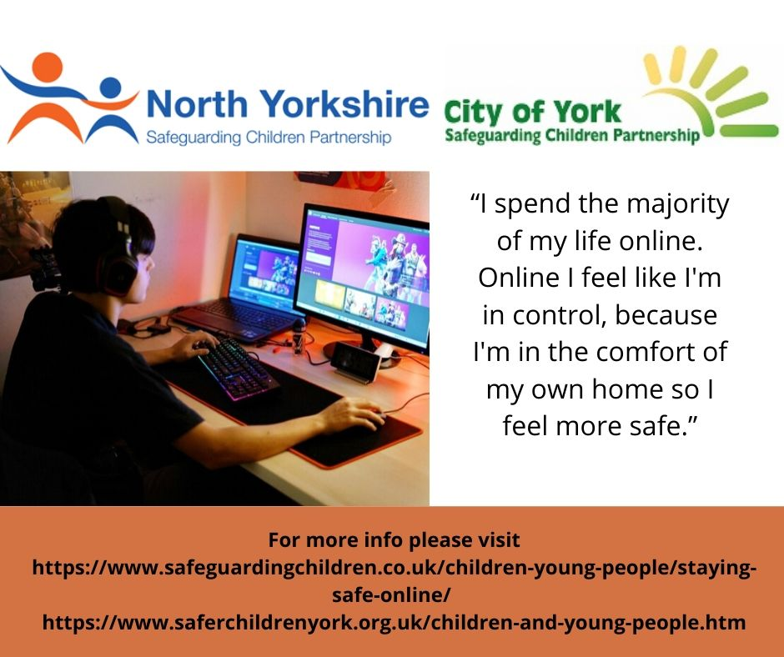

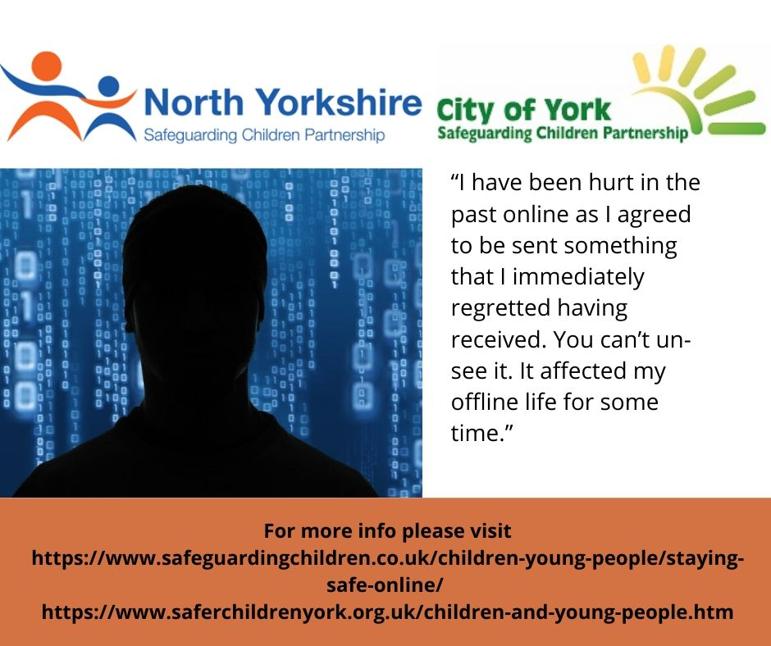

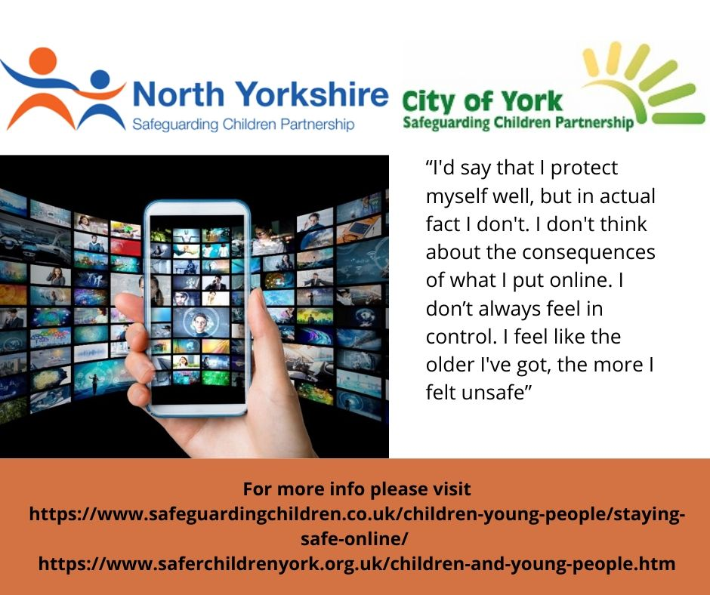

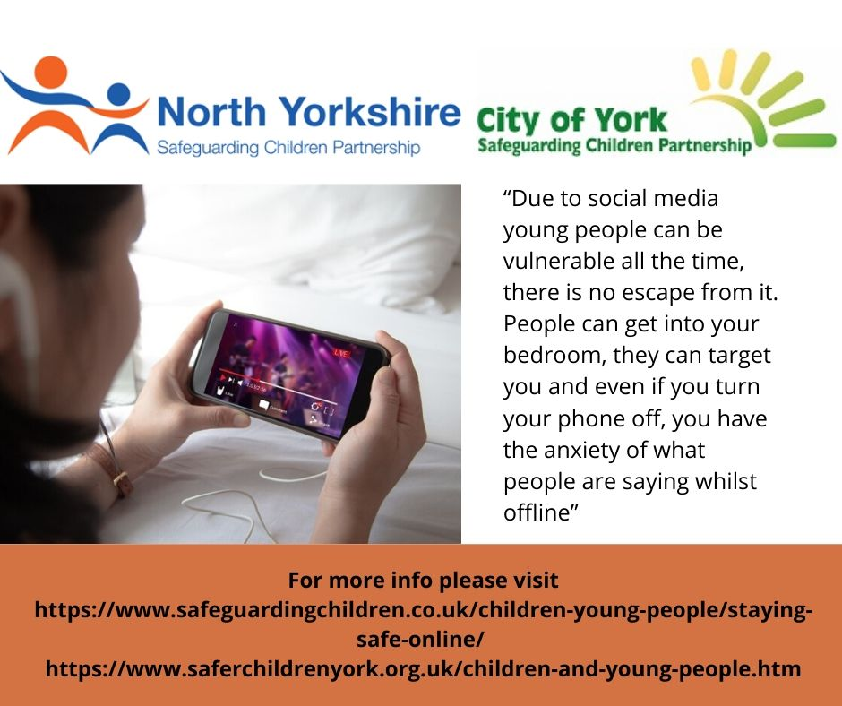

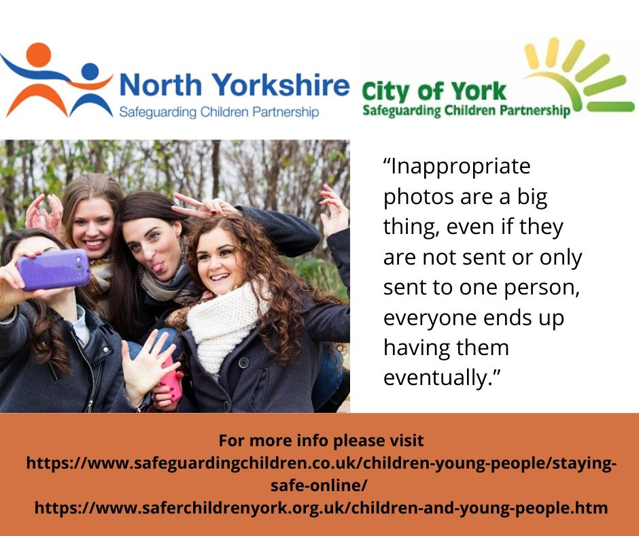

Parents Against Child Exploitation (PACE) Poster (right click and then click ‘save as’ to download image)

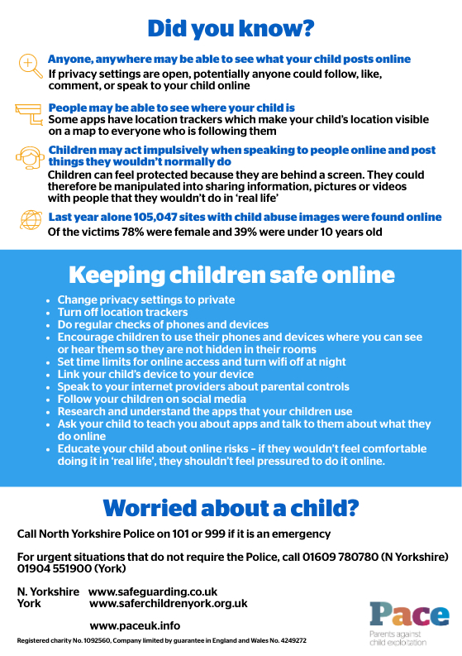

School Exclusion and CSE Poster (right click and then click ‘save as’ to download image)

