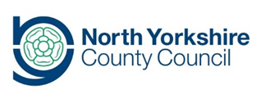
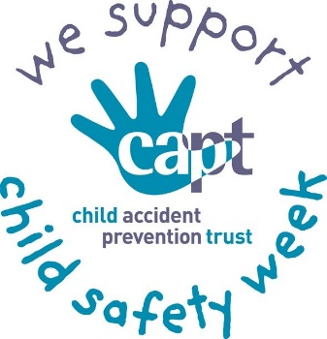

Child Safety Week 2020 - Campaign Briefing for Partners

What is Child Safety Week?
Child Safety Week is the flagship annual campaign run by the Child Accident Prevention Trust (CAPT). The campaign aims to bring together individuals and organisations around the country to promote safety messages to families in a fun and engaging way.
This year’s campaign takes place between Monday 1st June – Sunday 7th June, with the theme “Safety Makes Sense!” In response to COVID-19, the emphasis will be on social media to reach as many families as possible.

Why Are We Supporting Child Safety Week?
Although rates of hospital admission in North Yorkshire caused by unintentional injuries in children are relatively stable, they are significantly worse than the England average and our closet statistical neighbours – and the gap is widening.
Injuries are preventable and we can do something about it – supporting Child Safety Week by sharing campaign messages with families and communities across the County is one of the actions we are taking to help address the issue locally.

Why Is Your Support Needed?
Now that the majority of the families you work with will largely be at home for prolonged periods of time, it is vital that they are well equipped with the right messages and tips on how to prevent unintentional injuries for their children.
Unintentional injuries, particularly those in and around the home, are a leading cause of preventable death for children under five years old and are a major cause of ill health and serious disability.
The reduction of unintentional injuries in childhood therefore remains an important public health priority, both nationally and locally and it is even more important to try to prevent them in the current circumstances we are all adapting to.
90% of the most serious preventable accidents to the under-fives fall into five main areas:
- Threats to breathing – choking, strangulation or suffocation
- Falls
- Poisoning
- Burns and scalds
- Drowning

What Can You and Your Organisation Do?

- Share Resources:
- The free Parents Pack can be shared with families you support. It features top tips on keeping children safe: from burns, preventing poisoning, reducing choking and suffocation hazards, preventing falls, keeping safe around roads and, fire and water safety.
- There is new family-friendly content which is free for organisations to download or copy and paste into newsletters, websites, share on social media or circulate to other organisations who support families.
- All available through CAPTs website www.capt.org.uk
- You can use the “We support Child Safety Week” logo download
- Promote through Social Media:.
- Follow CAPT on Facebook for advice you can share directly with families
- Follow the CAPT on Twitter to share Child Safety Week posts on your Social Media accounts and get the messages out across your networks
- Follow NorthYorks Health twitter @nyorkshealth and retweet relevant content to help spread key messages
- Mobilise colleagues by sharing this briefing and asking them to join you in supporting the Child Safety Week Campaign.
- Post Child Safety Week content on your social media accounts (suggested content below)
- Please don’t forget to use the campaign hashtags on your posts #childsafetyweek #SafetyMakesSense

Stay safe in lockdown | Home can be an accident hotspot for youngsters, but there are small things you can do to make a big difference. Get down to your child’s level and see the world through their eyes, you can spot dangers, and help to keep them safe. #childsafetyweek #SafetyMakesSense | 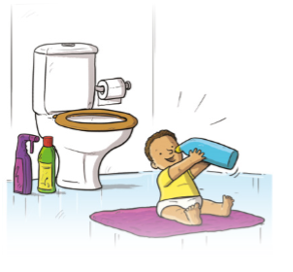
Stay safe in lockdown | Working at home with children can be challenging, try and make sure your home is as safe as possible to avoid preventable accidents. @CAPTcharity have a great parents pack for staying safe in lockdown: http://ow.ly/xSjc50zw4ck #safetymakessense #childsafetyweek | 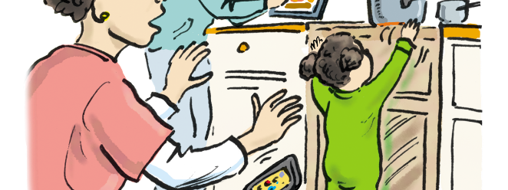
Burns: hot drinks | Your hot drink can scald a baby 15 minutes after it has been made. Look for safe zones in your house where you know your child can’t reach your hot drink. #childsafetyweek #SafetyMakesSense | download image
Burns: hot drinks | Anyone looking after children 24/7 right now deserves all the tea or coffee they can drink. Just remember to put your cuppa down in a safe spot out of reach of little hands that can grab as soon as your back is turned. You’ll be winning against hot drink burns. #childsafetyweek #SafetyMakesSense | download image 1  download image 2
Burns: Cooking | Breakfast, lunch, dinner, repeat … sound like your life at the moment? When you’re exhausted it’s easy to get distracted, so use the back rings of the cooker and turn pan handles in. It keeps danger out of reach of little hands that grab. #childsafetyweek #SafetyMakesSense | download image
Burns: Bathtime | An easy win to avoid horrendous bath water scalds … get in the habit of putting the cold in first and top up with hot. You’ll be saving your child from the risk of falling or climbing into a boiling bath. #childsafetyweek #SafetyMakesSense | download image
Button Batteries | Button batteries - small but mighty & can be deadly if swallowed. Look round your home for them – in products as well as spare and ‘flat’ batteries. You’ll be surprised where young children can find them – keep them out of reach! #childsafetyweek #SafetyMakesSense #BeBurnsAware | 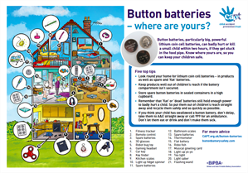
Poisoning | Bright bottles of cleaning liquid, squidgy washing tablets, shiny packets of painkillers ... small children are curious and want to learn more by putting things in their mouth. Put products away out of reach as soon as you’ve used them. #childsafetyweek #SafetyMakesSense | download image
Road Safety | Speed is everything when it comes to a child’s chances of survival. Keep an eye on your speed. Keep your phone in the glove compartment so it can’t distract you. #childsafetyweek #SafetyMakesSense | download image
Toy Safety | Buying toys online? Make sure you are buying from reputable sources. Always look for the CE Marks and Lion Marks on toys.  #childsafetyweek #SafetyMakesSense | 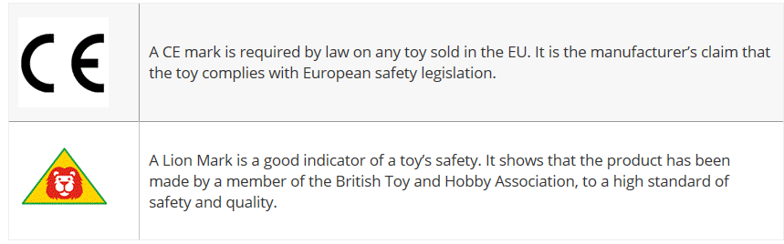

Need More Info?
For more information about reducing unintentional injuries in North Yorkshire or to discuss in more detail how you and your organisation can get involved, please contact the Public Health Team: Catherine Baker, Health Improvement Manager catherine.baker@northyorks.gov.uk or Dora Machaira , Health Improvement Officer dora.machaira@northyorks.gov.uk
Thank you in anticipation of your support for the 2020 Child Safety Week Campaign.

