This campaign has been produced in partnership by:

Partnership Information Sharing Form Campaign July 2020
Campaign Brief for Partners

What is the Partnership Information Sharing Form?
The Partnership Information Sharing Form (For North Yorkshire click here to access the form / For City of York click here to access the form) gives professionals a safe and direct way to share information with North Yorkshire Police. Information shared on the form could include a variety of points, such as:
- Information about a concerning incident
- Suspicious activity
- An unusual exchange between two or more people
- Something that makes a professional uncomfortable
Why are we running a Partnership Information Sharing Form Campaign?
North Yorkshire Police (NYP), North Yorkshire Safeguarding Children Partnership (NYSCP), North Yorkshire Community Safety Partnership (NYCSP), City of York Safeguarding Children Partnership (CYSCP), and Safer York Partnership (SYP) are running a campaign between Monday 6th – Friday 10th July 2020 to raise the profile and awareness of the Partnership Information Sharing Form alongside supporting guidance to support frontline professionals in using the form more widely as part of their practice.

Across North Yorkshire and the City of York the form provides valuable information to North Yorkshire Police which otherwise may not be known. It is key in building a picture of the contextual safeguarding needs within a community, for example providing information such as hotspots and locations where anti-social behaviour or child exploitation may be taking place.

The form however, is not widely well known or consistently embedded within professional’s practice. We would therefore like your support in raising awareness of the purposes and value in using the form to share information with North Yorkshire Police.

What Can You and Your Organisation Do?
- Post Partnership Information Sharing Form content on your social media accounts (suggested content overleaf)
- Follow NYSCP (@NYSCP1), CYSCP (@YorkSCP), SYP (@SaferYork) on Twitter to share Partnership Information Sharing Form posts on your accounts and get messages out across your networks
- Mobilise colleagues by sharing messages and asking them to join you in supporting the Partnership Information Sharing Form Campaign
Need More Info?
For more information about the campaign in North Yorkshire to discuss in more detail how you and your organisation can get involved, please contact NYSCP (nyscp@northyorks.gov.uk) or NYCSP (nypartnerships@northyorks.gov.uk). In York for further information please contact CYSCP (CYSCP@york.gov.uk) or SYP (info@saferyorkpartnership.co.uk).
Thank you in anticipation of your support for Partnership Information Sharing Form Campaign.

Ideas for Social Media
Look out for our posts on the NYSCP Twitter, CYSCP Twitter, SYP Twitter feed and re-tweet them to your followers. In addition, feel free to use below 8 pre-populated messages along with the 5 Social Media Graphics (see from page 3) to illustrate what the Partnership Information Sharing Form is to tweet from your organisation’s social media accounts. We encourage you to tweet twice a day, repeating messages throughout the week of the campaign:
Twitter Messages with North Yorkshire Links:
- Sharing information with the police is critical in safeguarding communities. Use the Partnership Information Sharing Form: www.safeguardingchildren.co.uk/professionals/forms-for-professionals/ #DontIgnoreItShareIt

- However minor or trivial the information you have may seem, it could help provide a clearer picture of local issues and wider community related problems. Use the Partnership Information Sharing to share this with the police: www.safeguardingchildren.co.uk/professionals/forms-for-professionals/ #DontIgnoreItShareIt

- Have the bigger picture in mind. Are there locations in a child’s community outside of their home which are a worry? A park, a building, a street, a shop front, a car? Pass this info on via the Partnership Information Sharing Form: www.safeguardingchildren.co.uk/professionals/forms-for-professionals/ #DontIgnoreItShareIt

- Unsure on what the Partnership Information Sharing Form Is? View our One Minute Guide on Intelligence Sharing for further information: www.safeguardingchildren.co.uk/wp-content/uploads/2020/02/NYSCP-NYCSP-Intel-sharing-OMG-2020-06-15.pdf #DontIgnoreItShareIt

- When submitting information to the police, your identify is protected. Share information with the police via the Partnership Information Sharing Form: www.safeguardingchildren.co.uk/professionals/forms-for-professionals/ #DontIgnoreItShareIt

- Creating safe spaces for children growing up in their community is crucial. Using the Partnership Information Sharing Form to pass info to the police helps to disrupt those who wish to commit harm. Download the form here: www.safeguardingchildren.co.uk/professionals/forms-for-professionals/ #DontIgnoreItShareIt

- Don’t assume someone else will see or hear what you have and share this information. Take responsibility and use the Partnership Information Sharing Form: www.safeguardingchildren.co.uk/professionals/forms-for-professionals/ #DontIgnoreItShareIt

- Think #ContextualSafeguarding. Harm against children such as Child Exploitation is often posed outside of the family home. Public & online spaces need to be safe. Share concerns you have via the Partnership Information Sharing Form: www.safeguardingchildren.co.uk/professionals/forms-for-professionals/ #DontIgnoreItShareIt
Twitter Messages with City of York Links:
- Sharing information with the police is critical in safeguarding communities. Use the Partnership Information Sharing Form: www.saferchildrenyork.org.uk/concerned-about-a-child-or-young-person.htm #DontIgnoreItShareIt

- However minor or trivial the information you have may seem, it could help provide a clearer picture of local issues and wider community related problems. Use the Partnership Information Sharing to share this with the police: www.saferchildrenyork.org.uk/concerned-about-a-child-or-young-person.htm #DontIgnoreItShareIt

- Have the bigger picture in mind. Are there locations in a child’s community outside of their home which are a worry? A park, a building, a street, a shop front, a car? Pass this info on via the Partnership Information Sharing Form: www.saferchildrenyork.org.uk/concerned-about-a-child-or-young-person.htm #DontIgnoreItShareIt

- Unsure on what the Partnership Information Sharing Form Is? View our One Minute Guide on Intelligence Sharing for further information: www.saferchildrenyork.org.uk/bitesize-guides-menu.htm #DontIgnoreItShareIt

- When submitting information to the police, your identify is protected. Share information with the police via the Partnership Information Sharing Form: www.saferchildrenyork.org.uk/concerned-about-a-child-or-young-person.htm #DontIgnoreItShareIt

- Creating safe spaces for children growing up in their community is crucial. Using the Partnership Information Sharing Form to pass info to the police helps to disrupt those who wish to commit harm. Download the form here: www.saferchildrenyork.org.uk/concerned-about-a-child-or-young-person.htm #DontIgnoreItShareIt

- Don’t assume someone else will see or hear what you have and share this information. Take responsibility and use the Partnership Information Sharing Form: www.saferchildrenyork.org.uk/concerned-about-a-child-or-young-person.htm #DontIgnoreItShareIt

- Think #ContextualSafeguarding. Harm against children such as Child Exploitation is often posed outside of the family home. Public & online spaces need to be safe. Share concerns you have via the Partnership Information Sharing Form: www.saferchildrenyork.org.uk/concerned-about-a-child-or-young-person.htm #DontIgnoreItShareIt

Please don’t forget to use the campaign hashtag on your posts:
#DontIgnoreItShareIt

Social Media Graphics
Why not include a Social Media Graphic along with a pre-populated message on Twitter to help widen the reach of the campaign? Right click and then click ‘save picture as’ to download an image.
1.
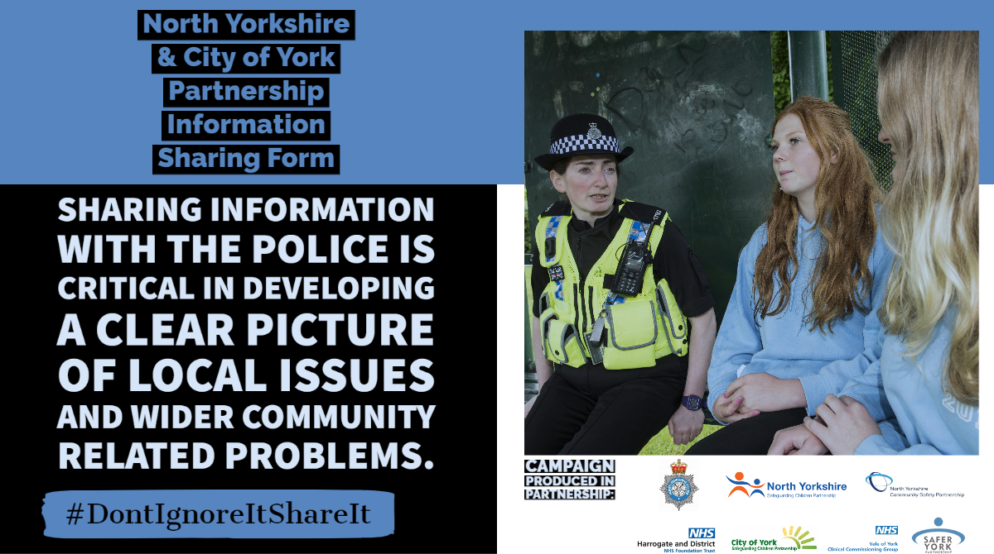

2.
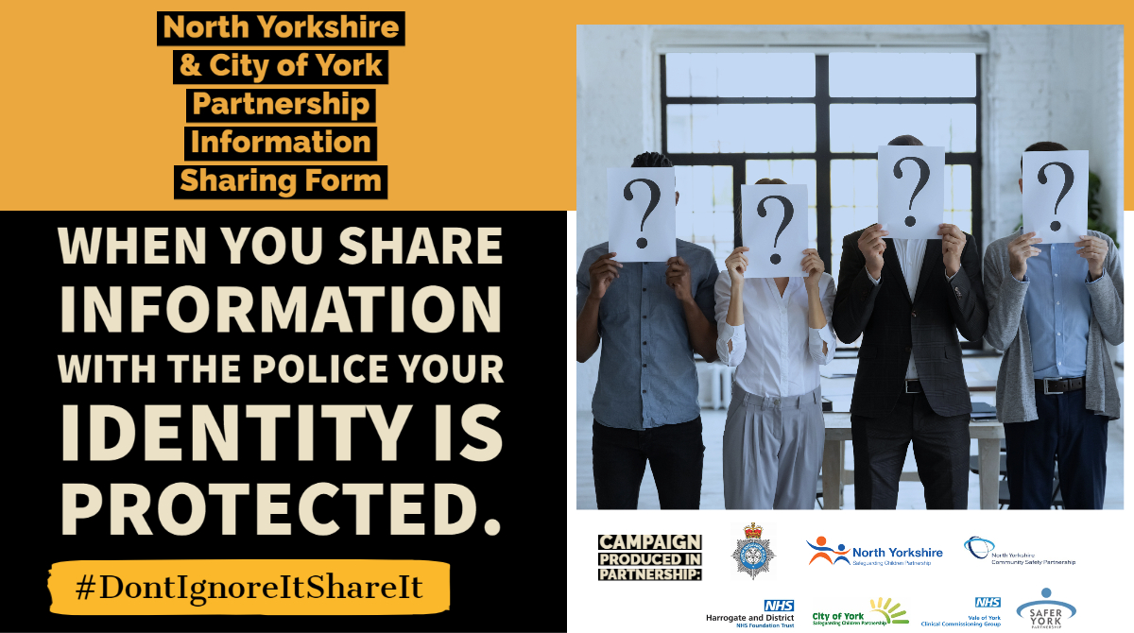
3.
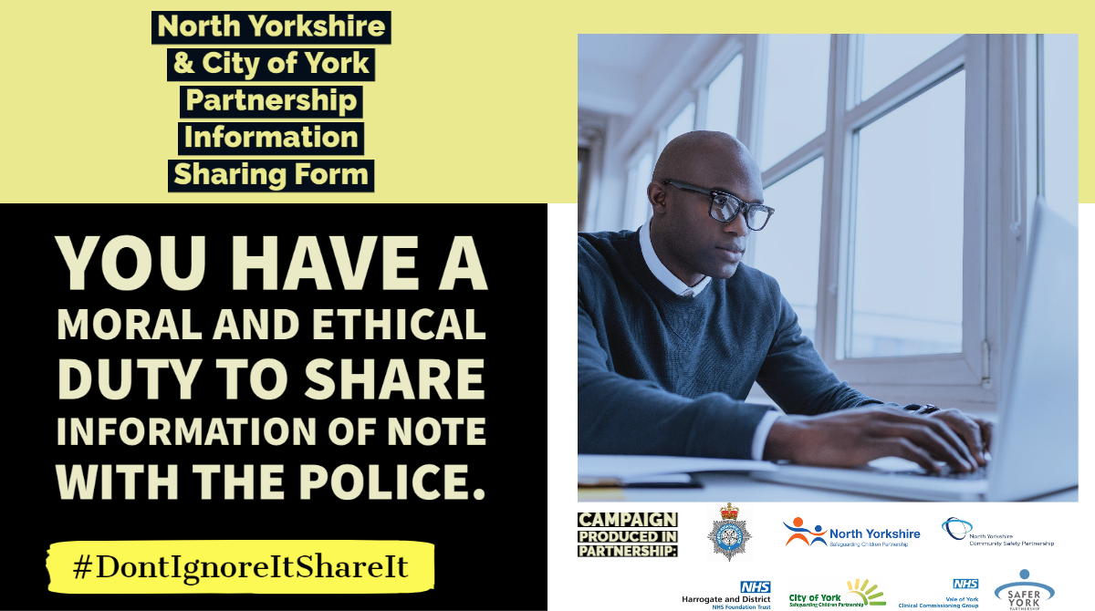

4.
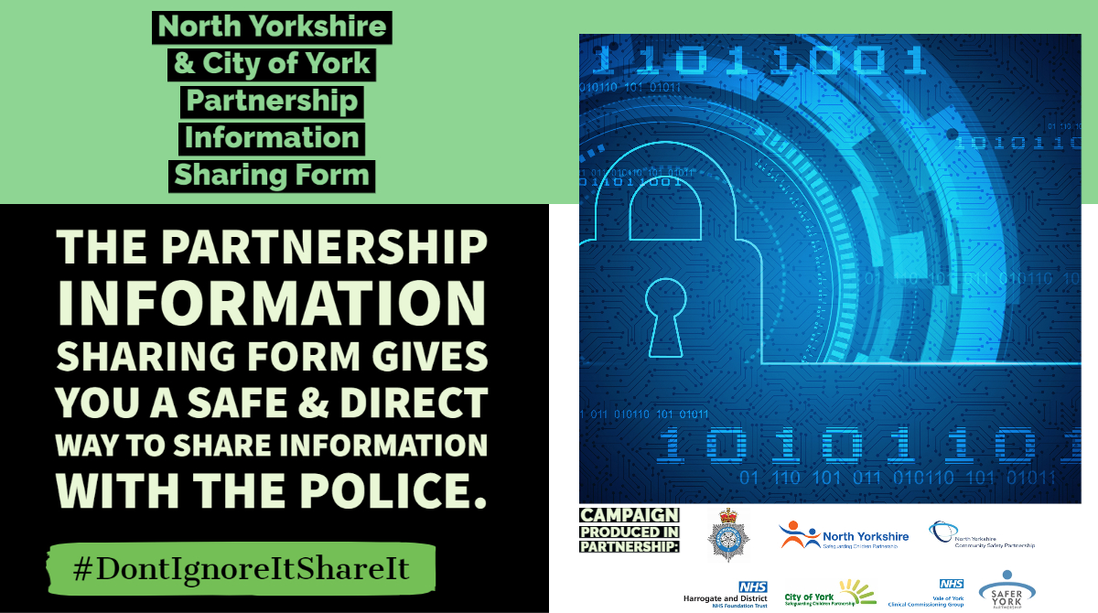
5. 