Our
Network

Safety and Support for Children and Families

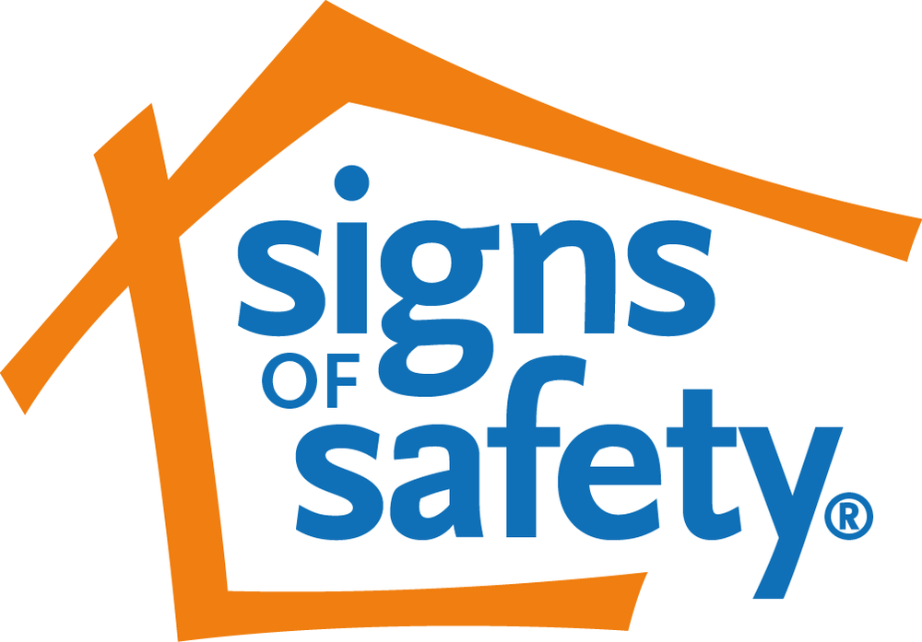
Our Network

This booklet is for families who are building their network during a difficult time. It explains what a network is for and how we will work with you and your network.

What is a Network?

A network is a group of people who have a connection with you, your children, and family.

They might be family, friends, neighbours or members of your community.

Some network members will live close by and some might live far away.

When it's not possible to see each other in person, networks use many different ways of connecting such as over the phone, texting, or video calls.

Networks always know how the children and family members are doing. They also know the things that might make them worry about the children and what to do if they are worried.

WHAT MAKES A NETWORK NECESSARY?

People on a network support you, the children, and young people at home, especially when life is difficult.

People on a network make sure the children and young people are safe, have the care they need, and are connected to family and their community.

For children and young people, this is a priority.

What to Expect

We will…

Talk with you and ask questions to help you decide who

- you want on your network

- you do not want on your network

- the children or young people would need on the network

- the children or young people would not want on the network

Understanding Together

Your Network will need to understand

- What the concerns are for the children or young people

- The best strengths in how the children and young people are looked after and all the times the network have been able to keep the kids safe in the past

- What the agency needs to see happening to close their file

Families can share this information by reading their Words and Pictures story.

A Words and Pictures Story is an agreed story that parents and caregivers and workers work on together to give the children and explanation why their family is working with the agency and what is going to happen now to make things better for everyone.

Making a Safety Plan

We will ask lots of questions to guide you and your network in making a safety plan. Sometimes these questions will be hard to think about. The workers are here to help the family and network with this.

There might be several safety planning conversations. Each conversation will look at a worry or danger and agree on rules about who will do what to make sure the children and young people are safe when things are difficult at home.

The Safety Plan in Action

When the Safety Plan is ready, you and the network can try the plan out to see what works well and what needs to change to make it stronger. More conversations with the workers will help get to a final plan that everyone knows can work.

When everyone agrees on the final safety plan, you and the network can make a simple Words and Pictures version for the children so they know what will happen and who will help if a worry comes up.

Once you, the network, and the professionals are confident that the plan works, and will continue to work, the network can take over full responsibility for the plan.

Who are the people In Our Network?

Name
Name
Name
Name
Name
Who are the people In Our Network who are available to the children or young people?

Name
Name
Name
Name
Name
Who would I like to ask to join Our Network?
Name
Name
Name
Who would the children like to ask to join Our Network?
Name
Name
Name

