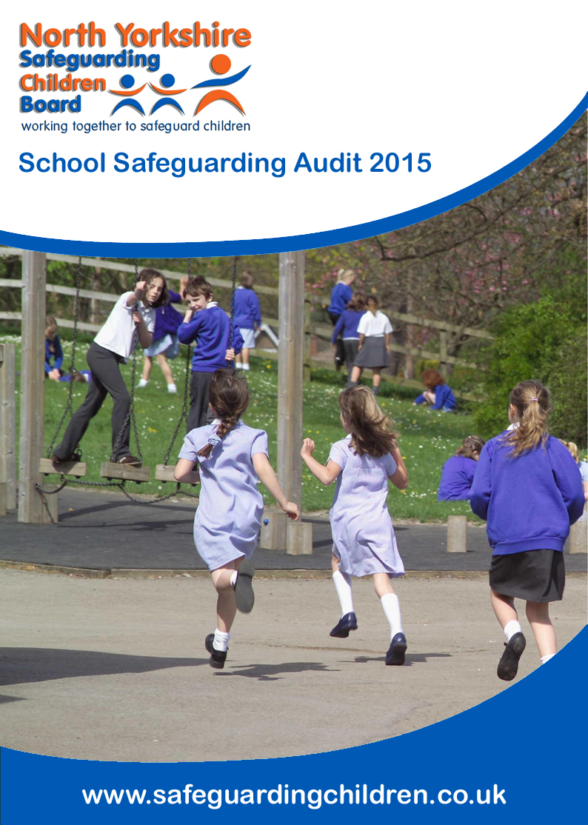
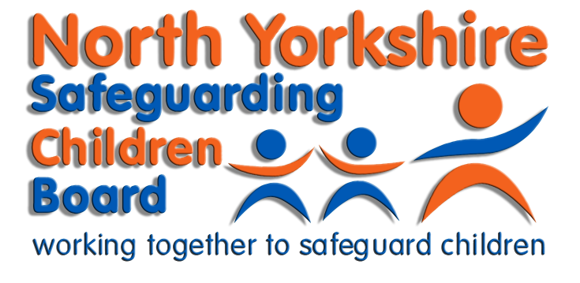
Guidance
School Safeguarding Audit 2020-2021
North Yorkshire Safeguarding Children Board
School Safeguarding Audit 2016

Contents

Contents 1
Introduction 2
Safeguarding – the current context 2
Safeguarding – a definition 2
Key legislation and guidance 2
Establishing a safeguarding culture 4
Carrying out a safeguarding audit 4
Regular and continuous monitoring of safeguarding procedures 5
Annual Safeguarding Report for the Governing Body 5
Submission of Safeguarding Audit Tool 5
Action Plans Created as a Result of the Audit 6
Suggested Safeguarding Curriculum Resources 6
Appendix B – Grading Classification 7

Introduction

This guidance has been produced to support schools in ensuring that their safeguarding arrangements are secure. It is for the immediate attention of senior leaders in schools and governing bodies.

Safeguarding – the current context

The inspection of safeguarding remains a key area within the framework for school inspection. The impact of safeguarding arrangements will be evidenced under the judgement on the quality of leadership and management and also its impact on the personal development, behaviour and welfare of children and learners. Inspectors will arrive at a judgement about whether the early years setting or school has effective safeguarding arrangements or not. This judgement will contribute towards the overall judgement on the effectiveness of leadership and management.

Safeguarding incidents continue to put safeguarding firmly in the spotlight in North Yorkshire. Where schools have encountered difficulties, or children’s safety has been put at risk, this has often been associated with one or all of the following:

- a lack of clarity amongst stakeholders about safeguarding procedures
- complacency or lack of rigour in implementing safeguarding procedures
- failure to monitor safeguarding procedures
- the failure of senior leaders to establish suitably robust safeguarding procedures

Safeguarding – a definition

This audit adopts the definition used in the Children Act 2004, and in “Working together to safeguard children” (2018). This can be summarised as:

- protecting children from maltreatment
- preventing impairment of children’s health or development
- ensuring that children are growing up in circumstances consistent with the provision of safe and effective care
- taking action to enable all children to have the best outcomes

Key legislation and guidance

- HM Government Working Together to Safeguard Children (2018)
- DfE Keeping Children Safe in Education (2020) statutory guidance for schools and colleges, statutory guidance for schools and colleges, which replaces the 2018 guidance.
- Additional Ofsted guidance for inspection of maintained schools and academies
- Ofsted Handbook for inspecting schools in England under section 5 of the Education Act

Safeguarding includes the establishment and implementation of procedures to protect children from deliberate harm. A school’s child protection procedures, safer recruitment practices and the maintenance of a robust single central record remain key requirements. However Safeguarding is not just about protecting children from deliberate harm. Safeguarding action may be needed to protect children and learners from:

- neglect
- physical abuse
- sexual abuse
- emotional abuse
- bullying, including online bullying and prejudice-based bullying
- racist, disability and homophobic or transphobic abuse
- gender-based violence/violence against women and girls
- radicalisation and/or extremist behaviour
- child sexual exploitation, child criminal exploitation, county lines and modern day slavery and human trafficking
- the impact of new technologies on sexual behaviour, for example sexting and accessing pornography
- teenage relationship abuse
- peer on peer abuse
- substance misuse
- issues that may be specific to a local area or population, for example gang activity and youth violence
- domestic violence
- female genital mutilation
- forced marriage
- fabricated or induced illness
- poor parenting
- other issues not listed here but that pose a risk to children, young people and vulnerable adults.

Safeguarding is not just about protecting children, learners and vulnerable adults from deliberate harm, neglect and failure to act. It relates to broader aspects of care and education, including:

- children’s and learners’ health and safety and well-being, including their mental health
- meeting the needs of children who have special educational needs and/or disabilities
- the use of reasonable force
- meeting the needs of children and learners with medical conditions
- providing first aid
- educational visits
- intimate care and emotional well-being
- online safety and associated issues
- appropriate arrangements to ensure children’s and learners’ security, taking into account the local context.

Establishing a safeguarding culture

A safeguarding culture begins and ends with the pupils. Pupils demonstrate the effectiveness of any procedures through their behaviour across the school day. It is essential therefore that there are regular, planned opportunities within the curriculum for each of the aspects described above to be explored with pupils, at an age appropriate level. This should not interrupt, but rather complement and be embedded within other areas of the curriculum.

Parents must be genuine partners in ensuring that agreed procedures are implemented. Some procedures may be ‘inconvenient’ for some parents. However, pupils’ safety cannot be compromised and it is useful therefore to involve parents regularly in formulating and agreeing any improvements to procedures, for example through a parent forum.

Staff are the most important factor in implementing procedures around safeguarding. It is essential therefore that regular training and high quality, transparent information supports them in carrying out these important duties effectively and consistently. Some schools make effective use of daily staff briefings to inform or remind staff of any particular aspects of safeguarding that may need more attention during that day or week. It is important that schools maintain records detailing how and when staff receive information or training.

Ultimately the Headteacher, in partnership with the governing body, is accountable for the effectiveness of safeguarding procedures. Where practice is most effective, safeguarding is a standing agenda item at senior leadership team and governing body meetings.

Carrying out a safeguarding audit

It is a requirement of the North Yorkshire Safeguarding Children Partnership (NYSCP) that all schools undertake this audit in order to review the robustness of existing safeguarding procedures. This should be carried out by a senior leader and a governor as a minimum requirement. However, where schools have involved a range of stakeholders, including pupils and parents, in auditing safeguarding, this has often led to significant improvement of arrangements, and a greater understanding and ownership of those procedures by stakeholders.

The audit is not a desktop exercise. It is essential that procedures are ‘tested out’, by observing pupils at key points in the school day, within and outside of lessons. Pupils will provide very clear information about how safe they feel and how well the school ensures their safety, so an audit should take every opportunity to seek their views about the different aspects of safeguarding.

It is not essential for schools to record extensive evidence to demonstrate where procedures are robust and effective; key points will suffice. However, it is essential that any deficiencies that may be identified are reported back to the governing body. Remedial action should be undertaken with urgency and rigour, and the impact of the changes discussed and recorded by the governing body. This will provide a vital evidence trail in inspection.

Regular and continuous monitoring of safeguarding procedures

It is the very nature of a school that it has an ever changing population. Cohorts of children move on, staff come and go. It is essential therefore that safeguarding procedures are regularly revisited in a systematic way, within the curriculum for pupils and through staff and governor training and induction.

It is also essential that different aspects of safeguarding are subject to regular monitoring checks by senior leaders, the governing body, pupils and parents. Some of these could usefully be ‘unannounced’, for example to check the veracity of information entered into the single central record, or to check that doors and gates that should be locked during the school day are indeed locked. This is not to catch people out, or to create an unwarranted sense of hysteria around safeguarding, but simply to ensure that critical safeguards are fully embedded into the school’s practice and culture and to identify any gaps

Pupils’ safety and wellbeing is central to the vision and aims of any school. It is through regular monitoring that effective schools communicate to all that their vision and aims matter. Schools can accept no less in relation to safeguarding.

Annual Safeguarding Report for the Governing Body

It is recommended that an annual safeguarding report is provided for the governing body on the school’s safeguarding practice that enables the governing body to monitor compliance with the Education Act 2002 Section 175, and to identify areas for improvement. An annual report template can be found at here

Submission of Safeguarding Audit Tool

All schools are required to complete their audit response which must be returned to the NYSCP, Please note that this includes all maintained schools as well as academies, free and independent schools. It is strongly advised that schools, following the audit, identify any necessary actions in consultation with staff and governors. This should then be progressed through the schools governance arrangements and accepted by its Board of Governors, Management Committee or Proprietors. All schools should also note that this audit includes requirements for schools whose governing bodies are also responsible for Early Years Provisions. If this is not applicable to your school then this section can be left blank.

All schools (this includes all maintained schools as well as all academies, free and independent schools) must submit their completed audit tool in its original form (i.e. word and not pdf) to nyscp@northyorks.gov.uk by Wednesday 31 March 2021. Please note that completed responses should also be approved by the school’s Board of Governors, Management Committee or Proprietors prior to submission. This audit is being undertaken in accordance with the statutory functions of the NYSCP and all schools are under a duty to comply with the audit.

If schools are in federations or multi-academy trusts, a separate response should be submitted for each school located in North Yorkshire which have a unique reference number.

Action Plans Created as a Result of the Audit

A template for an action plan for safeguarding is included in Appendix A. Action plans should not be submitted with the completed audit tool. These plans should be managed in accordance with the schools governance procedures and remain the responsibility of the school’s Board of Governors, Management Committee or Proprietors to complete.

Suggested Safeguarding Curriculum Resources

Schools can access the North Yorkshire PSHE and Citizenship Planning and Assessment toolkit which contains the PSHE and Citizenship curriculum entitlement framework for key stages 1-4 along with suggested resources specifically to support the safeguarding aspects of the curriculum by year group. It is accessible from the CYPS Information Site. See also NSPCC teaching resources and lesson plans.
For further information on safeguarding curriculum information, training and support please contact:
- Clare Barrowman, Health and Wellbeing Adviser 0-19, on 01609 536808, clare.barrowman@northyorks.gov.uk

Frequently Asked Questions
What is the purpose of the NYSCP School Safeguarding Audit?
The North Yorkshire Safeguarding Children Partnership (NYSCP) School Safeguarding Audit is intended to provide all schools (maintained, federated, free, academies, independent and special) within North Yorkshire a method of assessing their safeguarding and related practices to ensure that adequate arrangements are in place to ensure the safeguarding and wellbeing of children and young people.
The audit is also used to provide the North Yorkshire Safeguarding Children Partnership with assurance that adequate safeguarding arrangements are in place within schools and influence future NYSCP Strategies and training.
Which schools should complete the NYSCP School Safeguarding Audit 2020/2021?
All schools in North Yorkshire (maintained schools, federated schools, free schools, independent schools, special schools and academies for both primary and secondary phases of education) are requested to complete the audit. This should be approved by their governing board, trustees and other relevant governance roles and returned to the NYSCP by emailing this completed audit tool in Excel format (please DO NOT convert to PDF) to nyscp@northyorks.gov.uk no later than the close of business on Wednesday 31 March 2021.
Can one response be received for schools which are federated or in a multi-academy trust?
No, a response should be provided for each unique school if it has a unique reference number. While it understood that many federated schools and academies will have shared policies and arrangements, there will be unique and specific arrangements for each school. This audit is intended to identify the unique arrangements for each school.
Do I have to answer all questions?
Yes, unless a specific category of question is not applicable to a phase of education (these will be highlighted as primary or secondary only), all schools are expected to strive to achieve 5 (safeguarding concerns have been fully addressed).
How should I score each question?
Scoring for each question is identified in the table below:
1 | 2 | 3 | 4 | 5
The requirement does not relate to the operation of the school/Not applicable | No safeguarding controls in operation, previously unidentified risk | Identified Safeguarding Concerns/Weakness to be Addressed however no Agreed Action Plan in place | Identified Safeguarding Concerns/Weakness with an Agreed Action Plan being implemented | Safeguarding Concerns Fully Addressed
When identifying a score it is important for each school to consider whether the minimum standards for addressing safeguarding needs have been achieved. For example, where a school has sufficient safeguards in place to address safeguarding concerns, but action plans are in place to improve or modernise those arrangements, then the school is maintaining compliance and should record their achieved level of compliance as “5”. If any planned changes will result in safeguarding concerns, schools should record their level of compliance as level “2”, “3” “4” or “5” as appropriate.
The responses to a lot of questions is “1 – The requirement does not relate to the operation of the school/Not applicable”. Is the audit tool correct?
It is not appropriate to state that a requirement is not applicable only because the current cohort of children within the school do not fit certain criteria. If a school believes that a requirement is not applicable and selects "1", a full rationale must be provided to explain why the requirement is not applicable. For example, if a school is not aware of any private fostering arrangements currently in place within the school it is not appropriate to select "1" (not applicable) because no children currently meet this criteria as arrangements must be in place for when a child is identified to be privately fostered.
Who should be involved in the School Safeguarding Audit?
This audit should not be conducted by one person but should involve all relevant parties in the audit, for example, Headteacher, Designated Safeguarding Lead, Governors, etc. It is the responsibility of each school to identify those staff who should contribute to the audit.

Can I just provide a safeguarding statement which has been provided to the Governing Body or just update the previous tool?
No. We are unable to accept safeguarding statements provided to the Governing Body or updates to the previous audit tool. Submission of these types will not be accepted and any school response of this type this will be recorded as “not received” and the school contacted.
The School Safeguarding Audit has been updated from the previous audit tool as follows:
- All questions have been reviewed and updated in accordance with relevant changes is legislation and statutory guidance
- Questions have been reordered and combined to reduce repetition
- Additional columns have been added for identifying action owners and timescales to assist Governing Bodies, Trustees and/or Proprietors to monitor any actions which have been identified.
- The audit tool has been migrated to Excel for easier data analysis
Who needs to approve the School Safeguarding Audit before it is shared with the NYSCP?
For maintained schools the Board of Governors should approve the audit response prior to being submitted. For non-maintained schools the audit must be approved in accordance with the school’s governance arrangements prior to being submitted.
What do I need to do to submit the School Safeguarding Audit?
Prior to submitting the School Safeguarding Audit Tool to the North Yorkshire Safeguarding Children Partnership (NYSCP) please ensure that the tool is completed and has been approved through your school’s/academy’s governance arrangements.
Please do not convert the tool to a different format (e.g. PDF). The final completed submission must be returned to the NYSCP by email the response to nyscp@northyorks.gov.uk no later than Wednesday 31 March 2021.
What is the closing date for responses to be submitted?
The closing date for responses to be submitted to the NYSCP is 31 March 2021. This should give all schools adequate time to thoroughly complete the audit ensure it has been passed through the school’s governance arrangements.
Can I submit the response in an alternative format, e.g. PDF, Word, etc?
No, the tool has been specifically designed to capture information in spreadsheet format for date capture and reporting. Please do not to attempt to convert to an alternative format, reorder or remove any worksheets. Only cells which you may amend have been enabled for editing. Please do not enter any information on the worksheet “Data Capture (NYSCP Only)”, the will be automatically completed as you complete other sections of the School Safeguarding Audit Tool.

Action No. | Action | Responsible Officer | Date for completion | Update | Date Completed | RAG Rating
1
2
3
4
5
6
7
8
9
10
11
12
13
14
15
16
17
18
19
20
21

Appendix A – Action Plan Template

