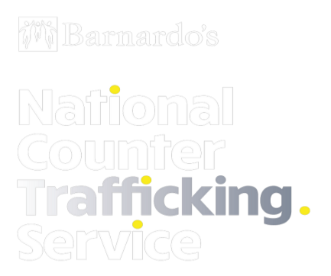
July 2021
Independent Child Trafficking
Guardianship Service (ICTG)
One Minute Guide

Background:
The Independent Child Trafficking Guardianship (ICTG) Service is outlined within Section 48 of the Modern Slavery Act. The service is commissioned by the Home Office and delivered by Barnardo’s in the following sites:

Bedfordshire | Greater Manchester | London | Wales
East Midlands | Hampshire & IOW | Merseyside | Warwickshire
Essex | Kent | North Yorkshire | West Midlands
Gloucestershire (inc. Bristol) | Lancashire | Surrey | West Yorkshire

The ICTG service offers advice, guidance and support for children (aged under 18) who have been exploited through trafficking and Modern Slavery. We also provide support, advice and guidance for professionals working with young people who are victims of trafficking and Modern Slavery.
Referrals to the ICTG service should be made when*:
- A child is identified as a victim of trafficking and Modern Slavery and they are the responsibility of one of the Local Authority sites listed above
- A child is referred to the NRM and they are the responsibility of one of the Local Authority sites listed above
Our aim is to work collaboratively with partner agencies to ensure that young people who are victims of trafficking and Modern Slavery receive support in line with their needs.
The service operates on a 24/7 basis. Advice and guidance, information about the service and queries regarding possible referrals can be made by contacting our ICTG Guardianship Assessment Team.
The Guardianship Assessment Team provide an initial triage assessment to better understand the immediate safeguarding needs of the child and provide appropriate advice to support safeguarding, risk management and safety planning
Referrals to the ICTG Service can be submitted via our Online Referral Form or by calling our Guardianship Assessment Team on: 0800 043 4303
The Home Office Guidance for the ICTG Service can be found here
*For the newly added sites of Bedfordshire, Essex, Gloucestershire (inc. Bristol), Kent, Lancashire, London (except Croydon), Merseyside, North Yorkshire, Surrey, Warwickshire and West Yorkshire referrals will be accepted for young people identified from 17th May 2021 onwards

Independent Child Trafficking Guardians (ICTG’s):
Independent Child Trafficking Guardians provide direct, specialist support for trafficked children and the professionals involved in their care. Direct support is available for any child who is identified as a victim of trafficking who is in the UK without someone with parental responsibility.
We help young people cope with the practical and emotional traumas of being trafficked. Our workers help them understand the systems and professionals working around them to offer support in ways that they can understand. Independent Child Trafficking Guardians:
- Build trusting relationships with trafficked children to help them build a positive future
- Help children navigate criminal justice, social care and immigration systems
- Give emotional and wellbeing support
- Support professionals working with children so that they can identify the indicators of trafficking and respond to meet their needs
Following recommendations through evaluation; the service is currently testing the extension of support where required for young people after their 18th birthday in Warwick, West Yorkshire and London.
Regional Practice Coordinators (RPC’s):
Regional Practice Coordinators take a strategic role, working with professionals already supporting children who have been trafficked who have someone with parental responsibility in the UK. Regional Practice Coordinators:
- Raise awareness of children who may be trafficked and improve identification, safeguarding support and improved outcomes
- Offer consultations, advice and guidance for professionals who are working directly with young people
- Provide awareness raising around the National Referral Mechanism and relevant legislation
- Support professionals to navigate the complex systems of social care and criminal justice for a trafficked child
Following recommendations through evaluation; the service is currently testing direct support for children who have a figure of parental responsibility for them in the UK where there is exceptional need in Wales, the East Midlands, and West Midlands Combined Authorities.

