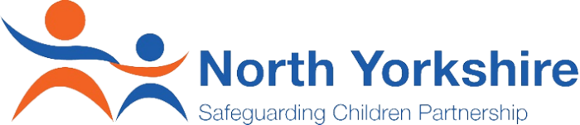

NYSCP Partnership Achievement Award

North Yorkshire Safeguarding Children Partnership would like to celebrate and showcase the great work happening right across our multi-agency partnership. We would like you to nominate individuals or teams working or volunteering with children and young people for a NYSCP Partnership Achievement Award. Please use the form below and tell us about an individual/team/group, who for you has..

- Stood out
- Gone beyond expectations
- Worked creatively and innovatively with children and young people in North Yorkshire

In line with NYSCP’s Strategy Being Young in North Yorkshire (BYinNY) please tick one of the following priority area that relates to your nomination

 | Safe |  | Happy |  | Healthy |  | Achieving

The details
Your Name |  |  | Name of the Nominee
Your Role |  |  | Nominees Role
Your Email |  |  | Nominees Email
Your Number |  |  | Nominees Number
Your nomination Summary (If you prefer you can proved your nomination summary using a video recording)
Please tell us in no more than 250 words about your nominee - Explain what their achievement/contribution/impact they have made.

Once complete please email: nyscp@northyorks.gov.uk

