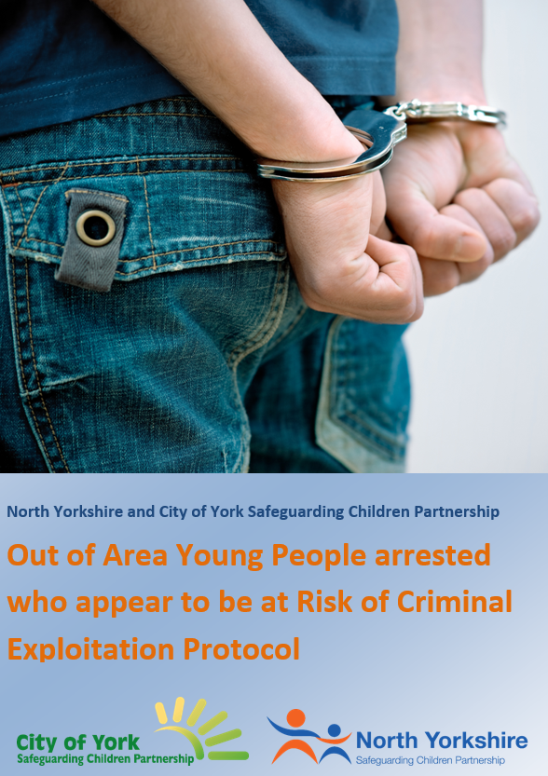
North Yorkshire Safeguarding Children Partnership and City of York Safeguarding Children Partnership
Out-of-Area Young People Arrested who Appear to be at Risk of Criminal Exploitation Protocol

Title | Out-of-Area Young People Arrested who Appear to be at Risk of Criminal Exploitation Protocol
Version | 1.7
Date | 20th December 2022
Author | Steve Walker

Update and Approval Process
Version | Group/Person | Date | Comments
1 | Practice Development Subgroup | 12/07/18 | Approved
1.1 | Heather Pearson | 25/07/18 | Reference to City of York to be revised
1.2 | Danielle Johnson | 14/12/18 | Wording around strategy meeting timescales changed
1.3 | Jo Gomerson | 01/03/19 | Protocol agreed
1.4 | Emma Phillips | 18/09/19 | Update NYSCP
1.5 | NYSCP Business Unit | 11/11/2019 | Updated following NYSCP launch
1.6 | Emma Phillips | 04/08/2021 | Reviewed and updated
1.7 | Kathryn Morrison | 20/12/22 | Reviewed and updated
1.8 | Kathryn Morrison | 8/5/2023 | Amendment to North Yorkshire council Terminology and contact number.

Issue Date | 20th December 2022
Review Date | 20th December 2024
Reviewing Officer | NYSCP Policy and Development Officer

North Yorkshire and City of York Safeguarding Children Partnership

Out-of-Area Young People Arrested North Yorkshire, who Appear to be at Risk of Criminal Exploitation

Summary of Key Actions -

- Formal safeguarding referral, at the earliest possible moment
- Welfare/safeguarding interview(s) with the young person
- Consultation with the young person’s home area services
- Consideration of a Strategy Discussion before the young person is released
- Safety Plan to protect the young person through to handover

- Formal safeguarding referral, at the earliest possible moment –

Police officers should be aware of the general indicators of CCE/County Lines - young people trafficked from urban areas who have no obvious reason to be in North Yorkshire or City of York, in possession of substantial quantities of drugs and/or cash, often armed with large knives or other weapons, and may be accompanied or arrested with adults. This is not the only form of CCE, but it is the main type we are seeing at this time.

Police officers who arrest young people under these circumstances should promptly make a written safeguarding referral. If the arrest was a planned intelligence-led operation, a confidential referral might be helpfully made in advance. Custody Sergeants should check at booking-in that a safeguarding referral has been made. Youth Justice workers who are informed of the arrest should also check that a referral has been made and if not ensure one is completed.

Referrals should be made by the normal form and process to NYC Customer Service Centre/York MASH. It is important that the referral explicitly sets out the urgent safeguarding requirement, for example : “This child appears to be suffering or at risk of significant harm, as a result of criminal exploitation.

The Local Authority should then expedite screening and allocation. Police powers to detain the young person are constrained by PACE, we have a small window for assessment and planning, therefore the response needs to be in line with this. Outside office hours, referrals are screened by EDT Customer Advisors. To expedite a response it is preferable that the referring officer also contacts EDT by phone.

- Welfare/safeguarding interview(s) with the young person

Safeguarding activity should be informed by the young person’s family background and immediate circumstances, and also take regard of their wishes and feelings. To ensure this, the young person should be visited in custody and spoken to privately at the earliest opportunity. During normal working hours, the initial welfare visit will be made by the Youth Justice Officer or Social Worker and out of working hours by EDT. Visits will need to be arranged with the Custody Sergeant, to avoid impact upon Police detention and investigation processes.

The initial welfare visit is a professional task of engagement, information-gathering and assessment – to ascertain the young person’s background and circumstances, how they came to be involved in this activity and how services might be able to protect them. It will be important to clarify with the young person that this is not a criminal investigatory interview. We do not want them to admit crimes or name their associates, and it is better if they do not do so as we might be obliged to disclose information of that kind to the Police.

Visiting professionals should also be careful to avoid inadvertent obstruction of criminal investigations. If the young person asked for any calls or messages to be sent for example, this must be consulted with Police before action. Ideally the visiting professional should talk to Police colleagues before meeting the young person, and also debrief with them afterwards to share information and agree actions, sharing what is necessary and proportionate.

If the worker who makes the initial visit establishes an influential rapport with the young person, it may be helpful for them to remain (or return) to support the formal PACE interview in capacity of Appropriate Adult. Otherwise, Youth justice volunteer AA’s will be available as required during normal service hours, and EDT will attend otherwise.

- Consultation with the young person’s home area services

North Yorkshire and City of York agencies should work together to gather relevant information from the home area services, ensuring that we understand the young person’s involvement with Children’s Services, Youth Justice and Police (also Education & CAMHS, where possible).

However the formal process of consultation, negotiation and joint planning with the home area Local Authority must be co-ordinated by the NYC/City of York safeguarding social worker, to ensure clarity and consistency of decision-making.

- Recorded Strategy Discussion before the young person is released (if appropriate)

A recorded Strategy Discussion must be considered in all cases. The home area authority must be invited and encouraged to participate in the Strategy Discussion, and it may be agreed that they lead it. More often this responsibility will lay with

North Yorkshire or City of York Children’s Services, as the area where the young person was ‘found at risk of significant harm’.

The Strategy discussion should record a provisional view of whether an NRM referral is appropriate, and if so identify who holds responsibility for this.

Youth Justice services should participate in the Strategy Discussion where practicable, including both home area services and the local teams in North Yorkshire or City of York area.

- Safety Plan to protect the young person through to handover

A safety plan is a plan to safeguard the young person and return them to the care or oversight of their family and/or home area services. This should particularly include consideration of travel, where applicable, and the likelihood of renewed contact with adult gang exploiters.

Consideration should be given to the powers and duties set out in the Bail Act 1976, and the young person should not be released from Police custody until there are safe arrangements for their accommodation and care. However detention under arrest is strictly regulated by the “PACE Clock” and cannot be used in place of welfare provision. Partners need to move briskly to have a package ready.

It would rarely be appropriate for a young person in this situation to be left to make their own way home on public transport. If the home area local authority is not willing to make arrangements for collection (by family or professionals) then it may be necessary for North Yorkshire or City or York agencies to take the young person home, or to arrange an escorted journey. In that situation we might wish to recover costs from the home LA.

